

**School of Computer Science and Mathematics**

**Behavioural Biometrics for Continuous User Authentication**

**Submitted by:**

**Akindepo Okiji**

**Student ID:**

**913432**

**Supervised By:**

**Dr Nathan Shone**

*This project is submitted for the module 6100COMP and complies with all relevant LJMU academic regulations, including plagiarism and collusion.*

Submitted on 03/05/2024

Acknowledgements

First, I am profoundly grateful to God Almighty for the strength and wisdom provided throughout my studies and during the completion of this project.

I am profoundly thankful for the love and support of my wife, Sylwia, my children, Elijah and Elizabeth. Their motivation and encouragement have been instrumental from the inception of my course four years ago until now.

I am immensely grateful to Dr. Nathan Shone, my supervisor, for his knowledgeable insights and practical guidance throughout this project. His intelligence and in-depth understanding of the subject matter have enriched my work, providing clarity and direction when most needed. Dr. Shone often reassured me that each part of the project was "straightforward," a testament to his eternal optimism about my pace of work despite the project often feeling like it required me to have the computing power of a small satellite!

I would also like to extend my gratitude to all participants who anonymously contributed their keystroke dynamics for this study. Your involvement was crucial in providing the data essential for my research, and your contributions have profoundly impacted the success of this project. My heartfelt thanks also go to my friends and extended family, whose encouragement and guidance have been invaluable. Their support has been a source of strength and inspiration, pushing me to strive for excellence. Furthermore, I would like to acknowledge my coursemates for their enlightenment and the stimulating discussions that have contributed to a lively learning environment. Their perspectives and challenges have added depth to my academic experience, making this journey not only educational but also immensely enjoyable.

Each of these individuals has played a significant role in my academic journey, and for that, I am massively grateful. Their contributions have not only shaped this project but have also profoundly influenced my personal and professional growth.

Abstract

In the context of escalating cybersecurity threats, traditional authentication methods such as passwords and biometrics are increasingly proving insufficient. This project investigates the potential of integrating Support Vector Machine algorithms with keystroke dynamics to enhance continuous user authentication systems in digital environments. The primary goal was to develop a machine learning model that leverages the unique typing patterns of users to provide a dynamic, real-time authentication solution that is both secure and non-intrusive.

The research included the development and refinement of a keystroke dynamics model using Support Vector Machine algorithms. This model was trained on a dataset consisting of keystroke data collected from various users engaging in multiple typing tasks. The data captured included metrics such as typing speed, error rates, rhythmic patterns, dwell-time, and flight-time which were used to differentiate between authenticated users and potential intruders. The model's performance was thoroughly tested for accuracy and efficiency in real-time processing, focusing on maintaining high levels of user privacy through anonymisation and secure data handling practices.

The findings from the project indicate that the Support Vector Machine based model achieved high precision and recall rates, effectively distinguishing legitimate user interactions from unauthorised attempts without generating false positives or negatives. This success highlights the model's capability to function as a reliable component of a comprehensive continuous user authentication system, thereby enhancing overall security in digital platforms. Additionally, the system demonstrated the ability to integrate seamlessly into existing digital infrastructures, suggesting its practical applicability in diverse operational environments.

The project also explored future enhancements for the continuous user authentication system. Potential areas for further development include the adoption of deep learning techniques for more sophisticated pattern recognition, the implementation of adaptive learning to accommodate the evolving typing patterns of users, and the exploration of privacy preserving techniques to enhance data security further. Additionally, the expansion of the system to support multi-factor authentication and its adaptation across various devices and platforms were identified as key areas to increase the robustness and scalability of the authentication system.

In conclusion, this research confirms the effectiveness of using Support Vector Machine algorithms in conjunction with keystroke dynamics to create a robust, efficient, and privacy conscious continuous user authentication system. It offers a significant contribution to the field of cybersecurity by providing a method that not only enhances the security of digital environments but also improves user compliance and convenience without compromising privacy.

Contents

Acknowledgements i

Abstract ii

Contents iii

List of Figures vii

List of Tables ix

List of Abbreviations x

Chapter 1 Introduction 1

1.1 Research Question 1

1.2 Aims and Objectives 1

1.2.1 Project Aim 1

1.2.2 Project objectives 1

1.3 Dissertation Overview 2

Chapter 2 Background 3

2.1 Introduction to Behavioural Biometrics 3

2.1.1 Comparative Analysis: Behavioural Biometrics vs Traditional authentication 4

2.1.2 Technical Mechanisms of Behavioural Biometrics and Sector-Specific Applications 5

2.2 CUA: A Paradigm Shift 7

2.3 ML: A Foundation for Behavioural Biometrics 8

Chapter 3 Literature Review 10

3.1 Behavioural Biometrics Research 11

3.2 CUA 12

3.3 ML for User Authentication 15

3.4 Challenges and Solutions in Deployment 17

3.5 Security and Privacy Considerations 17

3.6 Adversarial Challenges and Countermeasures 18

3.7 Synthesis and Future Directions 20

Chapter 4 Problem Analysis & Requirements 22

4.1 Requirement Analysis 22

4.1.1 Keystroke Dynamics as a Core Component of Continuous Authentication: 22

4.1.2 Evaluating Machine Learning Efficacy in Behavioural Biometrics for CA 22

4.1.3 Limitations of Traditional Authentication Methods 23

4.1.4 User Experience and Acceptability 24

4.1.5 Technological Constraints and Scalability 25

4.1.6 Ethical and Privacy Considerations 26

4.2 Methodology 26

4.2.1 Data Source and Collection Methodology 26

4.2.2 Integration of SVM and Data Handling 27

4.2.3 Ethical and Privacy Considerations 27

4.2.4 Testing and Validation 27

Chapter 5 Design 28

5.1 UI Design 28

5.2 Data Collection Design 30

5.3 System Architecture and Data Flow 32

5.4 Authentication Model Development 33

5.5 Security and Privacy Measures 34

5.6 Linking Design to Requirements 34

Chapter 6 Implementing the Behavioural Biometric CUA System 36

6.1 Main Implementation Tools and Technologies 36

6.2 Data Collection Implementation 37

6.2.1 Metrics Computation and Analysis 37

6.2.2 Key Classes and Their Interactions 39

6.2.3 System Workflow 47

6.2.4 Real-Time Capture Integration 48

6.3 Feature Extraction for CUA 49

6.3.1 Data Preparation 49

6.3.2 Data Importing 50

6.3.3 Feature Selection Rationale 51

6.4 Data Preprocessing for SVM 52

6.4.1 Custom Transformations and Encoding 52

6.4.2 Bigram Encoding Process 53

6.4.3 Punctuation Encoding Process 53

6.4.4 Feature Scaling 54

6.4.5 Missing Value Imputation 55

6.4.6 Custom Transformations with Task types 55

6.4.7 Data Cleaning and Final Preparation 55

6.4.8 Data Export for Modelling 55

6.5 Implementation of One-Class SVM for CUA 56

6.5.1 Dataset Overview 56

6.5.2 Data Preprocessing for SVM Training 56

6.5.3 Model Training and Parameter Selection 57

Chapter 7 Evaluation 59

7.1 Experiment Setup 59

7.2 Validation of Keystroke Metrics 59

7.3 Metric-Based User Behaviour Analysis 60

7.3.1 Custom Text Task 60

7.3.2 Fixed Text Task 60

7.3.3 Free Typing Task 61

7.4 Evaluation and Testing of One-Class SVM for CUA 62

7.5 Limitations and Challenges 63

Chapter 8 Conclusion and Future Work 64

8.1 Achievement of Aims and Objectives 64

8.2 Response to Research Question 64

8.3 Future Work 64

8.4 Technical Expansion 65

References 66

Appendices 74

Appendix A: Typing Task Materials 74

A1: Fixed Text Typing Task 74

A2: Transcript of Custom Text Voice Note 75

Appendix B: Firebase Admin SDK Configuration Template 75

Appendix C: Data Export Script For user 7, user_test11 and the rest of the users 76

Appendix D: Screenshot of Data Import Confirmation 77

Appendix E: Data Preprocessing Code 77

Appendix F: Screenshot of Pre-processed Data 78

Appendix G: Metrics chart code 78

G1: Code for flight time and dwell time 78

G2: Code for Error Rate, CPM and WPM Analysis 80

G3: Code for Sentence and Paragraph counts and Backspace usage Analysis 81

Appendix H: Dataset Snapshots for Post-Processing Analysis 82

Appendix I: Complete One-Class SVM Training and Testing Script 83

Appendix J: Comprehensive One-Class SVM Testing Results 84

Appendix K: Error Logs and System Performance Screenshots 84

Data Collection and Training Process 85

Live Authentication Process 87

Appendix L: GitHub Repository for Project Code 88

List of Figures

Figure 1 Evolutionary Timeline of Digital Security and Behavioural Biometrics (adapted from Codecademy [1], "The Evolution of Cybersecurity"). 3

Figure 2 Levin [2] – BioCatch Biometric Behaviour Analysis 4

Figure 3 Continuous Authentication Workflow Diagram [9] 7

Figure 4 User Flow through the Authentication System UI 29

Figure 5 Data Flow Diagram for Data Capture Methodology 32

Figure 6 System Architecture Diagram 33

Figure 7 Visualisation of Inter-Key Latencies in Typing Rhythm 38

Figure 8 Dwell Time Visualisation 38

Figure 9 Flight time visualisation. 38

Figure 10 MainApp class - System Controller and User Session Management 39

Figure 11 UserInterface Class Code Snippet 40

Figure 12 User Journey Through the GUI 41

Figure 13 SessionManager Class Code 42

Figure 14 Key Methods of the DataCollector Class Excerpt 43

Figure 15 MetricsCalculator Class Code Excerpt 44

Figure 16 TaskManager Class Implementation 44

Figure 17 DataBase Class Implementation 44

Figure 18 Firestore Database Structure for Storing Session Data 45

Figure 19 AuthenticationManager Class 45

Figure 20 Secure Storage of Hashed User Passwords in Firestore Database 46

Figure 21 ErrorHandler Class Code Implementation 46

Figure 22 User Authentication Error Dialogue 47

Figure 23 ConfigManager Class Overview 47

Figure 24 Firestore Data Retrieval Process 50

Figure 25 Data Types in Keystroke Dynamics Dataset 50

Figure 26 Encoding and Statistical Transformation Processes for Keystroke Dynamics 53

Figure 27 Bigram Encoding Process 53

Figure 28 Figure 25: Punctuation Encoding Process 54

Figure 29 Metrics scaling process 54

Figure 30 Missing value process 55

Figure 31 Handling Categorical Data: Task Type Encoding 55

Figure 32 pre-preprocessed data. 57

Figure 33 Code Demonstrating Anonymisation in Dataset 57

Figure 34 Nu Parameter Tuning for One-Class SVM 58

Figure 35 Cross-Task Training and Testing of One-Class SVM 58

Figure 36 Validation of Punctuation Metrics in Keystroke Data 59

Figure 37 Analysis of Dwell and Flight Times Across User 60

Figure 38 Error Rates, wpm and cpm Across Users 61

Figure 39 Sentence, Backspace and Paragraph count analysis 61

Figure 40 Firebase Admin SDK Configuration 75

Figure 41 Data Export Script for authenticated users without user 7 and user_test11 76

Figure 42 Data export for user 7 76

Figure 43 Data export for user_test11 77

Figure 44 Screenshot of Data Import Confirmation for userAll.csv 77

Figure 45 Pre-processed Data Overview 78

Figure 46 Analysis of dwell time and flight time 79

Figure 47 Analysis of error rate 81

Figure 48 Analysis of Sentence and Paragraph counts and Backspace usage 82

Figure 49 Overview of Keystroke Dynamics for Authenticated and Unauthenticated Users 83

Figure 50 One-Class SVM Training and Testing Script 83

Figure 51 One-Class SVM Testing Results 84

Figure 52 Live Keystrokes collection 85

Figure 53 SVM-based CUA for User11 86

Figure 54 Sessionmanger and predict method for CUA 87

Figure 55 Incorrect Authentication Prediction Despite Correct User Typing Behaviour 87

Figure 56 GitHub cloning command link 88

List of Tables

Table 1 Comparative Overview of Traditional Authentication vs Biometric Authentication Methods [4] 4

Table 2 Technical Mechanisms of Behavioural Biometrics and Their Industry Applications 6

Table 3 ML Techniques in Behavioural Biometrics Success Rates 23

Table 4 Metrics Collected for Keystroke Dynamics Analysis 30

Table 5 Typing Metrics Categorisation and Their Purposes Across Different Task Types 31

Table 6 Data Type Descriptions for Keystroke Dynamics Dataset 51

Table 7 One-Class SVM Performance Evaluation 62

List of Abbreviations

|  |  |
| --- | --- |
| Abbreviation | Full Term |
| AI | Artificial Intelligence |
| CAB | Continuous Authentication Blockchain |
| CNN | Convolutional Neural Network |
| CPM | Characters Per Minute |
| CUA | Continuous User Authentication |
| CUDA | Compute Unified Device Architecture |
| DL | Deep Learning |
| DT | Decision Trees |
| EEG | Electroencephalogram |
| EER | Equal Error Rate |
| XR | Extended Reality |
| FAR | False Acceptance Rate |
| FRR | False Rejection Rate |
| FGSM | Fast Gradient Sign Method |
| GANs | Generative Adversarial Networks |
| GPU | Graphics processing unit |
| HMD | Head-Mounted Display |
| IoT | Internet of Things |
| JSMA | Jacobian-based Saliency Map Attack |
| KNN | K-Nearest Neighbours |
| LMT | Logistic Model Trees |
| NN | Neural Networks |
| ML | Machine Learning |
| PART | Partial Decision Trees |
| RF | Random Forests |
| SVM | Support Vector Machines |
| TOTP | Time-Based One-Time Password |
| VR | Virtual Reality |
| WPM | Words Per Minute |
| UAV | Unmanned Aerial Vehicles |
| UI | User Interface |

# Introduction

This project explores the application of keystroke dynamics within continuous user authentication (CUA) systems, using Support Vector Machine (SVM) algorithms to strengthen security measures in digital environments. Keystroke dynamics, which analyse the unique patterns of users' typing behaviour such as timing between key presses and the duration of key holds, are increasingly vital in cybersecurity. This biometric approach offers continuous, passive authentication, which is essential given the dynamic nature of cyber threats.

Traditional authentication methods, including passwords and physical biometrics, are proving increasingly insufficient against contemporary cyber threats. A massive portion of data breaches involve credential theft, indicating the limitations of static authentication methods. According to the 2023 Verizon Data Breach Investigations Report[1], 74% of all breaches involved the human element, which includes errors, privilege misuse, the use of stolen credentials, and social engineering​, emphasising the urgent need for more robust security solutions.

Furthermore, advancements in behavioural biometrics present a compelling avenue for elevating authentication security. Research suggests that CUA systems that incorporate behavioural biometrics can significantly reduce false acceptance and rejection rates. Notably, systems that use keystroke dynamics have demonstrated error rates significantly lower than those typical of other biometric systems, highlighting their potential to enhance security efficacy.

The integration of SVM algorithms, known for their robust classification and pattern recognition capabilities, is central to this project. This approach aims to bridge the gaps identified in traditional and existing biometric authentication systems. The selection of keystroke dynamics is strategic, given its non-intrusiveness and the capability to seamlessly integrate into user activities without disrupting the workflow, thereby enhancing both security and the user experience in digital platforms.

Top of Form

## Research Question

The evolving landscape of cybersecurity, with its increasing reliance on behavioural biometrics and CUA, poses significant challenges. Traditional methods like passwords and physical biometrics only provide static security measures, often vulnerable to sophisticated attacks. This project seeks to answer:

**How can the integration of SVM algorithms with keystroke dynamics improve CUA systems in digital environments?**

This research seeks to develop a machine learning model that enhances security and enhances user activities, improving detection capabilities and user compliance without compromising privacy or convenience.

## Aims and Objectives

### Project Aim

The aim of this project is to enhance cybersecurity mechanisms through the development of a robust CUA system using keystroke dynamics. This system aims to provide a higher level of security in digital environments by continuously verifying the identity of users based on their unique typing patterns.

### Project objectives

To achieve this aim, the project will focus on several specific objectives:

1. **Develop a Keystroke Dynamics Model:** Implement and refine a ML model using SVM algorithms to accurately analyse and interpret user keystroke dynamics.
2. **Ensure High Accuracy and Efficiency:** Design the system to authenticate users accurately with minimal error rates and ensure real-time processing for continuous authentication.
3. **Prioritise User Privacy:** Implement data handling and storage protocols that protect user data, ensuring all keystroke information is anonymised and securely stored.
4. **Integrate with Existing Systems:** Ensure the system can be integrated with existing digital environments without significant modifications.
5. **Evaluate System Performance:** Test the system against a set of criteria to assess its effectiveness, focusing on reliability, scalability, and user acceptance.

**Evaluation Strategy**

The success of the project will be evaluated against these objectives, incorporating both technical performance assessments and the impact on user experience and privacy.

## Dissertation Overview

This dissertation is structured into eight main chapters, each addressing different aspects of behavioural biometrics for CUA using keystroke dynamics. Here is a brief overview of each chapter:

* **Chapter 1: Introduction** - Sets the stage for the dissertation by discussing the evolution of cybersecurity threats and the necessity for robust CUA systems. Introduces keystroke dynamics combined with SVM algorithms as a potential solution.
* **Chapter 2: Background** - Provides a detailed exploration of behavioural biometrics, highlighting its advantages over traditional authentication methods and detailing the technical mechanisms that support its application in various sectors.
* **Chapter 3: Literature Review** - Reviews existing literature on behavioural biometrics, CUA, and the integration of ML. It addresses the current challenges and advances in the field, identifying gaps that the dissertation aims to fill.
* **Chapter 4: Problem Analysis & Requirements** - Analyses the specific problem of enhancing continuous authentication with keystroke dynamics. Discusses the requirements necessary for effective implementation, including technological and user experience considerations.
* **Chapter 5: Design** - Describes the design of the CUA system, including user interface, system architecture, and the security measures integrated to protect user data.
* **Chapter 6: Implementation** - Details the implementation process of the keystroke dynamics-based authentication system, including the tools and technologies used, and the methodology for integrating the SVM model.
* **Chapter 7: Evaluation** - Presents the evaluation methods and results for the authentication system, demonstrating its effectiveness and efficiency in real-world scenarios.
* **Chapter 8: Conclusion and Future Work** - Summarises the findings and contributions of the dissertation, discusses the response to the research question, and outlines future research directions to further enhance the system.

# Background

In recent years, the realm of digital security has undergone significant transformations, with behavioural biometrics and CUA emerging as critical elements in safeguarding digital identities. This evolution stems from the escalating sophistication of cyber threats and the limitations of traditional authentication methods. Behavioural biometrics, leveraging unique individual patterns in behaviour, offers a more dynamic and continuous approach to security. This field has seen substantial advancements, particularly with the integration of ML techniques, enhancing accuracy and adaptability. The importance of this research lies in its potential to revolutionise user authentication, moving towards more secure, efficient, and user-friendly systems.

**Evolution of Digital Security**

Digital security has evolved significantly, facing increasingly complex threats over time. From early password systems to advanced cryptographic methods, Figure 1 illustrates this historical progression, leading up to the integration of behavioural biometrics and CUA. As shown, each phase marks a technological advance and a strategic shift towards continuous verification, a response to the persistent and sophisticated nature of modern cyber-attacks.

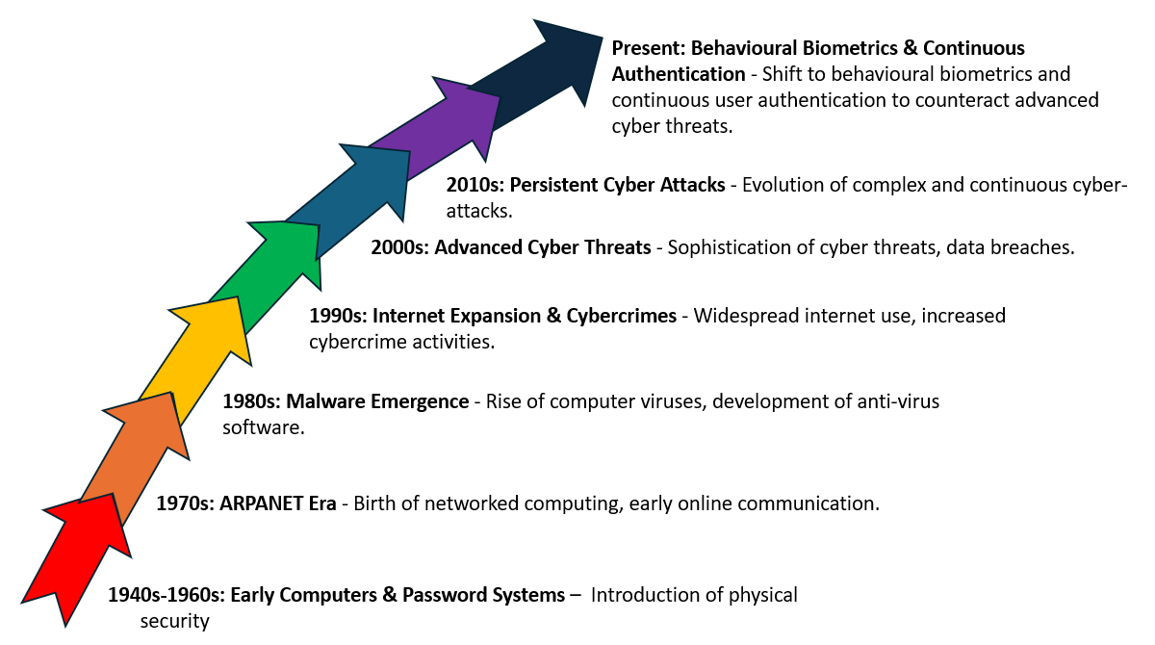

Figure 1 Evolutionary Timeline of Digital Security and Behavioural Biometrics (adapted from Codecademy [1], "The Evolution of Cybersecurity").

## Introduction to Behavioural Biometrics

Behavioural biometrics as outlined by Levin in BioCatch's analysis (Figure 2), refers to the unique ways in which individuals interact with devices and systems, such as typing patterns, mouse movements, and navigation habits. This technology goes beyond traditional biometrics by capturing a wide array of human interactions to create user profiles. It is used for continuous verification, providing a seamless security layer that operates in the background without disrupting the user experience. The integration of behavioural biometrics into authentication processes offers a dynamic and adaptive security measure that is difficult to spoof, thus enhancing overall system protection.

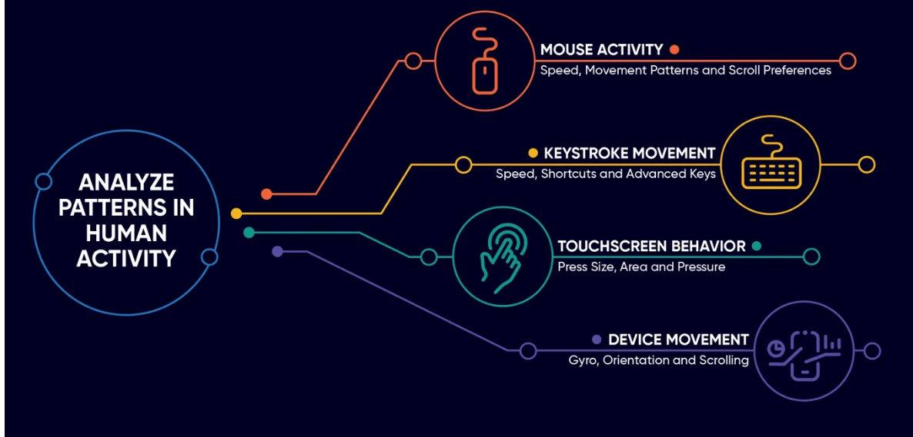

Figure 2 Levin [2] – BioCatch Biometric Behaviour Analysis

Below, the technical mechanisms of behavioural biometrics and their practical applications are explored.

The term **Biometrics** according to NIST [3]“is a measurable physical characteristic or personal behavioural trait used to recognize the identity, or verify the claimed identity, of an applicant. Facial images, fingerprints, and iris scan samples are all examples of biometrics.”

Nevertheless, behavioural biometrics sets itself apart by leveraging the unique behavioural patterns exhibited by individuals during their interactions with computer systems. Unlike static biometrics such as fingerprints, facial recognition, voice recognition, and signature verification which depend on consistent physical characteristics, behavioural biometrics delve into the dynamic aspect of human actions, which include keystroke dynamics and mouse movements.

### Comparative Analysis: Behavioural Biometrics vs Traditional authentication

In navigating the evolving landscape of biometric technologies, a comparative analysis of traditional and behavioural biometrics becomes essential, highlighting the advancements and differences that define modern authentication systems. Table 1 offers a structured comparison between traditional authentication methods and biometric authentication [4]. This comparative overview aims to explain the unique characteristics, potential vulnerabilities, and the overall effectiveness of each approach in the context of contemporary cybersecurity measures.

Table 1 Comparative Overview of Traditional Authentication vs Biometric Authentication Methods [4]

|  |  |  |
| --- | --- | --- |
| Aspect | Traditional Authentication (i.e., Passwords, PINs, Security Tokens) | Biometric Authentication (Fingerprints, Facial Recognition, etc.) |
| Security Vulnerabilities | Vulnerable to weak passwords, password reuse, phishing attacks, and brute-force attacks. | It reduced the risk of impersonation or unauthorised access due to the uniqueness of biometric identifiers. However, some systems may be susceptible to spoofing. |
| Accuracy | This can be compromised due to weak or reused credentials. | Higher accuracy as biometric identifiers are unique to each individual, reducing the risk of unauthorised access. |
| User Experience | Requires remembering and inputting credentials, which can be cumbersome and lead to weaker security practices. | Offers a seamless and user-friendly experience, eliminating the need to remember passwords or carry tokens. |
| Convenience | Often inconvenient as users must remember complex passwords or carry physical tokens. | Enhanced convenience as users can authenticate effortlessly with a touch, glance, or behavioural trait. |
| Data Privacy and Security | Vulnerabilities involve credential theft or misuse. | Concerns arise from storing biometric data in centralised databases; a breach can lead to irreversible consequences. |
| Adoption and Implementation | Widespread adoption due to familiarity and ease of implementation. However, user compliance can be an issue due to password fatigue. | Growing adoption due to increased security and convenience. However, implementation may involve sophisticated technology and infrastructure. |
| Future of Authentication | Increasingly being supplemented or replaced by more secure methods due to inherent vulnerabilities. | Seen as a robust solution for the future, especially when combined with other methods in multi-factor authentication (MFA) setups to mitigate potential risks. |
| Aspect | Traditional Authentication (Passwords, PINs, Security Tokens) | Biometric Authentication (Fingerprints, Facial Recognition, etc.). |
| Security Vulnerabilities | Susceptible to weak passwords, password reuse, phishing attacks, and brute-force attacks. | Reduced risk of impersonation or unauthorised access due to the uniqueness of biometric identifiers. However, some systems may be susceptible to spoofing. |
| Accuracy | Can be compromised due to weak or reused credentials. | Higher accuracy as biometric identifiers are unique to each individual, reducing the risk of unauthorised access. |
| User Experience | Requires remembering and inputting credentials, which can be cumbersome and lead to weaker security practices. | Offers a seamless and user-friendly experience, eliminating the need to remember passwords or carry tokens. |
| Convenience | Often inconvenient as users must remember complex passwords or carry physical tokens. | Enhanced convenience as users can authenticate effortlessly with a touch, glance, or behavioural trait. |

### Technical Mechanisms of Behavioural Biometrics and Sector-Specific Applications

Table 2 outlines the fundamental technical aspects of behavioural biometrics, examining their distinct functionalities and the breadth of their applications across a range of devices and industry sectors. The articulation of these mechanisms emphasises the sophisticated integration of behavioural biometrics in fortifying security frameworks and enhancing user interaction strategies.

Table 2 Technical Mechanisms of Behavioural Biometrics and Their Industry Applications

|  |  |  |
| --- | --- | --- |
| Mechanisms | Description | Applications in Devices/Industries |
| Keystroke Dynamics | This establishes the intervals (dwell and flight times) between key presses and releases. Every individual has a distinct typing rhythm that offers a consistent behavioural pattern. | Online Education (e.g., Coursera): Uses keystroke dynamics to authenticate students during courses, requiring them to type out specific sentences at the start and end of the course for identity confirmation [4].  Banking, Financial Services, Retail, Healthcare, Education, and Defence: Employ keystroke dynamics for multimodal biometrics, leveraging this technology to stay ahead of cyber threats and ensure secure user authentication [5]. |
| Mouse Dynamics | This examines the mouse's motion, and speed. To create a behavioural signature, it also takes click patterns and cursor movements into account. | E-commerce platforms: Used to identify and stop fraudulent activity by separating genuine users from scammers through the analysis of navigation patterns and mouse movement behaviours [5].  Continuous Authentication Systems: Integrated into workstation or remote work environments, these systems make sure that the active user is the rightful account holder based on their interaction patterns [5].  User Behaviour Analytics: Enhances an organisation's overall security posture by monitoring and analysing mouse movements to identify anomalies or malicious activity [5].  Online Banking Systems: Used for intruder detection by analysing user-specific mouse movements to identify and prevent unauthorised access [5]. |
| Voice Recognition | This examines characteristics of a user's voice, such as pitch, tone, and speaking rhythm. | Contact Centres: Streamlines customer service interactions by using voice for verification and authentication, saving time and effort for both consumers and agents [5].  Fraud Detection: Serves as a robust tool in multi-factor authentication setups to protect against unauthorised access to client data or financial resources [5].  Financial Services: Processes thousands of verifications daily in numerous languages, enhancing security in mobile banking and other FinTech applications [5].  Digital Signatures: Employs voice biometrics to create legally binding voice signatures for underwriting documents like life insurance contracts and authorising financial transactions [5].  Workforce Management: Commonly used in workforce management apps as a secure alternative to traditional badging systems, especially for organisations with large, distributed workforces [6]. |
| Gait Analysis | This is examining each person's individual gait, which is distinct from another. The length, pace, and rhythm of a person's stride can all be recorded by sensors. | Smartphone Security: Uses built-in accelerometers and gyroscopes to continuously monitor and authenticate users based on their walking patterns, enhancing device security and user authentication [7].  Health and Fitness Tracking: Employs gait data to monitor and analyse an individual's walking patterns for health and fitness applications, offering insights into physical well-being and activity levels [7].  Human Activity Recognition: Supports real-life human activity recognition using smartphone sensors, distinguishing between distinct types of activities and individuals based on their unique gait patterns [7].  Fraud Prevention and Access Control: Enhances security in various sectors by distinguishing individuals based on their gait, preventing unauthorised access, and ensuring that only authenticated individuals are granted entry [7]. |

## CUA: A Paradigm Shift

CUA represents a fundamental shift in digital security. Traditional methods typically rely on one-time authentication verifying a user's identity at the point of access through passwords, PINs, or biometric scans. However, these methods have limitations, often providing a snapshot rather than an ongoing verification of the user's identity. CUA changes this by maintaining a constant check on the user's identity, using behavioural biometrics that monitor patterns of interaction throughout a session. This method provides a dynamic security layer that is more reflective of the user's current status, offering enhanced protection against unauthorised access in the increasingly interconnected digital landscape. It adapts to the user's behaviour, making security checks more natural and less intrusive, while significantly improving the detection of anomalies that may indicate a security breach[8].

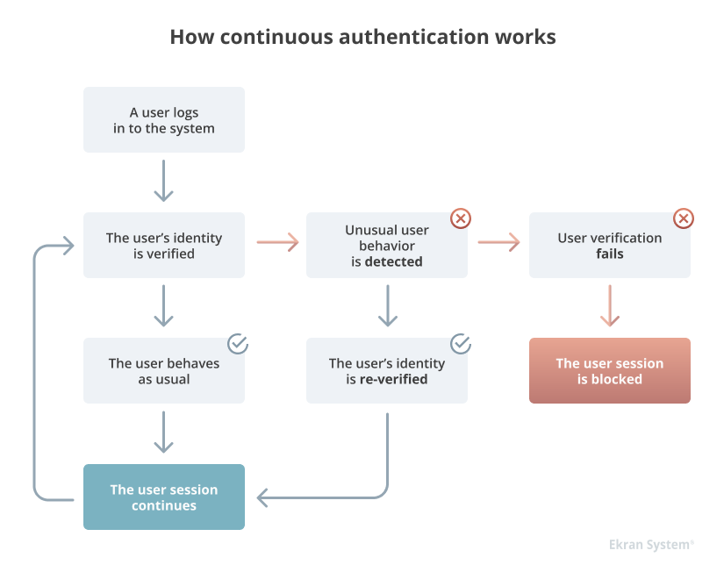

Figure 3 Continuous Authentication Workflow Diagram [9]

Figure 3 shows the process flow of CUA. It begins with a user logging into the system, followed by the initial verification of the user’s identity. As the user interacts with the system, their behaviour is continuously monitored to ensure it aligns with the established behavioural profile. If unusual behaviour is detected, the system triggers a re-verification process. Should this secondary verification fail, the user's session is promptly blocked to prevent potential unauthorised access. This diagram underlines the proactive nature of CUA, highlighting its ability to offer persistent security throughout a user session.

**Benefits of CUA**

* **Enhanced Security**: CUA solutions monitor a user's biometric, behavioural, and context-based data in real time throughout an online session, from login to logout, to continually confirm the user’s identity and flag anomalies, making it one of the most secure authentication methods available​​.
* **Anomaly Detection**: The system detects changes in pre-determined user patterns, such as idleness or unusual activity, and can block the account or force re-authentication, thus protecting against potential unauthorised access​​.
* **Real-Time Data Point Tracking**: CUA tracks various identity data points such as behavioural biometrics, browser activity, device reputation, and more, which are difficult to spoof and are used to continually verify a user's authenticity​​.
* **Protection Against Various Threats**: Continuous authentication is vital in today’s connected world where technology is used to manage highly confidential personal information. It is necessary to maintain security throughout an entire online session, not just at the point of login, to protect against hackers, careless employees, and malicious insiders[10]​​.

## ML: A Foundation for Behavioural Biometrics

ML is a branch of artificial intelligence that uses statistical models and algorithms to help systems learn to perform better over time at a given task without having to be explicitly programmed. By analysing and learning from a wide range of human interactions, ML plays a crucial role in the context of behavioural biometrics and produces highly accurate and adaptable user profiles.

**Core Concepts of ML in Behavioural Biometrics**

ML algorithms form the backbone of behavioural biometrics by enabling systems to learn and adapt to individual behavioural patterns. Below are some key ML concepts and algorithms that play a pivotal role in behavioural biometrics, as outlined by Travasoli [11]:

1. **Supervised Learning**: This involves algorithms learning from labelled data. Techniques like SVM, Decision Trees (DT), and Random Forests (RF) are used to classify and predict user behaviour based on historical data. In behavioural biometrics, these algorithms help in recognising and verifying individual patterns based on trained data.
2. **Unsupervised Learning**: Algorithms in this category work with unlabelled data and are excellent at discovering hidden patterns or structures within the data. Clustering algorithms like K-means and Hierarchical clustering are used in behavioural biometrics to group similar behavioural patterns or detect anomalies.
3. **Semi-supervised Learning**: A hybrid approach that uses both labelled and unlabelled data. It is beneficial when labelled data is limited. This approach can improve the learning process by using the larger set of unlabelled data to better understand the variations in behavioural patterns.
4. **Reinforcement Learning**: Although less common in behavioural biometrics, reinforcement learning involves learning optimal actions through trial and error. It can be applied to systems where the biometric system adapts to the changing behaviour of users over time.
5. **Key Algorithms**:
   * **Linear Regression**: Used for predicting numerical values based on historical data. It can be applied in behavioural biometrics for predicting future user actions based on past behaviour.
   * **K-Nearest Neighbours (KNN)**: A simple algorithm that classifies a data point based on how its neighbours are classified. This can be used in behavioural biometrics for classifying user behaviour as normal or anomalous.
   * **Random Forest**: An ensemble of decision trees that is robust to overfitting and can be used for classifying complex behavioural patterns.

These algorithms and techniques enable the creation of dynamic and adaptive models for user authentication, making behavioural biometrics a powerful tool in ensuring security in the digital domain.

**Implications for Behavioural Biometrics**

The integration of ML with behavioural biometrics presents a sophisticated approach to authentication. As Turgeman [12] notes, this integration facilitates a dynamic approach that's “impossible to copy or steal,” harnessing ML, deep learning (DL), and artificial intelligence (AI) to identify people by how they interact with devices and online applications. By continuously verifying a user's identity and adapting to new patterns, ML enhances the security and efficacy of behavioural biometric systems. This seamless integration not only improves defence against unauthorised access but also ensures that the authentication process remains user-centric and non-intrusive.

This background establishes a solid foundation for the upcoming exploration into the advancements in behavioural biometrics and CUA. The study seeks to develop innovative strategies and solutions to address the challenges of modern cyber threats. The following literature review will explore these developments, shedding light on the potential of these technologies to transform digital security and user authentication practices.

# Literature Review

This literature review aims to explore the interdisciplinary fields of behavioural biometrics, CUA, and ML algorithms in the context of security. In today's world, ensuring the authentication of individuals within computer systems and applications is paramount for information security. Conventional authentication methods, such as passwords, PINs, and even biometric technologies like fingerprints or facial recognition, have limitations, especially concerning the continuous verification of a user's identity throughout a session. To address these limitations, the concept of CUA has emerged as a promising approach.

CUA involves the real-time monitoring and analysis of user behaviour while they interact with a computer system. This method extends beyond the initial login credentials, aiming to maintain the ongoing verification of a user's identity throughout their session. A fundamental aspect of CUA involves the use of behavioural biometrics, encompassing various user-specific behavioural patterns, including mouse movements and keystroke dynamics.

In this literature review, the aim is to explore several thematic categories to offer a comprehensive understanding of the current state-of-the-art research in these areas:

1. **Behavioural Biometrics:** This section delves into various behavioural biometric features and methods, examining their application in user authentication. It highlights new innovations that facilitate real-time authentication and discusses how these advancements refine or diverge from preceding methods.
2. **CUA:**
   * Transition from Static to Continuous Authentication: This subsection discusses the shift from static to continuous authentication, spotlighting recent projects or publications that have contributed to this transition. It also explores fresh methodologies or algorithms proposed for continuous authentication and how they tackle the drawbacks of static authentication techniques.
   * Application of Emerging Technologies: This subsection explores the incorporation of innovative technologies in behavioural biometrics for enhancing continuous authentication. It also provides real-world examples or case analyses demonstrating the effectiveness and benefits of these emerging technologies, covering both biometric and non-biometric mechanisms like keyboard strokes and mouse movements.
3. **ML Applications in Authentication:** This section discusses novel suggestions for merging behavioural biometrics with other authentication strategies. It delves into the progress of employing ML and AI for refining behavioural biometric systems, covering aspects like anomaly detection within this context.
4. **Technical Challenges and Solutions in Deployment:** This section will explain the technical challenges encountered when deploying behavioural biometric systems CUA. It examines innovative solutions proposed in recent literature to address these challenges, discussing their effectiveness, and highlighting any remaining gaps or areas requiring further research. The technical challenges may include system integration hurdles, real-time processing requirements, and accuracy and reliability issues, among others.
5. **Security and Privacy Considerations:** Addressing ethical and privacy concerns is paramount in the realm of behavioural biometrics. This section focuses on the implications of collecting and analysing behavioural data. It explores strategies for maintaining user privacy while ensuring robust security measures and discusses the legal and ethical frameworks governing the use of behavioural biometric data for CUA.
6. **Adversarial Challenges and Countermeasures:** In the realm of behavioural biometrics for CUA, understanding the adversarial elements is crucial for designing robust systems. This section explores the various ways in which such authentication methods can be abused or exploited by adversaries. It discusses potential attack vectors, such as spoofing or behavioural mimicking, and reviews the existing literature on countermeasures and defensive strategies to mitigate these adversarial challenges. Additionally, it touches upon the evolving nature of adversarial tactics and the importance of continually advancing the defensive mechanisms to stay ahead of potential threats.

By structuring this literature review into these thematic categories, the goal is to provide a well-organised and comprehensive overview of the current state-of-the-art research in these domains. This knowledge will serve as a critical backdrop for this project, guiding it’s it toward addressing existing research gaps and challenges within this field.

## Behavioural Biometrics Research

In the rapidly evolving domain of cybersecurity, traditional methods of user authentication are increasingly faced with significant challenges such as vulnerability to phishing attacks, weak password practices, susceptibility to insider threats, and the risk posed by sophisticated hacking techniques like keystroke logging and credential stuffing. These are caused by the rise of advanced cyber threats, which underscore the need for innovative continuous user verification solutions. Within this context, Fact.MR[13] suggested that behavioural biometrics offer an advanced level of security compared to traditional authentication methods, leveraging unique behavioural patterns for robust and continuous user verification.

This leads to the examination of Sahdev’s [14] study, which offers a novel approach in digital banking security by using mobile screen swipes for user authentication. The research developed a specialised feature set for swipe-based authentication and evaluated it using algorithms including K-NN, Naïve Bayes, and SVM. The K-NN algorithm, especially with 7 neighbours, achieved 14% Equal Error Rate, indicating its potential in behavioural biometrics. While the study made significant progress in swipe data authentication, it also identified areas for improvement, such as enhancing accuracy and expanding beyond swipe and touch data.

Maghsoudi and Tappert [15] investigated the use of smartphone motion data in behavioural biometrics-based user authentication. This research is significant for its focus on the capabilities of built-in smartphone sensors, such as accelerometers and gyroscopes, to facilitate user authentication. Using motion data from 60 participants across various Android devices, the authors apply ML algorithms, specifically Multilayer Perceptron and K-NN. Through their experimentation, they achieve authentication accuracies ranging between 81% and 97% using these algorithms. This highlights the effectiveness of smartphone sensors in behavioural biometrics.

While the study shows potential, it also notes limitations with the proposed approach, namely varying algorithmic performance, and the dependency on sensor quality. Maghsoudi and Tappert's work underlines the viability of smartphone-based behavioural biometrics for secure user authentication, paving the way for future research in this area.

Transitioning to a different application of behavioural biometrics, Nishiuchi and Aoki's [16] research innovatively applies principles from the Consumer Information Processing Theory, specifically the information acquisition process and information integration process, to analyse user interactions on websites for predicting user interest levels in products based on web access logs. The authors gathered data from 60 participants engaged in online shopping tasks, tracking their web behaviour. By correlating web access patterns with users' stated interests in products, they identified behavioural indicators of interest levels. This approach successfully distinguished between various interest levels based on web activity, demonstrating the potential of behavioural biometrics to identify distinctive behavioural traits in understanding user preferences beyond conventional security applications. By leveraging complex patterns in user-web interaction, the study sheds light on how behavioural biometrics can extend its applicability to areas beyond traditional authentication scenarios. However, the study acknowledges its limitations, including the specific user and product range studied, which may influence the generalisation of its findings. However, the complexity of user decision-making might not be fully captured by web access logs alone. The author’s work is significant for its exploration of behavioural biometrics in a new domain, offering insights into user behaviour and preferences in online environments.

Further exploring practical applications, Monday and Dike [17] introduce a fingerprint-based attendance system, applying the waterfall model for user enrolment and identification in universities. It employs Java and Net Beans IDE, ensuring secure attendance tracking through physical biometric authentication. However, it contrasts with behavioural biometrics, focusing on physical traits rather than behavioural patterns. This distinction highlights the study's domain while suggesting the potential integration of both physical and behavioural biometrics for a more comprehensive authentication system.

The study by Faisal and Hossain [18] introduces “ONGULANKO”, an Internet of Things (IoT)-enhanced biometric system for efficient attendance management in educational settings. It automates the process by capturing and securely uploading fingerprint data to a server. Although it optimises attendance recording and data management, the system primarily focuses on physical identification through fingerprints, enhancing administrative efficiency, without incorporating behavioural analytics.

Concluding the exploration of innovative applications in behavioural biometrics, the study by Lin et al. [19] titled “CrossBehaAuth: Cross-Scenario Behavioural Biometrics Authentication Using Keystroke Dynamics” marks a significant advancement contributing to the field of behavioural biometrics by developing a system named CrossBehaAuth. This system addresses the challenge of authenticating users across multiple scenarios using keystroke dynamics, an unexplored area in behavioural biometrics.

Their methodology involves a deep neural network with a temporal-aware learning mechanism and local Gaussian data augmentation, enhancing the system's adaptability to various settings. The authors' evaluation of CrossBehaAuth on two datasets demonstrated its capability to significantly improve authentication accuracy in cross-scenario settings, proving its effectiveness in both single and multiple scenario applications.

## CUA

CUA emerges as a pivotal solution to the limitations and security vulnerabilities inherent in static authentication methods. In an era where cyber threats are increasingly sophisticated, the demand for more robust and adaptive authentication mechanisms is vital. CUA is designed to enhance security protocols while simultaneously improving user experience by seamlessly authenticating users in real-time, without interrupting their workflow.

In the context of these evolving security needs, VRCAuth by Sivasamy et al. [20] presents an innovative solution in Virtual Reality (VR) environments, addressing the limitations of traditional PIN and password mechanisms by implementing a novel system. Their proposed solutio, VRCAuth, uses head motion for continuous authentication. The methodology employed by the authors involves using ML techniques to classify the head movements of authorised and unauthorised users. Notably, VRCAuth is designed to be compatible with existing VR hardware, without requiring any operating system-level modifications or additional hardware.

The system employs Partial Decision Trees (PART) classifiers and Logistic Model Trees (LMT), and demonstrated a high level of accuracy, achieving a 99% success rate in just 0.02 seconds. This approach provides a more user-friendly and secure alternative to traditional authentication methods, as it does not require active user participation for each authentication process.

However, the study has certain limitations. It does not detail the testing conditions or the diversity of VR environments where the system was evaluated, which is important for understanding its applicability.

Expanding the scope of CUA to mobile devices, Dee et al.’s [21] study explores a novel approach using touchscreen interactions for secure and user-friendly authentication. The study innovates in the field of mobile device security by focusing on biometric data obtained from touch interactions on soft keyboards. The methodology involves collecting motion events via a modified software keyboard application, tokenising these interactions, and then organising them into n-grams. This approach simplifies authentication computations using a distance metric. The token sequences predict the probability of subsequent token occurrences, forming a user profile based on touchscreen interactions.

The research achieved a success, with the system attaining an overall accuracy of 78.7%. The efficiency of the system also achieved an 80% accuracy rate in less than 2 seconds, demonstrating its practicality for real-time authentication.

However, the study indicates variability in accuracy across different user-device scenarios, suggesting that the effectiveness of the system may differ based on specific use cases. Additionally, the computation time increases with the total model size, which might impact performance in scenarios requiring rapid authentication.

Junfeng's [22] proposal of a multibiometric-based continuous authentication scheme for mobile devices further diversifies the application of CUA, integrating various biometric sources for enhanced security. This study focuses on a more comprehensive approach to user authentication. The methodology involves a two-phase process: learning personal behaviour characteristics of users in the registration stage and then authenticating users based on these learned features in the continuous authentication stage. The scheme uses data from smartphone sensors, including the accelerometer, magnetometer, gyroscope, and front-facing camera, for biometric data collection. The data undergoes preprocessing and noise reduction using techniques including Kalman filtering and five-point smoothing. Feature extraction is then applied to this data, followed by a binary classification using SVM for user authentication.

The research achieved substantial success, with an accuracy rate of 98.3% in user authentication, demonstrating the effectiveness of the multibiometric-based approach. The fusion of sensor data with facial recognition proved particularly beneficial, especially with limited data.

However, the study's primary focus is on mobile devices, and it does not examine the broader applications of the authentication system beyond this specific context.

Shifting focus to the field of Unmanned Aerial Vehicles (UAV), Shoufan's [23] research introduces a unique perspective on continuous authentication by analysing UAV flight command data. This study is particularly important due to the high risks associated with processing fake commands in UAVs, which can lead to profound consequences.

Shoufan's methodology focuses on the behaviour of the UAV operator, specifically the sequence of flight commands sent using a standard radio control transmitter. This approach assumes that each UAV operator exhibits a distinctive pattern in controlling a UAV. To substantiate this, the study captured over 22,000 commands from five different operators, applying ML techniques to train a RF classifier.

The study achieved success using a RF classifier for UAV operator identification, demonstrating an accuracy of approximately 82% in a 10-tree configuration. These results demonstrate the potential of behaviometric-based "operator-specific flight command pattern recognition" continuous authentication in enhancing UAV flight security.

However, the study's limitation lies in its relatively small sample size, involving only five operators and a single type of UAV, which may affect the generalisability of the findings. Additionally, the practical aspects of real-time implementation on UAV systems and its impact on overall system performance were not extensively explored.

In the domain of IoT security, Al-Naji and Zagrouba's [24] Continuous Authentication Blockchain (CAB) framework, known as CAB-IoT, marks an advancement. The system connects blockchain technology to strengthen security infrastructure, through mutual authentication between end-users and fog nodes, establishing a secure and encrypted communication channel via smart contracts (programs stored on a blockchain that run when predetermined conditions are met.). The architecture, detailed through sequence diagrams, is shaped to efficiently use resources in the controlled IoT environments. The research highlighted that CAB-IoT proficiently handles increasing authentication demands ("larger authentication loads") with minimal impact on system resources, thus demonstrating its scalability and robustness. The using of fog nodes augments the framework's resource capabilities, mitigating IoT's inherent limitations and enhancing scalability. However, while the study explains the potential of blockchain in continuous authentication for IoT, it concentrates on this blockchain-centric approach, neglecting the exploration of other viable continuous authentication strategies. Furthermore, clearer explanation of how the CAB-IoT framework achieves “continuous” authentication is needed. This aspect, enabled by ongoing, active smart contracts, is crucial for understanding the system's ability to provide consistent security. Exploring this element in greater depth would enhance comprehension of how the framework maintains uninterrupted authentication, ensuring robust security in IoT environments.

Hu et al.'s [25] exploration of enhancing blockchain wallet security through behavioural biometrics introduces a new dimension to CUA, highlighting its relevance in the rapidly growing field of blockchain technology. This research holds particular significance within the context of blockchain technology and digital wallet security. The approach involves using mouse biometrics as the foundation for user authentication, leveraging a 12-layer Convolutional Neural Network (CNN) for data processing. The experimental setup encompassed Python, Keras, TensorFlow, Compute Unified Device Architecture (CUDA), and an NVIDIA GTX 1060 6GB Graphics processing unit (GPU). The team employed the False Acceptance Rate (FAR) and False Rejection Rate (FRR) as evaluation metrics for assessing the system's effectiveness. The study achieved real-time identity authentication at a rate of one authentication per second. On average, the FAR was 6.916%, and the FRR stood at 6.176% across five users.

However, the study focused exclusively on mouse behavioural biometrics, which may limit its applicability in scenarios where mouse interactions are not the primary mode of user engagement.

Building upon the innovative applications of continuous authentication in diverse fields, the research conducted by Grandi et al. [26] introduces a ground-breaking authentication technique for Extended Reality (XR) environments. This study is particularly significant as it addresses the unique security challenges in XR. The approach comprises a two-phase authentication process. The initial phase uses a Morse code-like Time-Based One-Time Password (TOTP) conveyed through haptic feedback; a technique resistant to surface attacks. The second phase employs continuous authentication by monitoring kinetic activity data from both the Head-Mounted Display (HMD) and the authentication device, ensuring consistent verification of the user's identity.

Their study successfully combines TOTP with continuous authentication, striking a balance between usability and security in XR environments. This dual-method approach effectively safeguards against unauthorised access and session hijacking, leveraging behavioural pattern monitoring. Despite its success, the study's focus remains within the XR environment, and its broader applicability or impact on various XR platforms and user experiences are not extensively explored.

## ML for User Authentication

The evolution of behavioural biometrics has paved the way for integrating advanced ML algorithms to enhance user authentication techniques. Highlighting the integration of ML in biometric authentication, Ouadjer's [27] study on smartphone touch gestures sets the stage by employing the XGBoost algorithm for feature selection, highlighting the efficiency of ML in enhancing user recognition.

Through analysing 30 touchscreen interactions collected from 41 participants; 7 key interactions were identified as significant for accurate user recognition. This method achieved a remarkable success rate of 99.41% in recognising users based on these interactions, with a reduced feature set.

This work highlights the potential of employing machine learning algorithms like XGBoost to optimise the feature selection process in behavioural biometric systems. It presents a pathway towards not only enhancing the accuracy of CUA systems but also towards achieving efficiency by reducing the feature set necessary for high-accuracy user recognition.

Furthering this exploration, Wazzeh et al. [28] present a cluster-based split federated learning approach, effectively integrating multiple biometric data sources for enhanced user authentication on mobile devices. This research is pivotal in the field of machine learning and cybersecurity, particularly focusing on the integration of multiple biometric data sources.

The methodology involves using a fusion of data from smartphone sensors (accelerometer, gyroscope, magnetometer) and front-facing cameras for biometric data collection. The framework employs SVM classifiers to differentiate between the legitimate smartphone owner and unauthorised users.

The study achieved substantial success, demonstrating a 98.3% accuracy rate in authenticating users. This high accuracy highlights the effectiveness of the multibiometric-based approach and sets a benchmark for future research in the field.

However, the paper's scope is primarily focused on mobile devices and does not delve into the broader applicability of the scheme to other types of devices or environments.

Subsequently, Bansa et al.’s [29] research demonstrates the integration of FastAPI with ML, focusing on efficient and accurate user authentication in the realm of behavioural biometrics. FastAPI, a modern web framework for building APIs with Python 3.7+, is established for its high performance, speed, and ability to manage large datasets and concurrent user requests efficiently. This research is significant in enhancing the responsiveness and efficiency of authentication systems in cybersecurity. Their methodology combines the efficiency of FastAPI, which excels in handling large datasets and concurrent user requests, with ML models for analysing behavioural biometric data. The focus is on using these technologies to achieve quick and accurate user authentication.

The study reported achieving the best accuracy of 23% with an authentication time of less than 5 seconds. This figure is contextualised as a significant improvement, considering the method's rapid authentication time and its efficiency in handling large datasets and multiple user requests. However, it is important to note that “significant” here refers not only to accuracy but also to these operational enhancements over traditional methods. While the 23% accuracy might seem low, it is paired with improvements in speed and scalability that are important for real-time authentication systems. Further research and comparisons with traditional methods would be beneficial to fully understand and validate this claim of improvement.

Extending the application of ML in biometrics, Miyake's [30] work explores Electroencephalogram (EEG) data responses to "invisible visual stimuli," which are visual signals presented at low contrast and high speed, making them almost undetectable. This innovative approach generates subconscious brain responses, particularly for non-intrusive authentication systems. The study uses these stimuli with ML techniques, such as SVM and Neural networks (NN), for distinction authentication analysis, it reduces the Equal Error Rate (EER) from a previous 9.4% to 8.1%, a significant leap, highlighting the method's refined performance and potential in biometric security. However, the focus on EEG responses to such specific stimuli might affect the generalisability of this research across broader biometric applications.

In a complementary development, Kong et al. [31] introduce FingerPass, a novel system that integrates user authentication with human-computer interactions in smart homes. This system leverages Channel State Information from Wi-Fi signals to identify users based on their unique finger gestures, advancing the concept of user authentication beyond protecting user privacy to also facilitating personalised services in smart home environments. FingerPass operates in a non-intrusive and device-free manner by employing widely deployed Wi-Fi infrastructures.

FingerPass divides the user authentication process into two distinct stages: login and interaction. In the login stage, a deep learning-based approach is developed to extract behavioural characteristics of finger gestures, ensuring highly accurate user identification. For the interaction stage, the system is designed to provide continuous authentication in real-time to ensure a satisfactory user experience. This is achieved by designing a verification mechanism with lightweight classifiers that authenticate the user's identity during each finger gesture interaction. As a result, FingerPass achieves high authentication accuracies of 90.6% under in-domain scenarios and 87.6% under cross-domain scenarios, while maintaining a low response latency with a 186.6ms response time during interactions​​.

This innovative approach highlights the adaptability of ML in behavioural biometrics for smart homes, offering a non-intrusive, real-time solution for user authentication through unique finger gestures. The high accuracy rates and quick response times highlight the potential of FingerPass in enhancing security and user experience in smart home environments.

Mosenia et al.'s [32] study introduces "CABA: Continuous Authentication Based on BioAura," a novel system that enhances user authentication in computer systems beyond the initial login phase. Unlike traditional methods that rely on single-instance biometrics (like fingerprints or face recognition) or betamimetics (like keystroke patterns), CABA uses a continuous authentication approach. It leverages an ensemble of biomedical signal streams, referred to as BioAura, which are collected continuously and non-invasively through wearable medical devices​​.

BioAura represents a combination of various biomedical signals, or Biostreams, such as body temperature or blood pressure, which on their own lack sufficient discriminatory power. However, when these Biostreams are collectively analysed, they form a robust BioAura that can effectively authenticate individuals continuously and transparently. CABA distinguishes itself by providing a continuous, real-time authentication process, using the power of ML techniques such as SVM and AdaBoost to analyse the BioAura data. This methodology significantly enhances the security of computer systems, ensuring that the user is continuously authenticated beyond the initial login, and has achieved impressively low EER of 2.4% with AdaBoost and 2.6% with SVM​​.

This research is a significant advancement in the field of cybersecurity, demonstrating the potential of biomedical signals in improving authentication systems. However, further exploration is needed to determine its broader applicability across different cybersecurity domains.

## Challenges and Solutions in Deployment

The deployment of behavioural biometric systems encompasses a range of technical challenges that span various platforms and environments. First among these is the issue of system integration, a critical aspect explored in depth by Meng et al. [33] in their study “Surveying the Development of Biometric User Authentication on Mobile Phones”. They examined the evolution of biometric authentication techniques on mobile phones, focusing on both physiological and behavioural approaches. It discusses the deployment challenges, including system integration, real-time processing, and accuracy issues in mobile environments.

Extending the discussion on mobile biometric systems, Das et al. [34], further explore the difficulties of integrating biometric technologies into mobile platforms. They discuss the integration, processing, and accuracy issues, alongside technological improvements in sensor and algorithm efficiency.

Building on these insights, Ryu et al. [35] shift the focus to the technical challenges in deploying multimodal biometric authentication systems, such as the complexity of integrating various biometric modalities and ensuring efficient real-time processing. It also explores the solutions to these challenges, focusing on advanced techniques like improved fusion methods and algorithmic enhancements, which contribute to increasing the accuracy and efficiency of these systems.

The exploration of biometric authentication on mobile devices, as presented in the studies by Meng et al. [33], Das et al.[34], and Ryu et al. [35], reveals key deployment challenges such as system integration, real-time processing, accuracy, and security. These papers collectively contribute to an understanding of how to navigate these hurdles, offering solutions like algorithmic improvements and enhanced integration methods. Yet, there remains scope for further research, especially in adapting these solutions to diverse user environments and advancing the efficiency of biometric systems for broader and more secure applications.

## Security and Privacy Considerations

Addressing ethical and privacy concerns in behavioural biometrics continuous authentication is extremely critical. Cooper and Yon [36] provide a comprehensive examination of ethical concerns in biometrics. The methodology involves sorting and analysing ethical issues related to biometrics such as privacy, data conversion, informed consent, and social exclusion. The paper contributes significantly to understanding the lag in management specifications compared to biometric technology development. It successfully highlights the need for accelerated ethical and regulatory governance in biometrics, addressing privacy protection, autonomy, and social exclusion concerns. The authors' emphasis on ethical issues in biometrics is directly relevant to behavioural biometrics, highlighting crucial aspects like privacy and the need for ethical governance in CUA systems.

Telo's [37] comprehensive review examines the complex landscape of behavioural biometrics, shedding light on not only the technology's potential but also the privacy and ethical concerns it raises. The review states that while behavioural biometric authentication models provide advanced security measures, their effectiveness can be compromised due to privacy concerns. Users may alter their behaviour to safeguard their privacy, inadvertently leading to inaccuracies in user behaviour identification by the models.

To mitigate these concerns and promote the widespread adoption of behavioural biometrics, Telo highlights the need for a fine balance between robust security and respecting user privacy. This includes the implementation of stringent privacy policies and data protection measures. Companies are required to obtain user consent, maintain transparency in data collection and usage, and ensure that data is securely stored and accessible solely to authorised personnel.

Moreover, Telo highlights the importance of employing techniques like data anonymisation and encryption to protect personal data, allowing for accurate profiling of user behaviour without compromising privacy. Despite the challenges, the collection of extensive personal data is essential to the precision and effectiveness of behavioural biometric systems.

Telo’s insights support the need for ethical governance and a user-centric approach in the field of behavioural biometrics. The review emphasises that with the right balance of security measures, privacy considerations, and legal compliance, behavioural biometric authentication systems can not only enhance security but also garner user trust and confidence, paving the way for their broader acceptance and application.

Baig and Eskeland [38] explore the complexities of continuous authentication, particularly focusing on the relationship between security, privacy, and usability. They address the fundamental challenges inherent in continuous authentication, such as poor matching rates and the susceptibility of systems to replay attacks. The authors particularly highlight the privacy implications of continuous data collection and processing, noting that the privacy concerns can significantly affect the accuracy and effectiveness of behavioural biometric authentication models. For instance, users might alter their behaviour to safeguard their privacy, leading to potential inaccuracies in user behaviour identification by the models.

A crucial part of their survey is the emphasis on the need for secure and transparent data handling policies. The authors advocate for robust systems that not only ensure security but also uphold user privacy. They highlight the importance of implementing strict privacy policies and data protection measures, ensuring that the systems are not just secure, but also respectful of user privacy.

The significance of striking a balance between security, privacy, and usability is emphasised by the authors. They draw attention to the fact that although continuous authentication provides a faultless and transparent method of authentication, it also gathers private information about users, including behavioural, physiological, and context-aware data. In addition to discussing methods like data anonymisation and encryption that help protect personal data while still enabling precise and efficient user authentication, the authors compare several privacy-preserving strategies.

The authors conclude by making suggestions for future research, emphasising the necessity of more investigation and creativity in order to create safe, private, and intuitive CUA systems. They support a comprehensive strategy that considers the various difficulties and lays the groundwork for upcoming improvements to CUA systems.

Finally, Wendehorst and Duller's [39] work for the European Parliament examines biometric recognition and behavioural detection's ethical/legal aspects, emphasising the need for responsible use and a legislative framework. It specifically highlights datafication, unauthorised access, surveillance, and discrimination risks in public spaces. Their recommendations aim to align technological advancements with ethical standards and legal protections, ensuring these technologies are used in a manner that safeguards individual rights and societal values.

## Adversarial Challenges and Countermeasures

In the ever-evolving landscape of behavioural biometrics, it is crucial to recognise the limitations of current security measures. As highlighted by Keyless [40], while liveness detection plays a critical role in biometric authentication, it falls short against sophisticated spoofing techniques like deepfakes. This realisation calls for integrating liveness detection with stronger, additional authentication factors, underlining the necessity for multifaceted security strategies in combating advanced adversarial threats.

Similarly, Kufel’s [41] research on “Adversarial Attacks against Behavioural-based Continuous Authentication” reveals the use of generative models for mimicking user behaviour, challenging existing security measures. This study emphasises the urgency for advanced defence solutions to address these sophisticated adversarial capabilities.

Tan's study [42], reveals significant vulnerabilities in behavioural mouse dynamics authentication systems to sophisticated adversarial techniques. The research categorises these attacks into white-box and black-box attacks, with specific methods like the Fast Gradient Sign Method (FGSM) and the Jacobian-based Saliency Map Attack (JSMA) being used in white-box scenarios. Remarkably, the study also demonstrates the effectiveness of simple statistics-based methods in generating adversarial mouse trajectories, significantly compromising the robustness of target classifiers.

The study further proposes three adversarial approaches; statistics-based, imitation-based, and surrogate-based to evade authentication models in a remote behavioural mouse dynamics authentication scheme. These findings highlight the complex challenges in ensuring the security of behavioural biometrics and underscore the need for developing more resilient defence mechanisms against these sophisticated and evolving adversarial strategies.

Xiaojian's [43] "Power IoT Security Protection Architecture Based on Zero Trust Framework" addresses the pressing vulnerabilities in IoT systems and behavioural biometrics. The study introduces the zero-trust security model, a comprehensive approach that shifts from traditional perimeter-based security to a more dynamic, data-centric framework. This model operates under the principle of “never trust, always verify,” ensuring rigorous, real-time authentication and authorization of every entity within the network.

Key to the zero-trust model is its focus on continuous verification and strict user authentication, making it adept at countering sophisticated cyber threats. The model enforces a unified identity management system for all users and devices, enhancing the security of behavioural biometrics by minimising the risks associated with unauthorised access and data breaches. This approach is critical in environments where behavioural biometrics are used, as it provides a robust framework for developing advanced security measures and adapting to the evolving landscape of cyber threats.

The study by Alsmadi et al. [44]"Adversarial ML in Text Processing: A Literature Survey" offers critical insights that are particularly relevant to the theme of behavioural biometric CUA. The research methodically categorises adversarial attacks based on the attacker's knowledge of the target model, shedding light on white-box, black-box (Zero-Knowledge Attacks), and gray-box (Limited Knowledge Attacks) scenarios. In white-box attacks, where the attacker has in-depth knowledge, methods such as the Fast Gradient Sign Method (FGSM) and the Jacobian-based Saliency Map Attack (JSMA) are used, demonstrating the sophistication of these techniques. Furthermore, black-box attacks highlight the vulnerability of even advanced systems to simple adversarial strategies, resulting in a significant challenge to the robustness of target classifiers.

For behavioural biometric CUA systems, these findings are crucial. They emphasise the need for a comprehensive understanding of potential adversarial threats and the development of tailored defence mechanisms. The study's discussion on adversarial training techniques, such as targeted and non-targeted attacks, emphasises the intricate landscape of threats that such authentication systems may face. It also highlights the necessity for continuous evolution and strengthening of defence strategies to protect against sophisticated and dynamically evolving adversarial tactics.

This survey outlines the advancement of security measures in behavioural biometric CUA. It stresses the importance of staying ahead in the cybersecurity race by understanding and mitigating the risks posed by adversarial attacks in text processing and, by extension, in any domain reliant on ML models, including behavioural biometrics.

The study by Edwards et al. [45] "Quantum Adversarial Machine Learning: Status, Challenges, and Perspectives" explores the complex dynamics of adversarial attacks in continuous authentication systems, particularly focusing on the movement-based authentication schemes. The authors explore the landscape of adversarial attacks and the corresponding defensive mechanisms. It emphasises the growing threat posed by sophisticated generative models, such as Generative Adversarial Networks (GANs), which can craft data mimicking user behaviour, thus enabling attackers to breach continuous authentication systems undetected.

The authors examine and categorise these adversarial attacks into two main frameworks: perturbation models and generative models. Perturbation models aim to bypass continuous authentication by slightly modifying data samples to prompt incorrect predictions. In contrast, generative models produce data samples from the ground up, maintaining the characteristics of the dataset to launch more deceptive attacks. The paper highlights the utility of various models like FGSM, JSMA, and several other methods, laying out a detailed analysis of their methodologies and implications.

One of the significant contributions of authors’ work is the proposition of novel adversarial strategies specifically tailored to motion-based continuous authentication systems. The authors examine the potential of these attacks, contrasting the impacts of generative adversarial attacks against the perturbation attacks, thereby enhancing the discourse on continuous authentication security. It highlights the urgent need for resilient defence mechanisms, capable of achieving these sophisticated and evolving adversarial strategies, to safeguard the integrity of behavioural biometrics in continuous authentication frameworks.

## Synthesis and Future Directions

This literature review has explored the interdisciplinary fields of behavioural biometrics, CUA, and ML within the security context. The research has demonstrated advancements in biometric authentication techniques, for instance in mobile and other varied environments. Despite these innovations, challenges such as system integration, real-time processing, and maintaining accuracy in diverse environments persist.

In response to these challenges, keystroke analysis has emerged as a particularly promising research direction. Unlike traditional biometric methods that depend on physical traits, keystroke dynamics leverage unique typing patterns inherent in everyday computer use, offering a non-intrusive method for continuous authentication. This technique aligns well with the need for seamless integration into existing systems, requiring no additional hardware and minimal user behavioural change, which addresses deployment challenges across diverse environments[46].

Keystroke analysis effectively addresses privacy and user acceptance issues by operating unobtrusively, without the need for direct physical interaction. Its adaptability and scalability are enhanced by advances in ML, which can analyse keystroke latency, rhythm, and pressure to continuously refine user identification processes. These capabilities make it highly effective at distinguishing between genuine users and impostors in real-time, a critical requirement in security-sensitive environments[47].

Additionally, the dynamic nature of keystroke analysis allows it to adapt to evolving user behaviour, a significant advantage over static biometric systems that may require re-enrolment or recalibration. This feature is particularly relevant in the context of ML advancements that encourage the ability of keystroke dynamics to adjust to new typing patterns or environmental changes, ensuring sustained accuracy and security.

The selection of keystroke analysis as a focal point for future research is justified not only by its potential to address the specific limitations identified in previous studies but also by its capacity to align with broader cybersecurity frameworks. This approach promises to enhance security, usability, and privacy in user authentication systems, making it a robust and user-friendly solution for continuous authentication challenges.

By bridging the gaps identified in this review, further investigation into keystroke dynamics can lead to the development of a more secure, scalable, and adaptable authentication framework. This not only meets the evolving demands of cybersecurity but also provides a pathway for practical implementation that could see broader adoption across various technology platforms.

# Problem Analysis & Requirements

## Requirement Analysis

This project focuses on the complex realm of behavioural biometrics with a specific focus on keystroke dynamics for the purpose of CUA. Keystroke dynamics are characterised by the unique patterns and rhythms of a user's typing behaviour, offering a biometric identifier that is inherently challenging to spoof. The research aims to identify the most effective and efficient ML techniques for analysing these dynamics, enhancing the accuracy and reliability of CUA systems. The goal is to strike a balance between user accessibility and system precision, ensuring near real-time verification while preserving user privacy. This requires a thorough approach to maintaining the confidentiality and integrity of user data and ensuring uninterrupted access to authentication services. By integrating advanced ML models, this project seeks to strengthen cybersecurity measures through intelligent, user-centric CUA solutions. These solutions are designed to be both practical and user-friendly, minimising intrusiveness and maximising adaptability across diverse digital environments, all the while adhering to the fundamental values of confidentiality, integrity and authenticity.

### Keystroke Dynamics as a Core Component of Continuous Authentication:

Keystroke dynamics offer several unique advantages that make them particularly suitable for continuous authentication[48], [49],[46]:

* **Non-intrusiveness**: Unlike other biometric techniques that require physical interaction, keystroke dynamics operate faultlessly in the background as the user interacts with their device, thereby offering a less intrusive form of authentication.
* **High Adaptability**: Keystroke dynamics can dynamically adjust to the evolving typing patterns of a user, making it highly adaptable and capable of providing personalized security measures.
* **Low Implementation Barrier**: Implementing keystroke dynamics does not necessitate additional hardware since it uses the existing keyboards or keypads of devices, which significantly reduces implementation costs and complexities compared to other biometric systems.
* **Enhanced Security**: By continuously analysing typing patterns, keystroke dynamics can detect anomalies in real-time, thereby enhancing security throughout a user's session.

These features make keystroke dynamics an ideal choice for organisations aiming to implement robust yet unobtrusive security measures. Their use not only improves system security but also enhances user acceptance by minimising privacy concerns and user interaction requirements.

### Evaluating Machine Learning Efficacy in Behavioural Biometrics for CA

Table 3 provides a summary of important studies in behavioural biometrics, focusing on the effectiveness of different machine learning techniques for CUA. This analysis is important in guiding the problem analysis phase of this project. In addition to highlighting the success rates of these approaches, it emphasises how important it is to choose a machine learning strategy that satisfies the operational and computational requirements of real-world applications, while also exhibiting high accuracy. Finding the best ML technique(s) to develop reliable continuous authentication systems that strikes a balance between accuracy, effectiveness, and user-centric design requires careful consideration of the findings from these studies.

Table 3 ML Techniques in Behavioural Biometrics Success Rates

|  |  |  |
| --- | --- | --- |
| Authors | Main Theme | Key Findings (Success Rate) |
| Sahdev [14] | Swipe-based Authentication in Digital Banking | K-NN algorithm: 14% Equal Error Rate |
| Maghsoudi and Tappert [15] | Smartphone Motion Data for Authentication | Multilayer Perception, k-Nearest Neighbour: 81% - 97% respectively |
| Sivasamy et al. [20] | User Authentication in Virtual Reality Using Head Movement | PART classifier and LMT: Both achieving 99% success rate in 0.02 seconds |
| Dee et al. [21] | Continuous Biometric Authentication on Mobile Devices | N-gram approximations: 78.7% accuracy. |
| Shoufan's [23] | Continuous Authentication of UAV Flight Command Data | Random Forest classifier: 82% accuracy in identifying UAV operators |
| Junfeng's [22] | Multibiometric-based Continuous Authentication Scheme | Support Vector Machine: 98.3% accuracy rate |
| Hu et al.'s [25] | Blockchain Wallet Security Using Mouse Biometrics | Convolutional Neural Network: 6.4% error rate |
| Ouadjer's [27] | Feature Importance Evaluation for Biometric Authentication | XGBoost algorithm 99.41% success rate in user recognition |
| Wazzeh et al. [28] | CUA on Mobile Devices | SVM: 98.3% accuracy rate |
| Bansa et al.’s [29] | Continuous Authentication Using FastAPI and Machine Learning | Best accuracy of 23% with <5 seconds authentication time |
| Miyake's [30] | EEG-based Biometric Authentication | SVM and NN: Equal Error Rate of 8.1% |
| Kong et al. [31] | Continuous Authentication for Smart Homes | Long Short-Term Memory networks within Deep Neural Networks (LSTM-based DNNs): Up to 90.6% accuracy rate |
| Mosenia et al.'s [32] | Continuous Authentication Using Biomedical Signals | Error rate as low as 2.4% with AdaBoost, 2.6% with SVM |

Table 3 provides a summary of important studies in behavioural biometrics, highlighting the effectiveness of different ML techniques for CUA. This analysis is important in guiding the problem analysis phase of this project. It emphasises the importance of choosing a ML strategy that not only meets operational and computational requirements of real-world applications but also exhibits high accuracy. The selection of SVM for the analysis of keystroke dynamics is well-founded, given their proven success across multiple studies summarised in Table 3, such as by Wazzeh et al., Mosenia et al., and Miyake. The convergence of high accuracy and low error rates in these studies highlights the effectiveness of SVM in diverse and challenging scenarios, indicating its suitability for keystroke dynamics analysis in this project.

### Limitations of Traditional Authentication Methods

Reliance on traditional authentication methods such as passwords and PINs, and even physical biometrics like fingerprints and facial recognition, is being scrutinised increasingly for their static nature[50]. They only authenticate a user's identity at the initial login phase and fail to account for the dynamic nature of user interaction over extended sessions. This static approach presents significant security risks. For example, once a password is compromised, unauthorised access remains possible throughout the user's session as these methods do not re-verify identity. The dynamic, real-time verification capability of keystroke dynamics addresses these limitations effectively, offering a more secure and responsive solution to modern cybersecurity challenges.

This static approach presents notable security risks. For instance, once a password is compromised, unauthorised access remains possible throughout the user's session, as these methods do not re-verify identity. Bonneau [51] highlights this vulnerability, noting that common passwords remain a weak link in system security. Similarly, biometric systems, despite their perceived robustness, do not account for the possibility of spoofing or the user's presence post-initial verification.

In response to these vulnerabilities, the concept of CUA emerges as a crucial advancement. It promises to fill the gaps left by traditional methods, offering real-time, ongoing validation of a user's identity throughout their interaction with a system. This approach aligns with the evolving needs of cyber security, ensuring a dynamic and responsive authentication process. The limitations of conventional methods, particularly in the context of continuous verification of identity, have been discussed in the broader fields of behavioural biometrics and ML algorithms, underscoring the need for more advanced approaches in this area.

**Comparative Evaluation of Authentication Methods**

Traditional methods involve one-time verification such as passwords or physical biometrics, which might leave a security gap after the initial login. In contrast, continuous authentication methods use behavioural biometrics to provide ongoing verification, enhancing security through real-time anomaly detection. The comparison is structured around several key factors:

1. **Security Effectiveness**: Traditional methods like passwords and physical biometrics offer one-time verification, potentially leaving a security gap after initial login. Continuous authentication, using behavioural biometrics, provides ongoing verification, enhancing security by detecting anomalies in real-time.
2. **User Convenience**: Traditional methods can be inconvenient, requiring users to remember passwords or use physical tokens. Continuous authentication is more user-friendly, operating seamlessly in the background.
3. **Implementation Cost**: Implementing traditional methods is less costly and complex. Continuous authentication requires more sophisticated technology and integration, potentially increasing costs[5].
4. **Scalability**: Traditional methods scale easily but may not adapt well to varying security needs. Continuous authentication scales with user behaviour, offering adaptable security but may require more resources to manage effectively.
5. **Adaptability**: Traditional methods are less adaptable to diverse user environments. Continuous authentication, leveraging ML, adapts to individual user patterns, offering personalised security.

While traditional methods provide basic security and are cost-effective, continuous authentication excels in providing dynamic, user-centric security, especially in high-risk situations.

### User Experience and Acceptability

When behavioural biometrics are integrated into continuous authentication, the user experience is more secure than with traditional methods. In contrast to biometric scans or passwords, which require deliberate user input and may disrupt the workflow, continuous authentication operates silently in the background. By decreasing the need for repeated manual authentications, this technique improves convenience.

However, it is important to balance the enhanced security with a user-friendly experience. As Lexisnexis [52] insightfully notes, companies face the challenge of strengthening their online services against unauthorised access while ensuring legitimate customers are not hindered by excessive security measures. The author states, “The easy answer is to add more security measures, but undue friction negatively impacts user experience. Some customers may abandon transactions rather than prove their legitimacy.” This observation is particularly relevant in the context of online shopping, banking, or any service requiring secure user authentication. It highlights the importance of implementing security measures that are robust yet unobtrusive, ensuring that users do not abandon transactions due to heavy or excessive verification procedures.

Although continuous authentication is convenient, it poses serious privacy risks. Concerns regarding data misuse and privacy invasion may arise from behavioural biometrics' ongoing data collection and monitoring. To preserve user trust, these issues must be addressed with clear policies and safe data handling procedures. According to Soni [53], there is the issue of user acceptance, even though continuous authentication for business is a more viable idea in the present era of technology than in the past.

Continuous authentication offers a more tailored security experience by adapting to various user behaviours, which enhances security by closely monitoring user activities in real-time. However, this method must strike a delicate balance between enhancing security and respecting user preferences for simplicity and privacy. While the adaptability of continuous authentication allows for customised security measures, its complexity and the perceived intrusive nature of continuous monitoring can be off-putting for some users. These users often value straightforward, less invasive security solutions that afford them greater control over their data. Therefore, the implementation of continuous authentication systems needs careful consideration to ensure they do not alienate users by compromising their experience or violating their privacy expectations. This balance is crucial in maintaining trust and ensuring the effectiveness of security measures without overwhelming or deterring users [37] [38].

### Technological Constraints and Scalability

**Integration Challenges**: Implementing CUA systems often involves integrating complex ML algorithms with existing infrastructure, which can be challenging. These systems must be compatible with multiple devices and platforms, requiring significant development and testing to ensure smooth integration [54].

**Data Quality Challenges:** The effectiveness of CUA systems is impacted by the quality of input data. Inaccuracies in sensor-reported movements and variables like unstable frequency, angle snapping, and outdated technology can introduce “data noise,” leading to inconsistencies. Addressing these challenges is crucial, as precise measurement and data integrity are fundamental for seamless integration and reliable performance of these systems across diverse devices and platforms [55].

**Resource Requirements**: Some continuous authentication techniques can require a lot of resources, especially those that use sophisticated machine learning. Devices with lower specifications may be limited by their potential need for significant computational power and memory [54].

**Scalability in Diverse Environments**: Although these techniques are theoretically very scalable, their scalability in practice can differ. It is still difficult to guarantee consistent performance in a variety of settings and across various kinds of devices. According to Zucisystems [56], data security and governance in AI/ML systems pose significant challenges, particularly when scaling. The aggregation of diverse data types in one place heightens vulnerability to business risks and can impact brand reputation. The author notes that while AI systems hold the promise of scalability, achieving consistent performance across different settings and devices remains a challenge. This is due to the unique security and privacy considerations required when dealing with AI systems, where even non-sensitive data, when combined with other data, can introduce complex business challenges​.

**Adaptability to Quick Technological Changes:** Due to involving of cyber threats and technology, CUA systems need to be quick to update and flexible. It is critical to preserve this adaptability without sacrificing system integrity [57].

### Ethical and Privacy Considerations

**Ethical Implications**: The use of continuous authentication raises ethical concerns, particularly regarding user autonomy and consent. Continuous monitoring of user behaviour can be seen as intrusive, making it imperative to establish ethical guidelines that respect user privacy and autonomy[58].

**Privacy Concerns**: Since continuous authentication methods collect and process extensive user behavioural data, privacy is a major concern. It is imperative to address the storage, use, and protection of this data. It is essential to manage data with transparency and make sure users are aware of the types of data being collected and how they will be used.

**Data Protection and Regulation Compliance:** It is critical to abide by laws pertaining to data protection, such as GDPR. This involves making certain that user control over their data is maintained and that data collection is legitimate, open, and safe[59].

**Balancing Security and Privacy**: Striking a balance between enhancing security through continuous authentication and protecting user privacy is a key challenge. Implementing robust security measures while respecting privacy rights is crucial for the acceptability and success of these methods[59].

The detailed requirement analysis emphasises the requirement shift from traditional methods to a more dynamic, user-responsive approach, offering a balanced overview of the complex details of continuous authentication. It highlights how important it is to use ML in behavioural biometrics by illuminating the technological, ethical, and operational aspects that are vital to the effective deployment of strong cybersecurity measures. This provides a strong basis for the project's advancement and guarantees a thorough strategy for improving digital security with a strong emphasis on security and user experience.

## Methodology

This section will outline the comprehensive approach that will be taken to design and develop a CUA system leveraging keystroke dynamics. Central to this exploration will be the strategic application of the SVM algorithm, aimed at interpreting and analysing typing behaviour to ensure secure and user-centric authentication. The project will address key challenges in cybersecurity, including enhancing system security, ensuring user privacy, and optimising operational effectiveness. Drawing on insights from requirement analysis, the methodology will present a framework for implementing, testing, and refining the authentication model. It will encompass the processes from data collection through to system evaluation, aligning each step with the project’s defined objectives.

### Data Source and Collection Methodology

The keystroke dynamics data, critical to this project, will be collected from eleven volunteer users under conditions ensuring anonymity and ethical compliance. Each participant, referred to by pseudonyms (User1 to User11), will interact with a custom application designed to log various keystroke metrics such as dwell time, flight time, and error rate during predefined typing tasks. This approach ensures a robust dataset capturing the nuances of individual typing behaviours.

### Integration of SVM and Data Handling

The project will primarily employ the SVM algorithm for its robust capabilities in pattern recognition, making it ideal for analysing keystroke dynamics. Python, within the Visual Studio Code environment, will be used to implement SVM due to its extensive library support and flexibility in handling data analysis tasks. The development process will also leverage Firebase for secure and scalable data storage, ensuring real-time data availability for continuous authentication.

### Ethical and Privacy Considerations

Throughout project phases, ethical guidelines will be strictly adhered to, ensuring participant informed consent, data anonymisation, and secure data handling. These practices will be embedded into both the data collection and analysis processes to uphold the highest standards of privacy and ethical responsibility.

### Testing and Validation

The testing phase will methodically assess the system’s functionality, security, and performance. Initial tests will verify the accurate calculation of keystroke metrics and the system’s ability to handle data securely and efficiently. Subsequent tests will evaluate the User Interface (UI) for usability and perform rigorous security assessments to ensure the system accurately distinguishes between authentic and spoofed data entries.

# Design

This chapter details the design of the CUA system, focusing on leveraging keystroke dynamics for enhanced security measures. As outlined in Chapter 1, the primary goal is to develop a robust framework that ensures continuous, accurate, and efficient user authentication while maintaining user privacy and system adaptability.

**Design Objectives and Requirements**  
The design of the CUA system is driven by the following key requirements:

1. **Accuracy in Authentication:** The system must accurately differentiate authorised users from intruders by analysing keystroke dynamics to prevent unauthorized access.
2. **Efficiency and Near Real-Time Processing:** Authentication processes should be fast enough to operate in near real-time, ensuring there is no noticeable delay for users.
3. **User Privacy and Data Security:** The system must incorporate strict data protection measures to ensure all user data is anonymised and stored securely, adhering to privacy laws and regulations.
4. **System Adaptability and Scalability:** The architecture should be flexible and scalable, capable of evolving in response to new security threats and changing user needs.

**System Architecture and Component Design**  
The design section aims to:

* Provide a comprehensive architectural blueprint of the CUA system, highlighting how various components interact and function.
* Detail the specific technologies and methodologies used for keystroke data capture, analysis, and authentication decision-making.
* Explain the integration of system components and data flow processes that ensure operational efficiency and security.

**Aligning Design with Objectives**  
Each element of the system is explicitly designed to meet the outlined objectives:

* **Accuracy and Efficiency:** Using advanced SVM algorithms and processing techniques to analyse keystroke dynamics accurately and efficiently.
* **Privacy and Security:** Implementing encryption, secure data protocols, and anonymisation techniques to protect user data.
* **Adaptability and Scalability:** Using a modular design that allows for effortless updates and scalability without extensive modifications.

## UI Design

The UI is designed to enhance user engagement and streamline the data collection process within the CUA system. The design emphasises user-friendly interaction points, ensuring that users can navigate the system with ease from the outset.

**Account Creation and Access**

* The **Initial Screen** presents users with the option to sign in or register. This is the gateway to the authentication system, designed to be welcoming and straightforward.
* In the **Registration Interface**, prospective users can create a new account, with the system prompting for essential details such as username and password. If a username conflict arises, the system is implemented to prompt the user to choose a different one, enabling a seamless onboarding experience.
* The **Sign-In Interface** provides access to returning users, enabling access through a secure login form. It is presented with clarity, requesting only the username and password, and is equipped with robust authentication protocols to verify user credentials efficiently.

**Task Selection:** Following a successful login, the **Task Selection Interface** is presented, offering users a choice between three distinct typing tasks. Each task is designed to gather specific keystroke dynamics, contributing to the system's data diversity.

**Typing Interface and Data Capture**

* Choosing a task transitions the user to the **Typing Interface**. Here, a text box is provided for input, and it is within this space that the keystroke dynamics are recorded capturing metrics integral to the user's unique typing pattern.
* Users have the autonomy to **Pause and Resume** their typing activity at will, which accommodates for any interruptions, ensuring the user's comfort without compromising the integrity of the data collected.
* Upon task completion, a clear and visible **End Session** option allows users to conclude their typing activity, signalling that data capture for that session is complete.

The UI design is conceived with a minimalist approach to prevent distractions and maintain focus on the data collection tasks. The aim is to ensure that all interactive elements are intuitive and accessible, enhancing the overall user experience and facilitating the precise capture of keystroke dynamics.

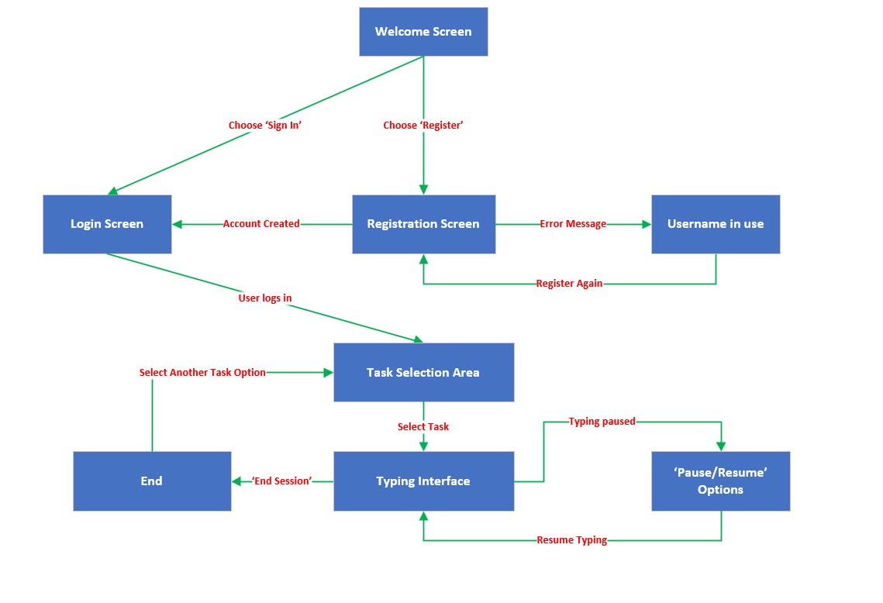

Figure 4 User Flow through the Authentication System UI

Figure 4 shows the sequence of user interactions from the initial screen to task selection and data capture.

## Data Collection Design

The data collection process is a critical component of the continuous authentication system, designed to capture and process keystroke dynamics data effectively. This section will detail the metrics collected, their purpose in the context of the project, and how they integrate with the system's architecture.

Table 4 Metrics Collected for Keystroke Dynamics Analysis

|  |  |  |  |
| --- | --- | --- | --- |
| Task Type | Metric | Description | Purpose/Application |
| General Metrics | Words Per Minute (WPM) | Calculates typing speed in words per minute. | Provides a baseline measure of typing speed for general analysis.[47] |
| Characters Per Minute (CPM) | Calculates the number of characters typed per minute. | Offers detailed insights into typing speed, useful for profiling typing behaviour across different contexts.[47] |
| Inter Key Latencies | Measures the time intervals between keystrokes. | Helps identify the rhythmic patterns in typing, which are unique to each individual[60]. |
| Rhythm Variability | Calculates variability in typing rhythm. | Indicates consistency or variability in typing, which may reveal user-specific patterns or stress levels[60]. |
| Backspace Count | Counts the number of times backspace is used. | Assesses correction frequency during typing, which may indicate typing accuracy or hesitancy. |
| Bigram Frequencies | Analyses the frequency of two-character combinations. | Provides insights into commonly used key pairs, potentially identifying user-specific habits or errors[61]. |
| Capitalisation Pattern | Measures frequency and pattern of capital letter usage. | Useful for identifying user-specific patterns in using capital letters, such as in names or at sentence starts. |
| Shift Key Usage | Tracks usage of the shift key during typing. | Helps understand capitalisation habits and can indicate typing style or errors in using shift for capital letters. |
| Fixed Text | Error Rate | Calculates the rate of errors during typing tasks. | Important for assessing accuracy in controlled text-entry tasks, reflecting the ability to follow given text accurately. |
| Punctuation Count | Counts punctuation marks used during typing. | Important for understanding punctuation habits in fixed text contexts, such as formal writing or data entry. |
| Custom Text | Dwell Time | Duration a key is held down during typing. | Reflects the cognitive processing time for each character, useful in tasks requiring careful thought or precision[61][60]. |
| Flight Time | Time interval between releasing one key and pressing the next. | Indicates the speed of sequential key entries, important for analysing natural typing flow and rhythm[60], [61]. |
| Free Typing | Paragraph Count | Counts the number of paragraphs entered during free typing. | Helps analyse how users structure their thoughts in unstructured text creation, such as essays or creative writing. |
| Sentence Count | Measures the number of sentences constructed during free typing. | Provides insights into sentence structuring and grammatical correctness in creative or informal writing tasks. |

Table 4 aligns with project’s objectives by providing a comprehensive overview of each metric, their calculation methods, and their relevance to different typing tasks. This approach ensures a robust and detailed analysis of user typing behaviour, supporting the development of an effective continuous authentication system based on keystroke dynamics.

Table 5 Typing Metrics Categorisation and Their Purposes Across Different Task Types

|  |  |  |
| --- | --- | --- |
| Task Type | Description | Purpose and Importance |
| General Metrics | Applicable to All Tasks (Fixed Text, Custom, Text and Free typing) | Provide a baseline of typical user typing behaviour to detect anomalies. Capture essential typing habits applicable across all scenarios to establish a user profile. |
| Fixed Text | Participants type a provided text of about one page in length. See Appendix A1 for the fixed text provided. | Measure accuracy against a known text, which is crucial for authentication using predefined phrases. Assess the ability to replicate specific phrases accurately, particularly for controlled authentication environments. |
| Custom Text | Participants transcribe a given voice note into text as they listen. See Appendix A2 for the transcript of the voice note. | Observe more natural typing behaviour with fewer constraints. Provide insights into the rhythmic and timing aspects of typing, essential for identifying natural typing flow. |
| Free Typing | Participants freely choose a topic and type without specific guidance. | Capture the most naturalistic typing behaviour in unrestricted settings. Analyse writing structure and style, important for identifying typical writing behaviour and anomalies[62]. |

Table 5 categorises the metrics for different typing tasks within the keystroke dynamics authentication system. This categorisation highlights the design strategy, aligning with the project's objectives to ensure accurate and secure user authentication across varied text entry context.



Figure 5 Data Flow Diagram for Data Capture Methodology

The workflow for data collection and processing, as shown in Figure 5, illustrates the sequence of actions from user engagement to the secure storage of their keystroke data. This highlights the system's comprehensive and privacy-conscious approach, a demonstration to the design's commitment to the project's key objectives of security, efficiency, and user protection.

## System Architecture and Data Flow

This section will show the overall structure and workflow of the CUA system based on keystroke dynamics. The system is designed to ensure a secure and efficient process from user data input through to the final stage of data storage and analysis. Figure 6 presents a System Architecture Diagram that shows the various components of the system and their relations. This visual representation will assist in understanding how keystroke data is captured, processed, and used for authentication purposes.

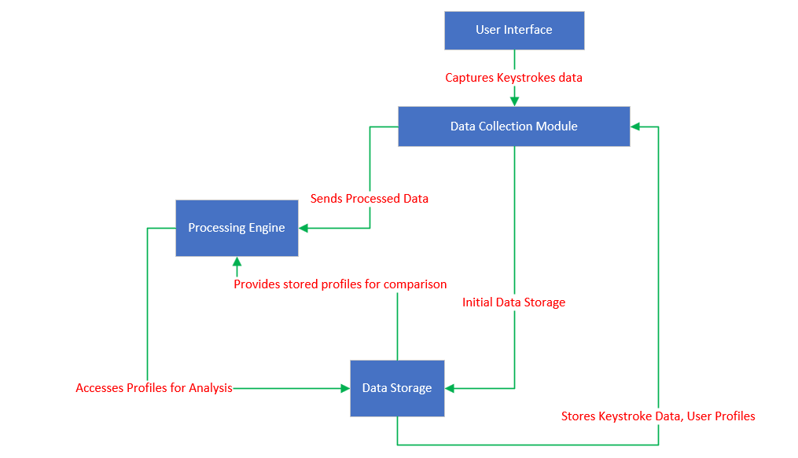

Figure 6 System Architecture Diagram

Figure 6 provides a view of the keystroke dynamics continuous authentication system. Starting with the UI, where users perform their typing tasks, the data flows through to the Data Collection Module, which captures the raw keystroke metrics. From here, data is passed to the Processing Engine, where it is processed and analysed against stored user profiles for authentication purposes. Once processed, the data is anonymised to ensure user privacy before being stored for future reference and evaluation. This architecture is important for maintaining the integrity and efficiency of the CUA process, highlighting the system's capability to provide real-time user verification.

## Authentication Model Development

This section examines the design and prospective development of the SVM model, a vital component in the continuous authentication system aimed at accurately recognising and verifying user identity through keystroke dynamics.

**Feature Selection**

* The cornerstone of the SVM model design is the selection of features, vital for the accuracy of the model [63]. A careful examination of collected data points, such as dwell time, flight time, and error rates, leads to identifying the subset that most effectively reflects unique typing patterns.
* The process of choosing these features relies on statistical methods and domain knowledge to pinpoint keystroke characteristics that signal individual user behaviours.
* The features chosen are intended to meet project objectives, capturing distinctive behavioural biometrics efficiently without altering user privacy.

**Model Training**

* Training the model begins once the features are identified. It uses a dataset where keystrokes are labelled with user profiles as a base for teaching the model.
* Techniques such as cross-validation are used to validate the model's applicability across various scenarios, aiming to reduce overfitting and ensure consistent performance with new, unseen data [64].
* The model's training will be a continuous process, with frequent evaluations and fine-tuning of hyperparameters to progressively enhance the model's precision.

**Linking Model to Requirements**

The SVM model's blueprint is shaped by the project's core requirements:

* **Accuracy**: Ensuring the model can authenticate users correctly using their keystroke dynamics is crucial. The design process includes thorough testing to ensure a high degree of accuracy in determining between legitimate and illegitimate access attempts.
* **Efficiency:** The model must process data swiftly in real-time, in line with the need for immediate and ongoing authentication.
* **User Privacy:** In training the model, only non-personal features will be used, demonstrating the project's dedication to maintaining user privacy and confirming that personal data remains secure.

## Security and Privacy Measures

The CUA system's design is firmly rooted in ethical standards and a commitment to privacy protection. With a particular focus on the secure treatment of user data for participants labelled User 1 through User 11, the system incorporates specific security measures.

* **Password Hashing**: To safeguard sensitive data, the system ought to employ a robust hashing process for passwords. This ensures that passwords are stored not as plain text but as hashed values. Hashing provides a high level of security since the original passwords cannot be derived from these hash values, effectively protecting user information even in the event of data access breaches.
* **Informed Consent and Ethical Handling**: The system's adherence to ethical guidelines is demonstrated through securing informed consent from all participants and ensuring transparent communication about how their data is used. This commitment affirms the system's commitment to safeguarding participants' privacy and rights.
* **Privacy-Focused Architecture**: Privacy is a foundation of the system's design, incorporating secure authentication mechanisms to safeguard user identity and data. Features for model training exclude personal identifiers, focusing on non-identifiable data to protect personal information.
* **Compliance with Data Protection Regulations**: The development and operational protocols of the system are tailored to comply with the current data protection laws, ensuring the system's safety and legal compliance.

As outlined chapter 4.2 (Methodology), this section highlights the planned security and privacy measures, emphasising password hashing and ethical data handling. These measures are important for safeguarding the data associated with users, highlighting the effort to create a secure and privacy-respecting authentication framework.

## Linking Design to Requirements

* **UI Design:** The design of the user interface is influenced by the project's emphasis on non-intrusiveness and user accessibility. The seamless interaction model is chosen to reduce user burden and integrate naturally with their daily activities, aligning with the advantages of keystroke dynamics which operate effectively without explicit user intervention.
* **Data Collection Design:** The decision to use existing keyboard inputs for data collection stems from the project's requirement for low implementation barriers. This approach uses the existing infrastructure, thus minimising the complexity and costs, which aligns with the project's goal to implement a system that is adaptable and easy to deploy.
* **System Architecture and Data Flow:** The architecture is designed to support efficient and near real-time processing, directly addressing the project's need for a system that can quickly process data to keep pace with dynamic user interactions. The design ensures that data flows smoothly within the system.
* **Authentication Model Development**: The choice of the SVM model for authentication is based on its suitability for handling the types of data involved in keystroke dynamics, as identified during the requirement analysis phase. This model is selected for its robustness in pattern recognition, which is important for the accurate analysis of the complex data points captured by the keystroke dynamics system.
* **Security and Privacy Measures**: The design incorporates measures like password hashing and data anonymisation, complementing the project's privacy requirements and compliance needs. These measures ensure adherence to the highest standards of data protection and user privacy from the outset.

# Implementing the Behavioural Biometric CUA System

This chapter marks the transition from design to implementation, detailing the creation of a CUA system that employs keystroke dynamics. The approach integrates critical cybersecurity principles confidentiality, integrity and authenticity with a user-centric design, aligning with the project's objectives to enhance digital security and user experience.

The implementation encompasses:

* **Implementation Tools and Technologies**: Libraries and software tools for implementation of CUA system.
* **Data Collection Implementation**: Capturing keystroke dynamics in real-time.
* **Feature Extraction Techniques**: Extracting meaningful features from keystroke data.
* **Machine Learning Model Implementation**: Training the SVM model with extracted features.
* **Authentication Workflow**: Continuously authenticating users with the trained model.

## Main Implementation Tools and Technologies

This section describes the software tools, programming languages, and libraries selected for the development of the Behavioural Biometric Continuous Authentication System, detailing the reasons for each choice and their relevance to the project's goals:

* **Python**: Chosen as the primary programming language due to its flexibility and the extensive library ecosystem available for data manipulation, machine learning, and application development. Python's syntax and broad acceptance make it ideal for rapid development and iterative testing, particularly for a project that involves complex data processing and machine learning model tuning [65].
* **Visual Studio Code (VS Code)**: Selected as the Integrated Development Environment because of its robust features for Python development, including built-in support for Python debugging, intelligent code completion, and marketplace for extensions that enhance productivity and integration with other tools[66].
* **Tkinter**: Used to develop the user interface because of its simplicity and effectiveness in creating graphical interfaces in Python. Tkinter allows for quick adjustments and is widely supported, making it suitable for setting up controlled environments for data collection that mimic common user interactions[67].
* **JSON**: Employed for data serialisation, JSON facilitates easy exchange and storage of data structures between the server and clients. Its lightweight nature and human-readable format make it an excellent choice for web applications[68].
* **Time Module**: Critical for measuring precise intervals between keystrokes, essential for calculating metrics like dwell time and flight time. The Time module’s functions provide high-resolution timing, which is necessary for capturing accurate typing dynamics.
* **Hashlib**: Used for anonymising participant data. Hashlib offers a variety of secure hash functions to transform identifiable information into anonymised tokens, enhancing data privacy and security[69].
* **Scikit-learn (Sklearn) SVM**: The SVM module from Scikit-learn is used due to its proven effectiveness in classification tasks, particularly in pattern recognition applications like keystroke dynamics. It supports both linear and non-linear models, providing versatility in handling various data types and distributions[70].
* **Firebase**: Selected for data storage because of its secure, scalable cloud services that support real-time data capture and analysis. Firebase's robust security features ensure that data is protected against unauthorized access, adhering to ethical standards and privacy regulations [71].

## Data Collection Implementation

This segment focuses on the orchestration of key components in capturing keystroke dynamics for authentication. It presents the architecture and functionality of essential classes, the real-time data capture process, and the transition of keystrokes from user input to secure database storage. An insight into the code and user interface provides clarity on the system's operation.

### Metrics Computation and Analysis

Below is a summary of how individual metrics are calculated to identify CUA. The rationale behind each metrics can be found in chapter 5.2.

1. **Typing Speed Calculation (calculate_typing_speed):** The formula will be,

WPM = $\frac{Words}{Minutes}$ where Words = Characters / 5 (assumed average word length).

1. **Error Rate Calculation (calculate_error_rate):** The formula will be,

Error rate = $\frac{Correcions}{Effective Characters}$, where Effective Characters = Total Characters - Corrections.

Where:

* + Count the total number of **corrections** made (BackSpace and Delete keys).
  + Calculate the effective characters by subtracting the corrections from the total characters typed.

1. **Characters Per Minute (CPM)**: The formula will be:

CPM = $\frac{total characters }{time elapsed in minutes }$

Where:

* + Count the total number of characters typed.
  + Determine the time elapsed from the first to the last keystroke.

1. **Shift Key Usage**: Calculation involves calculating the occurrences of "Shift_L" and "Shift_R" in the keystrokes to calculate shift key usage for the left and right Shift keys.
2. **Backspace Usage**: Calculation involves counting the occurrences of “BackSpace” in the keystrokes to calculate backspace usage.
3. **Capitalisation Pattern**: Calculation involves counting the number of uppercase letters typed.
4. **Punctuation Metrics**: Calculation involves counting the occurrences of each punctuation mark in the keystroke.
5. **Structure Analysis** (Text Structure Analysis): Calculation involves counting the number of paragraphs and sentences in the provided text.
6. **Paragraph Count Metrics:** Calculation involves counting the number of paragraphs in the provided text.
7. **Bigram Frequencies:** Calculating bigram frequencies, the following steps will be performed:

* Initialise an empty dictionary to store bigram frequencies.
* Extract just the keystroke characters, ignoring non-string types and the “BackSpace” key.
* Iterate through the keystrokes, forming bigrams and updating their counts.
* Return the dictionary containing bigram frequencies.

1. **Typing Rhythm Variability**: Formula involves the standard deviation of inter-key latencies, which measures the latency between consecutive keystrokes. Figure 7 shows the visualisation of the calculation.

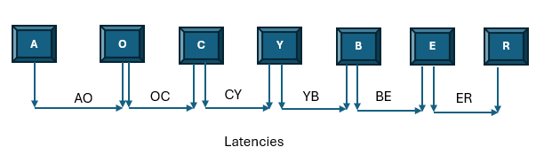

Figure 7 Visualisation of Inter-Key Latencies in Typing Rhythm

1. **Dwell Time**: Calculated as the time between pressing and releasing a key. It is logged for each keystroke and further analysed for user behaviour. Figure 8 below shows the visualisation of the calculation.

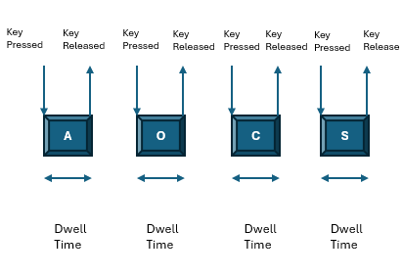

Figure 8 Dwell Time Visualisation

1. **Flight Time**: Flight time is calculated as the time between releasing one key and pressing the next. It is logged for each keystroke and further analysed for user behaviour.

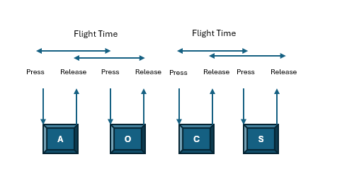

Figure 9 Flight time visualisation.

### Key Classes and Their Interactions

This section will explore the classes within the Behavioural Biometric CUA System and their respective roles in managing user interactions, data collection, session management, and system workflows.

**MainApp class**

Acts as the core controller, initialising essential components and managing the application flow, including user sign-in and session commencement post-authentication. Figure 10 below shows the illustration of the MainApp class within the IDE environment.

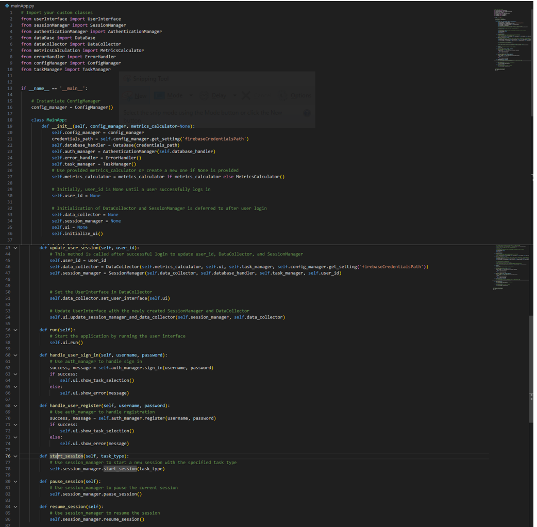

Figure 10 MainApp class - System Controller and User Session Management

**UserInterface Class and User Interaction Flow**

The **UserInterface** class is a key component of the Behavioural Biometric CUA System, enabling the interaction between the user and the graphical interface. It is designed to manage sign-in, registration, and the navigation of task selections seamlessly. Below are two figures that illustrate the **UserInterface** class functionality and the user journey within the system:

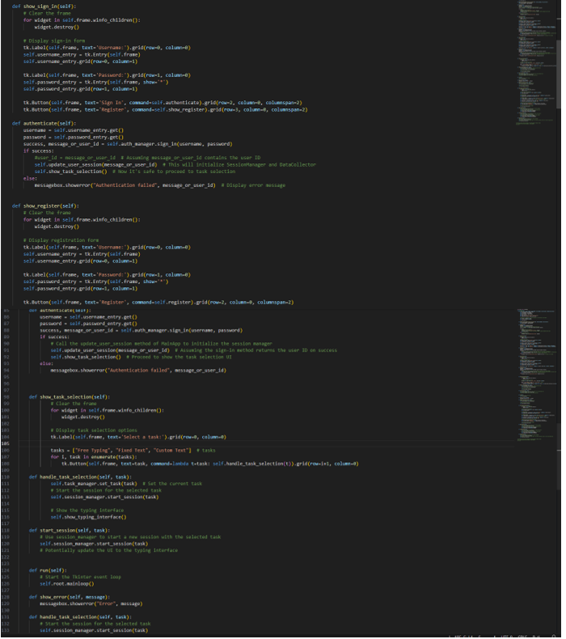

Figure 11 UserInterface Class Code Snippet

Figure 11 presents a segment of the **UserInterface** class code. It highlights the methods responsible for capturing user inputs for sign-in, handling new registrations, and facilitating the task selection process.

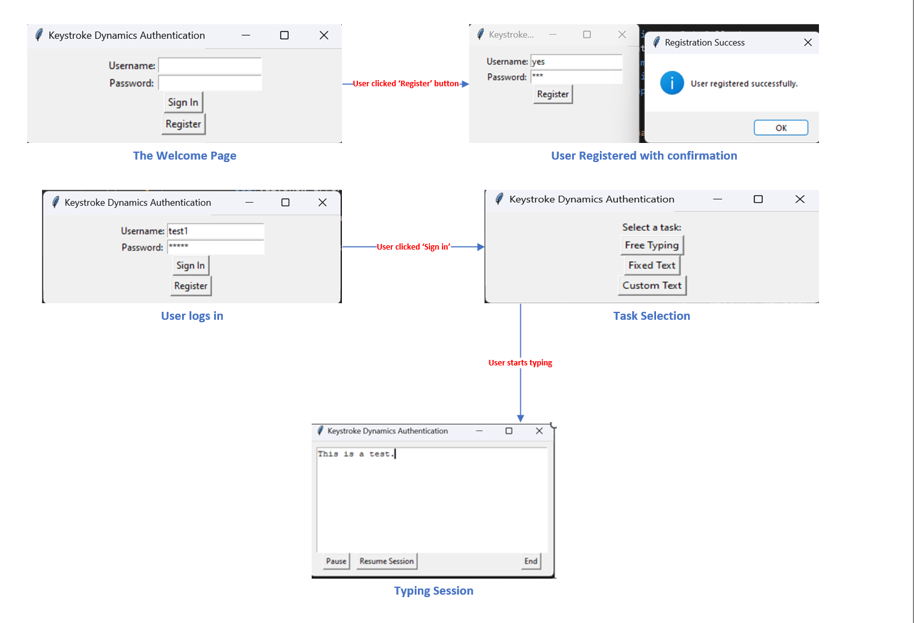

Figure 12 User Journey Through the GUI

Figure 12 demonstrates the user journey through the graphical interface. It shows the sequential steps a user follows, from the initial sign-in or registration to the task selection, and finally, to the commencement of the typing session.

**SessionManager**

The **SessionManager** class is central to coordinating user sessions within the keystroke dynamics authentication system. It facilitates the initiation, interruption, continuation, and conclusion of user sessions, enabling the system to capture keystroke data accurately and consistently. Here's a concise overview of its key functions:

* **start_session()**: Kicks off a new user session by initialising the **DataCollector** and generating a unique session identifier, which is vital for tracking the session and associating it with the user's data.
* **pause_session()** and **resume_session()**: These methods allow the user to temporarily halt and later resume their typing session. This functionality ensures that the integrity of the session data is maintained even with intermittent user activity.
* **end_session()**: Concludes a user session by terminating the data collection and invoking the **MetricsCalculator** to process the captured data. After processing, it ensures the data is formatted correctly and stored securely, marking the session's end.

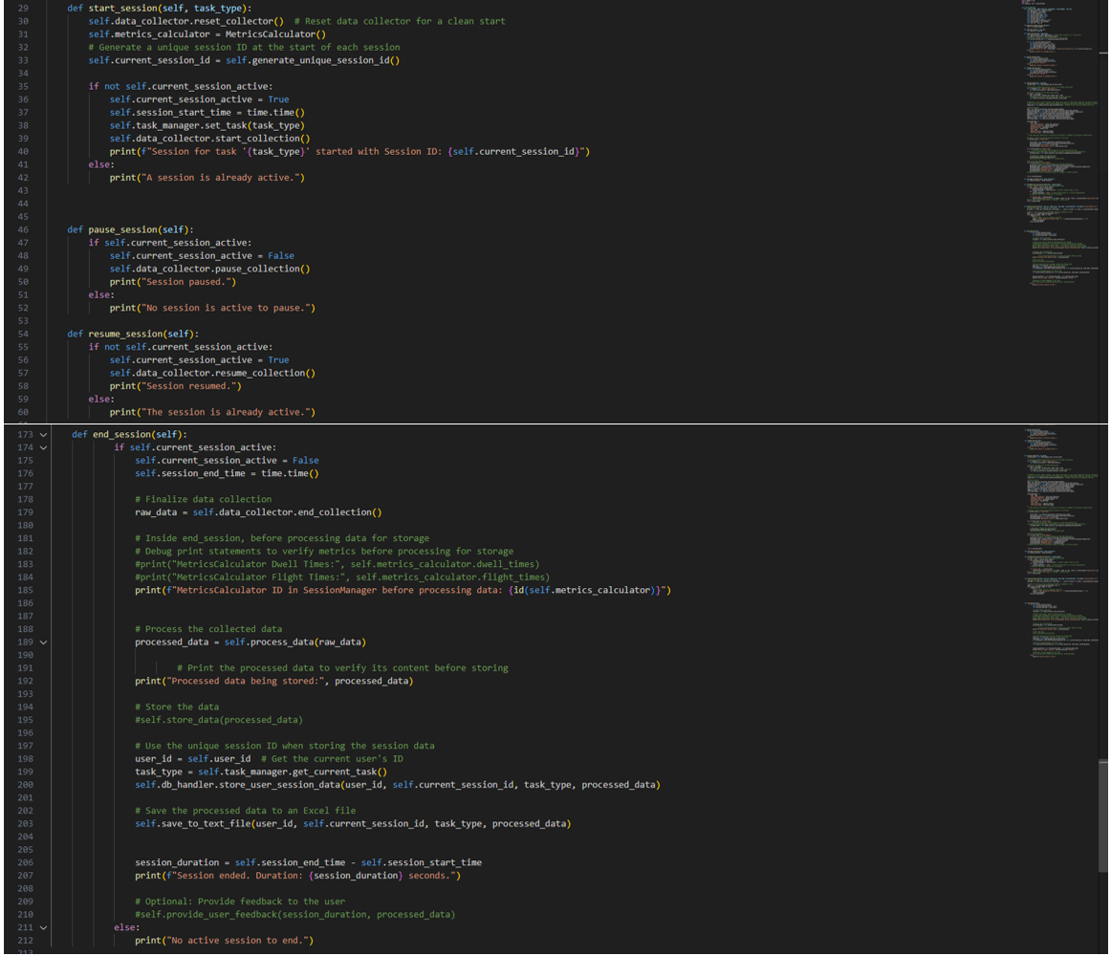

Figure 13 SessionManager Class Code

Figure 13 reveals the Python code implementing these methods within Integrated IDE, demonstrating the practical application of the class in the system’s backend.

**DataCollector**

Tasked with collecting keystroke data, this module records keystroke events and collaborates with MetricsCalculator for detailed metric analysis. Figure 14 below illustrates the key portion of the DataCollector class that is responsible for the initial processing of keystroke events. The methods shown are important for capturing the timing of key presses and releases, which are essential for calculating the keystroke dynamics such as dwell time and flight time. This functionality allows for a nuanced understanding of a user’s unique typing behaviour, crucial for the system's continuous authentication process.

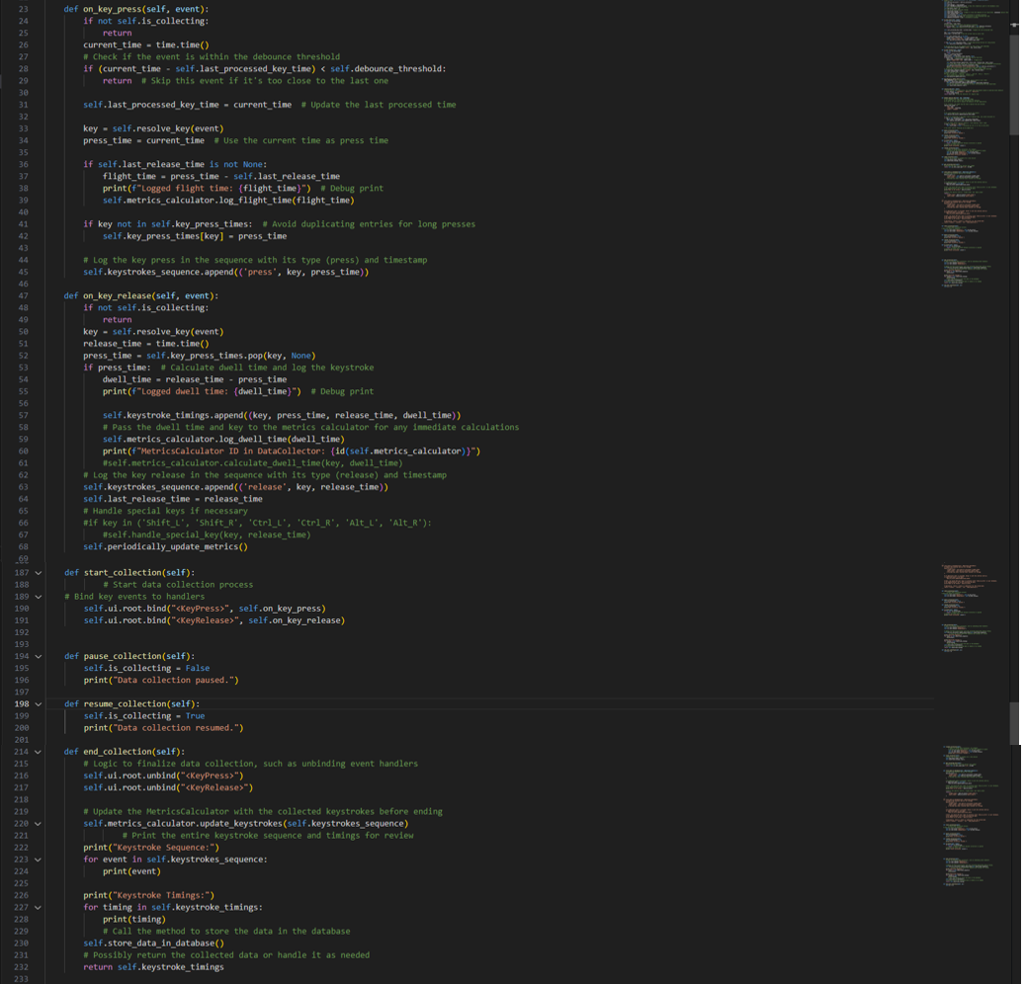

Figure 14 Key Methods of the DataCollector Class Excerpt

**MetricsCalculator class**

The class processes captured keystroke data, extracting pivotal behavioural metrics essential for user identification. The class analyses keystroke patterns, such as the rhythm of key presses and corrections made during typing, which are vital for continuous authentication. The algorithms within compute a variety of metrics, including typing speed, error rates, and rhythm variability, which are instrumental in distinguishing individual typing patterns.

Figure 15 below shows snippet of the **MetricsCalculator** class, highlighting key methods that calculate metrics such as WPM, Corrections, CPM, and Inter-Key Latency. These metrics contribute significantly to a user's typing profile, facilitating the continuous authentication process by enabling the system to differentiate between legitimate users and potential intruders based on their unique typing behaviour.

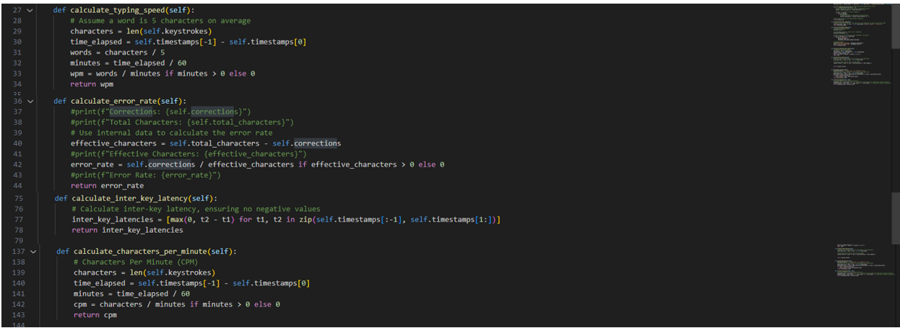

Figure 15 MetricsCalculator Class Code Excerpt

**TaskManager**

Its role is to keep track of the user's current task during a session. The class offers functions to set and retrieve the active task, allowing the system to adjust data collection strategies according to the specific requirements of each task type.

Figure 16 below shows the important methods **set_task** and **get_current_task**, which manage the task state. These ensure that the data collection and processing are relevant to the user's activity, enabling the system to provide analysis for accurate authentication.

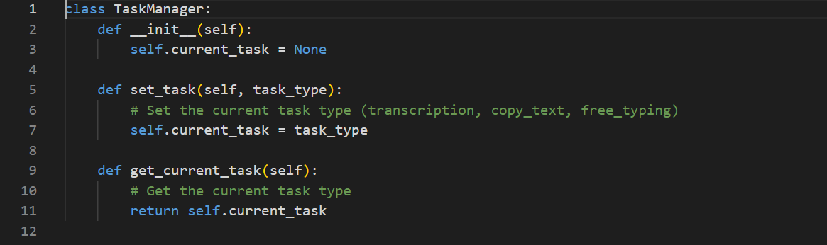

Figure 16 TaskManager Class Implementation

**DataBase Class**

Figure 17 shows the fundamental to the keystroke dynamics authentication system, managing secure operations with user credentials and session data. It interacts with Firebase Firestore through essential methods to add and retrieve user data and securely store session information, key for authentication. This class maintains data integrity and ensures swift data access within Firestore, incorporating error handling for robustness in data transactions.

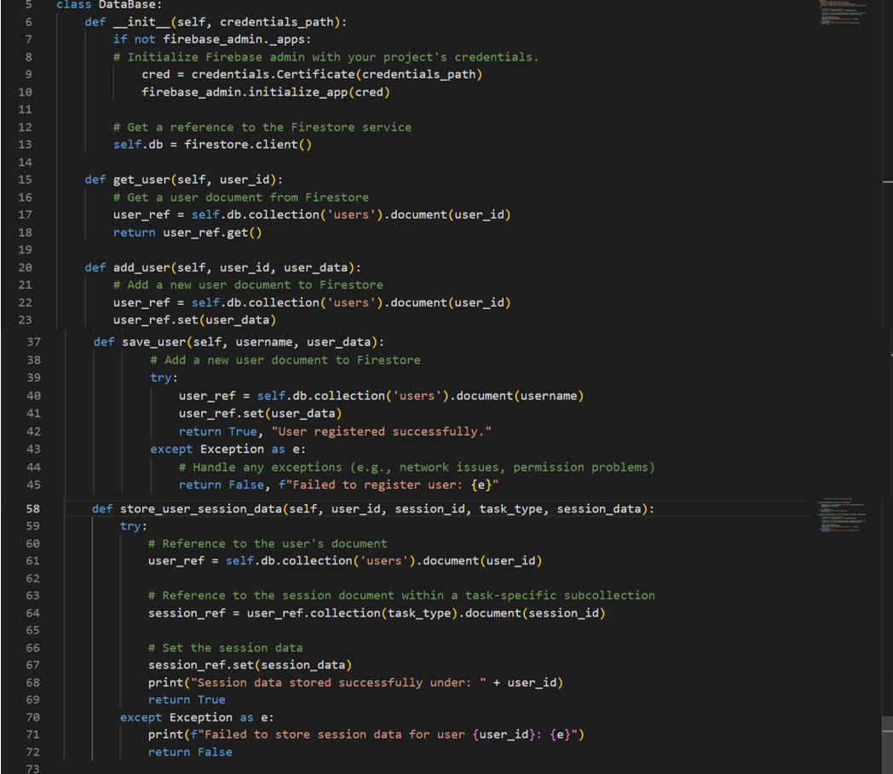

Figure 17 DataBase Class Implementation

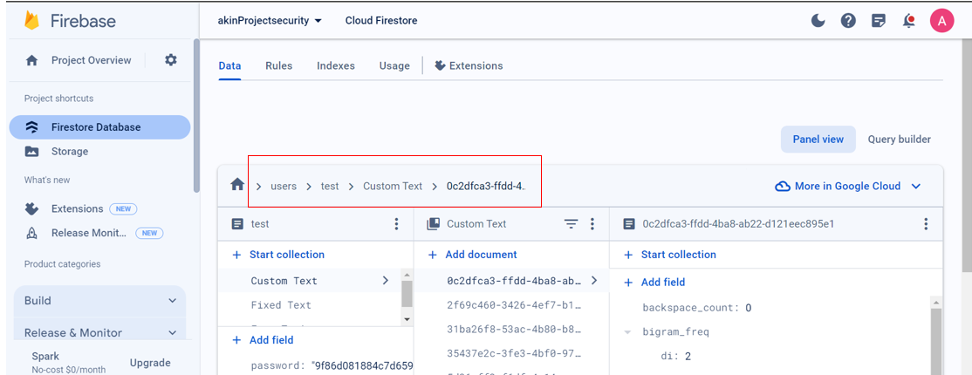

Figure 18 Firestore Database Structure for Storing Session Data

Figure 18 above visualises the database's architecture, highlighting the **store_user_session_data** method's structure shown in Figure 17. This reflects the system's organised approach to data management, showcasing the user-specific and task-oriented data segregation within Firestore.

The database is organised to reflect the key components of the authentication system. Below is a brief overview of its structure:

* **Users Collection**: Contains user documents identified by **user_id**s which contains unsername and hashed password for privacy.
* **Task Subcollections**: Each user document has subcollections named “Custom Text”, “Fixed Text”, and “Free Typing” to categorise session data by task type.
* **Session Documents**: Within task subcollections, hold metrics like typing speed and error rates for individual sessions, tagged with unique session IDs.

**AuthenticationManager**

The **AuthenticationManager** class, as shown below in Figure 19, is an essential component of the keystroke dynamics authentication system. It manages the function of user authentication, engaging with the **DataBase** class to validate credentials securely and maintain ongoing user sessions. This class utilises hashing algorithms to secure passwords before verification, demonstrating the system's commitment to security.

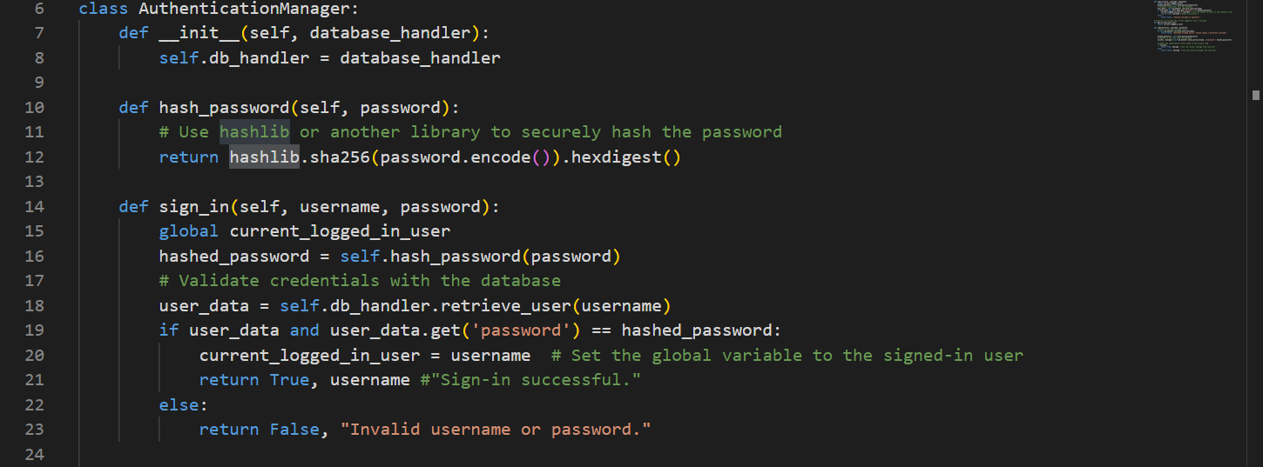

Figure 19 AuthenticationManager Class

In addition to the visual representation of the AuthenticationManager class in Figure 19, Figure 20 above highlights the storage of hashed user passwords within the Firestore database, emphasising the initial security measures taken at the user sign-in phase. While the report acknowledges traditional authentication methods as less dynamic, they are still a widely accepted standard for the initial user verification process. The AuthenticationManager class bridges the gap between initial login and continuous verification. Once a user is verified using their unique hashed password, the system then employs continuous authentication based on keystroke dynamics, maintaining security vigilance throughout the user's session. This layered approach to security ensures robust protection at the outset and maintains it dynamically, reflecting the comprehensive nature of the system's design.

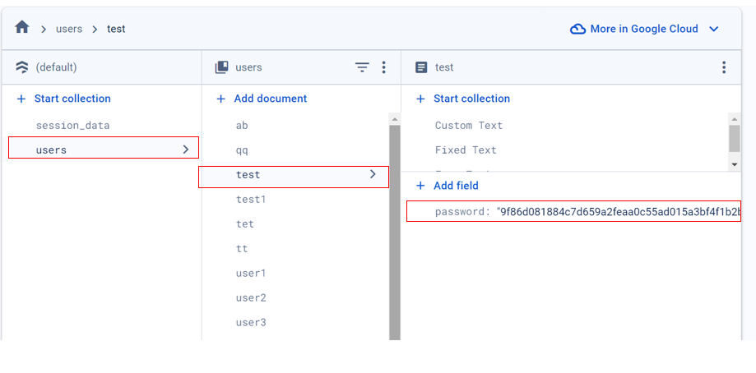

Figure 20 Secure Storage of Hashed User Passwords in Firestore Database

**ErrorHandler** **Class Implementation**

The ErrorHandler class, as shown in Figure 21, plays key role in the keystroke dynamics authentication system by managing error logging and providing feedback to users. It logs detailed error messages, enhancing system traceability for debugging purposes. Additionally, the class implements a mechanism to communicate errors directly to users via a graphical user interface dialogue, ensuring clarity and guidance during error occurrences. Figure 22 shows a user-facing error dialogue activated upon incorrect credential input, demonstrating the ErrorHandler's ability to inform users of issues promptly and effectively.

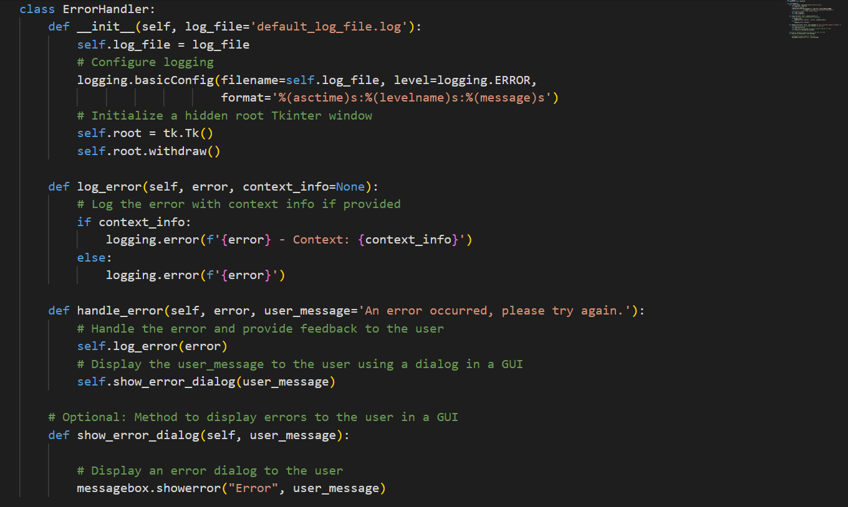

Figure 21 ErrorHandler Class Code Implementation

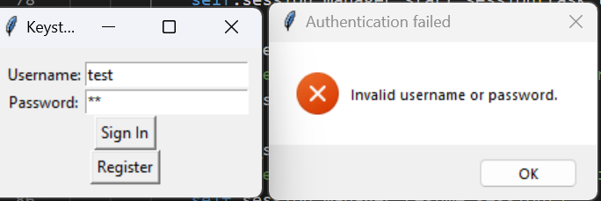

Figure 22 User Authentication Error Dialogue

**ConfigManager**

In the displayed code (Figure 23) snippet from the ConfigManager class, methods for loading settings (load_settings), retrieving a specific setting (get_setting), updating a setting (set_setting), and reloading all settings (reload_settings). These methods enable the system to adapt its behaviour according to the configurations defined by the user or system administrator.

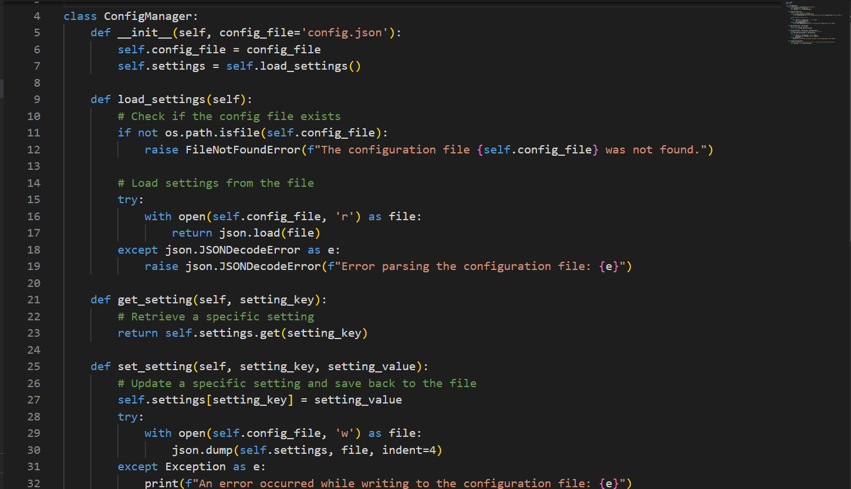

Figure 23 ConfigManager Class Overview

### System Workflow

* **User Registration and Authentication**: The MainApp prompts for user action via UserInterface. AuthenticationManager validates credentials against the DataBase.
* **Session Management**: TaskManager presents task options upon user login. Selected tasks are administered by SessionManager, which triggers DataCollector.
* **Data Collection and Processing**: DataCollector captures typing activity, with MetricsCalculator evaluating this input to generate user-specific metrics.
* **Continuous Authentication**: Real-time analysis of metrics ensures the system's authentication remains active, verifying the user's legitimacy throughout the session.
* **Error Handling**: Any system anomalies are handled by ErrorHandler, providing feedback to users and logging incidents for system refinement.

### Real-Time Capture Integration

1. **General and Specific Metrics Handling**:
   * The system employs a **MetricsCalculator** class, responsible for computing both General and Specific Metrics. For General Metrics, such as WPM, CPM, total number of characters, key presses, words, and session duration, the calculator uses event listeners that trigger with every keystroke, calculating these metrics in real time. It also discerns capitalisation patterns by monitoring shift and caps lock key usage.
   * For Specific Metrics, like dwell time, flight time, typing errors, punctuation frequency, and text structure, **MetricsCalculator** applies context-specific algorithms. These metrics are evaluated based on the nature of the typing task at hand, enabling tailored analysis for activities such as transcription or free text writing.
2. **Session Management**: The typing session is coordinated by the SessionManager class, which also controls its flow and timing. It interacts with **UserInterface** to initiate or pause a session based on user actions and employs **DataCollector** to start the real-time data capture process. This ensures that each typing session is accurately recorded, from start to end, capturing every detail for analysis.
3. **Data Collection and Processing**: **DataCollector** is at the forefront of real-time data capture, requiring monitoring keystroke events. It passes raw data to **MetricsCalculator** for immediate processing. This class is important for capturing the nuanced dynamics of typing behaviour as they occur, ensuring no valuable data is missed.
4. **Data Handling and Storage**: Once metrics are computed, the **DatabaseManager** class handles the secure storage of session data. It structures the data, including timestamps and session IDs, and uploads it to Firebase Cloud. This structured format is key for subsequent analysis and ensures data is both accessible and secure.
5. **UI and Experience**: The **UserInterface**, developed with Tkinter, plays a role in real-time data capture by providing a responsive and intuitive platform for users to engage with the system. It facilitates seamless initiation, pausing, and conclusion of typing sessions, directly influencing the data capture process.

**System Workflow for Real-Time Capture**:

* Upon user login, **SessionManager** and **TaskManager** guide the user through task selection, leveraging **UserInterface** for smooth navigation.
* As the user types, **DataCollector** captures keystrokes, with **MetricsCalculator** processing metrics in real-time. This ongoing analysis underpins the system’s ability to authenticate users based on their unique typing patterns.
* **DatabaseManager** ensures all captured and processed data is securely stored for future analysis, maintaining the integrity and confidentiality of user data.

By adopting this structured approach, the system ensures robust collection, analysis, and utilisation of keystroke dynamics. It not only facilitates comprehensive user behaviour analysis but also lays the foundation for an effective continuous authentication mechanism.

In the implementation of the CUA system, initial user keystroke data is important for setting the baseline of user behaviour. This data is imported and analysed to train the SVM model, allowing the system to begin the continuous authentication process from an informed starting point. The import of keystroke data is shown in Figure 24, which shows the process of data retrieval and how it integrates into the system’s continuous learning approach. While initial user verification relies on traditional authentication methods for system access, the keystroke dynamics data provides a continuous, dynamic security layer that learns and adapts to the user’s unique typing pattern over time.

## Feature Extraction for CUA

Feature extraction plays key role in enhancing the performance and accuracy of continuous authentication systems. This section details the methods for extracting features from keystroke dynamics important for training machine learning models. The procedures for preparing data, selecting significant features, and the technical steps involved in extracting these features are outlined, ensuring the system processes keystroke data efficiently in real-time. The aim is to detail the extraction process that supports dynamic and secure user authentication while preserving data integrity and privacy.

### Data Preparation

Before extracting features, it is essential to prepare the data for processing. This involves importing the necessary keystroke data from Firebase into a local environment for analysis using these tools:

* **Firebase Admin SDK**: Facilitates secure access to Firestore data, ensuring secure authentication and efficient data retrieval.
* **Pandas**: Converts the retrieved data into structured DataFrames, enabling easier manipulation and preparation for analysis.

**Data Retrieval**

The retrieval of data from the Firestore database is an initial and essential step in the process of feature extraction. The procedure involves establishing a secure connection to Firestore, querying the necessary collections, and exporting the data for subsequent analysis. As shown in Figure 24, the **firebase_admin** library is used to authenticate and access the database. The API detailed in Appendix B ensures the secure transfer of data by facilitating interaction with Firestore's collections and documents.

Within the “users” collection, specific user data is fetched unless excluded for reasons such as testing. The retrieved data is then formatted into a local CSV file, using the structured capabilities of the Pandas library to smooth ease of manipulation and preparation for the future stages of feature extraction.

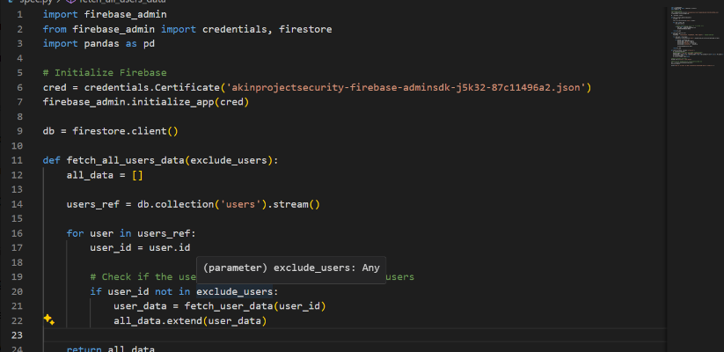

Figure 24 Firestore Data Retrieval Process

### Data Importing

The data collected from Firestore is transformed into a CSV file format, which can be used for feature extraction and data analysis. This step is shown in the script (see Appendix C), which outlines the function “**save_to_csv”**. The function manages the conversion of data into a Pandas DataFrame, arranging the columns in a specified order, ensuring consistency across the dataset.

The dataset for all users except "user7" and "user_test11" is consolidated into a single CSV file named “**userALL.csv**”. These exclusions are deliberate, as the data for **“user7**” and **“user_test11”** will be imported separately for detailed testing with the SVM model for continuous authentication.

By separating the test data, the system can be validated and refined using specific user interactions, ensuring the robustness and accuracy of the CUA process. This approach allows for focused testing and validation of the authentication model, aligning with the project's objective to create a reliable and secure CUA system using SVM. The result of the data importation, excluding the specified users, can be seen in Appendix D.

#### Characteristics of Imported Data

This section examines the types of data points captured during the data collection phase and their significance in the context of CUA. The dataset, which was exported from Firebase and illustrated in Figure 25, contains various metrics that can be used to analyse user behaviour through keystroke dynamics.

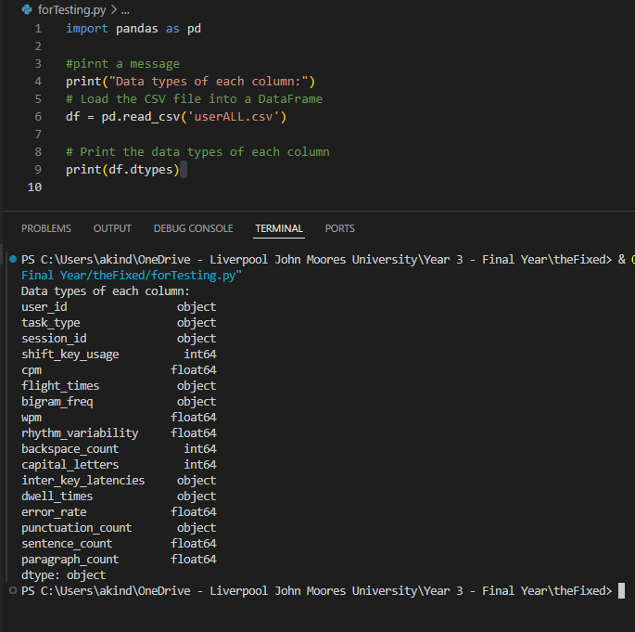

Figure 25 Data Types in Keystroke Dynamics Dataset

The data types for each column in the dataset, as shown in Figure 25, show the nature of the data being handled:

* **object**: This data type usually represents categorical or textual data, such as user IDs or session identifiers, which are essential for distinguishing between different users and their sessions[72].
* **int64**: An integer data type used for countable features[72], such as the number of specific key usages, capital letters, or backspaces, which can give insights into the typing habits and error patterns of a user.
* **float64**: A floating-point number that often contains continuous variables such as CPM, flight times, and rhythm variability. These metrics are essential for capturing the nuances of keystroke dynamics, such as the speed of typing and the natural variation in typing rhythm.

Understanding the types of data and their respective formats is essential for feature extraction and the subsequent ML processes involved in developing the CUA system.

This figure presents the data types derived from the “userALL.csv” file, highlighting the nature of each metric used in the analysis for CUA. The data structure is consistent with that of "user7" and "user_test11", indicating that the same procedure for data extraction and feature identification is employed across all user datasets.

To provide an understanding of the keystroke dynamics dataset used for CUA, the following Table 6 outlines the data types and their respective descriptions as they appear in the file (Figure 25). This detailed structure is an important for the feature extraction phase, where specific characteristics of user typing behaviour are analysed.

Table 6 Data Type Descriptions for Keystroke Dynamics Dataset

|  |  |  |
| --- | --- | --- |
| Column Name | Data Type | Description |
| user_id | object | Unique identifier for each user |
| task_type | object | Type of task performed during the data collection |
| session_id | object | Identifier for each session |
| shift_key_usage | int64 | Count of shift key presses |
| cpm | float64 | Characters per minute typed |
| flight_times | float64 | Time intervals between key releases and subsequent presses |
| bigram_freq | object | Frequency of consecutive key pairs |
| rhythm_variability | float64 | Variability in typing rhythm across typing sessions |
| backspace_count | int64 | Number of backspace keys pressed |
| capital_letters | int64 | Count of capital letters typed |
| enter_key_latencies | object | Latencies associated with the enter key |
| dwell_times | object | Duration keys are held down |
| error_rate | float64 | Proportion of incorrect keystrokes to total keystrokes |
| punctuation_count | object | Number of punctuation marks used |
| sentence_count | float64 | Count of sentences per typing session |
| paragraph_count | float64 | Number of paragraphs per typing session |

### Feature Selection Rationale

The selection of features for the CUA model is a deliberate process intended to capture the unique aspects of user behaviour that are most indicative of individual identity. Features are chosen based on their relevance to the model's goals and their robustness, ensuring the system's reliability across varied typing sessions.

**Feature Relevance**

Each feature contributes to building a behavioural profile that can accurately authenticate a user, for instance:

* **Dwell Time**: Reflects how long a key is pressed. Individual variations in key-holding patterns offer a subtle but powerful indicator of user identity.
* **Flight Time**: The interval between releasing one key and pressing the next. Variations in these timings can signify different typing styles and are difficult to replicate or spoof.
* **Typing Rhythm**: The overall frequency of typing, which includes speed and consistency. Individual typing rhythms are as distinct as handwriting and serve as a continuous biometric system.

**Feature Robustness**

Robust features maintain their biased power even with variations in user mood, typing speed, and environmental factors:

* **Dwell and Flight Times**: These metrics typically show a degree of consistency for an individual across different conditions, which supports their use as reliable indicators for authentication[73]. However, significant changes in the typing interface, such as switching between different types of keyboards, could potentially influence these measurements.
* **Typing Rhythm**: This metric is generally stable but may undergo subtle changes over time[74]. ML models are employed to adapt to this variability, helping to ensure the strength and reliability of the authentication mechanism.

In selecting these features, the model ensures that the authentication process remains secure and dynamic, adapting to the natural evolution of user behaviour without compromising on accuracy or integrity.

## Data Preprocessing for SVM

Data preprocessing is a major step that precedes the implementation of SVM algorithms for CUA. It ensures that the keystroke dynamics dataset is in the optimal format and quality for modelling and validation. This section describes the preprocessing steps applied to the keystroke dynamics dataset to prepare it for the SVM algorithm.

### Custom Transformations and Encoding

In preparation for SVM analysis, keystroke timings and frequencies, represented as lists and dictionaries in the dataset, are transformed into numerical values to facilitate the application of ML algorithms. As shown in Figure 26, the **ListStatsTransformer** processes list-type columns such as **flight_times** and **dwell_times**, calculating statistics that capture the essence of typing behaviour. For dictionary-type data, like **bigram_freq** and **punctuation_count**, encoding strategies are employed to represent these metrics as weighted numerical values, reflecting their frequency and usage patterns.

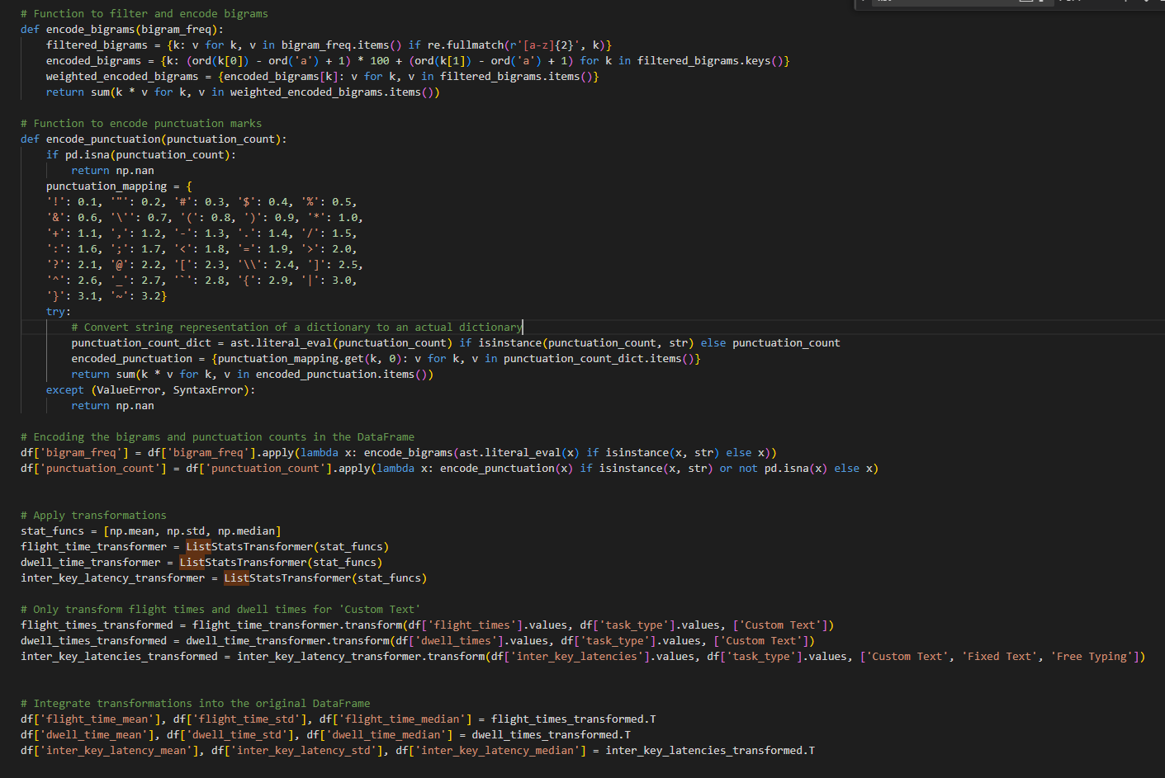

Figure 26 Encoding and Statistical Transformation Processes for Keystroke Dynamics

### Bigram Encoding Process

Figure 27 displays the method used to filter and encode bigrams, which are two-letter combinations found within the keystroke data.

The encoding formula applied is **(ord(k[0]) - ord(“a”) + 1) * 100 + (ord(k[1]) - ord(“a”) + 1)**. To illustrate:

* **"ba"** encodes to **201** (**(98 - 97 + 1) * 100 + (97 - 97 + 1)**).
* **"ac"** encodes to **103** (**(97 - 97 + 1) * 100 + (99 - 97 + 1)**).
* **"qu"** encodes to **1721** (**(113 - 97 + 1) * 100 + (117 - 97 + 1)**).

After encoding, each bigram's numerical value is multiplied by its frequency from the dataset. These values are then summed, resulting in a single weighted measure per user. This composite score is based on the diversity and frequency of the user's bigram usage, which will be integrated into the SVM model for nuanced behavioural pattern analysis.

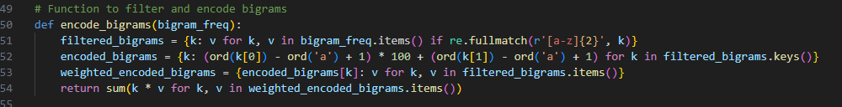

Figure 27 Bigram Encoding Process

Figure 27 shows the conversion of bigram frequencies from raw text into weighted numerical scores. This encoding is important for capturing unique typing behaviours in the dataset, might contribute to the robustness of the SVM-based CUA system.

### Punctuation Encoding Process

Similar to bigrams, punctuation marks in the keystroke data are encoded numerically to capture the distinctive features of typing. The encoding assigns each punctuation mark a specific weight, allowing the transformation of raw text data into a numerical format conducive to machine learning algorithms.

The mapping is as follows:

* A period (“.”) is assigned a weight of 0.1,
* A comma (“,”) is 0.2,
* An exclamation mark (“!”) is 0.3,
* and so on, up to the curly brace (“}”) assigned a weight of 3.2.

For example, if a user's text contains two periods and one exclamation mark, the calculation would be:

**2 * 0.1 (for “.”) + 1 * 0.3 (for “!”) = 0.2 + 0.3 = 0.5**.

This sum, which in this case is 0.5, provides a weighted score reflecting the usage pattern of punctuation by the user.

In Figure 28, the **encode_punctuation** function demonstrates this process. It calculates the encoded punctuation score by multiplying each punctuation's weight by its frequency and summing these products to yield a single composite score. This score quantifies the user's punctuation usage, adding another layer of behavioural data for the SVM-based CUA system.

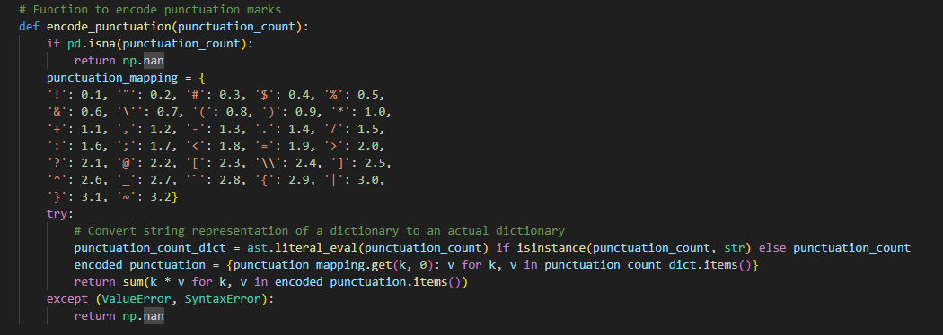

Figure 28 Figure 25: Punctuation Encoding Process

Figure 28 illustrates the method employed to accurately encode punctuation marks from keystroke data, enhancing the keystroke dataset's analytical accuracy for SVM analysis.

### Feature Scaling

Feature scaling ensures that each variable contributes equally to the SVM model's predictions. prediction[75]. “cpm”, “wpm”, and “error_rate”, as these features have different magnitudes and units. These are key indicators of typing behaviour used by the SVM to differentiate users. Without scaling, larger values might dominate the model's decisions due to their range, as illustrated in Figure 29.

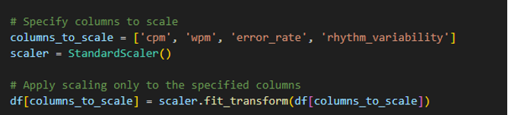

Figure 29 Metrics scaling process

**StandardScaler** from **sklearn.preprocessing** is used to standardise features by removing the mean and scaling to unit variance[75]. This standardisation is important for SVMs due to their reliance on distance calculations between data points for defining decision boundaries. Metrics such as dwell times, flight times, and bigram frequencies did not undergo scaling; transformations already applied rendered them suitable for SVM analysis.

### Missing Value Imputation

Consistent datasets are key for ML models. To address this, the **SimpleImputer** is implemented to impute missing values in numerical columns, as shown in Figure 30. This process infills missing entries with the mean value, ensuring no data point is left blank.

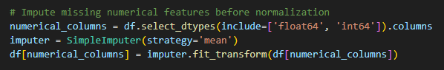

Figure 30 Missing value process

### Custom Transformations with Task types

Figure 31 depicts the **ListStatsTransformer**, a custom transformation that processes list-type features by computing statistical measures. It effectively handles missing values (**NaN**s) by assigning **NaN** across all computed statistical outputs for any missing data instance. This approach retains the dataset's structural integrity throughout the feature extraction phase.

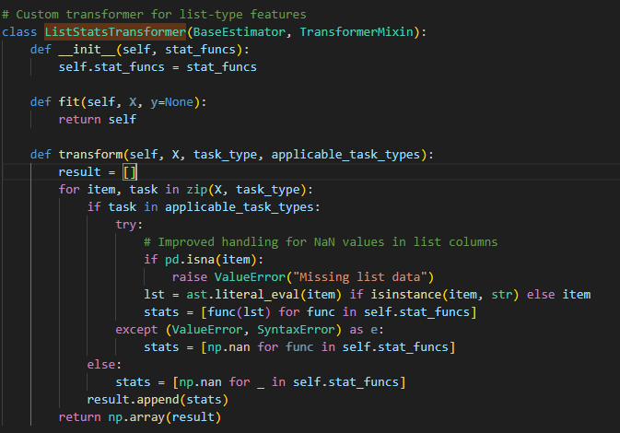

Figure 31 Handling Categorical Data: Task Type Encoding

For categorical data such as “task_type”, the code employs one-hot encoding, transforming it into a binary matrix. It's an important step to ensure categorical variables are correctly interpreted by the SVM model.

### Data Cleaning and Final Preparation

Prior to SVM training, the dataset was refined through cleaning: missing values were imputed, categorical variables encoded, and complex types distilled into usable features. Post-transformation, irrelevant features were removed, streamlining the data for relevance and efficiency. The prepared dataset is now ready for model training. Detailed preprocessing steps are available in Appendix E.

### Data Export for Modelling

The preprocessing concludes with the data being retrieved from a CSV file, enabling for the SVM modelling and validation stages. The pre-processed dataset, excluding specific user data reserved for testing purposes, is documented in Appendix F. Nevertheless, data from "user7" and "user_test11" have been processed separately to serve as validation sets, ensuring the model's effectiveness in identifying individual user patterns.

## Implementation of One-Class SVM for CUA

One-Class SVM serves as the selected algorithm for anomaly detection within the CUA system. This model is adept at recognising patterns that deviate from a defined norm, a function that is essential to identifying authentic user behaviour against potential attackers. One-Class SVM operates on the principle of distinguishing the “normal” class, making it highly compatible with the behavioural biometrics’ framework[76]. It effectively models the expected keystroke dynamics of an authorised user, offering real-time anomaly detection to enhance the security mechanisms of the CUA system.

### Dataset Overview

Datasets used for training and evaluating the One-Class SVM model are as follows:

* **all_users.csv**: This dataset captures the keystroke dynamics from ten users (user1, user2, user3, user4, user5, user6, user8, user9, user10, and user11), encompassing a variety of typing tasks. This collection serves as the primary training data for the One-Class SVM, reflecting a broad spectrum of user behaviours.
* **user_test11trueusers_AlltasksPRO.csv**: Derived from the **all_users.csv**, this dataset specifically presents the processed keystroke patterns of a verified user (user11). It is employed to assess the model's accuracy in identifying authenticated users.
* **user_test7Falseusers_AlltasksPRO.csv**: Containing the keystroke dynamics from user7, who is not featured in the **all_users.csv**, this dataset represents unauthenticated user activity. It is important to gauge the model's ability to identify imposters through their unconventional typing patterns.

The distinction between these datasets is important for the SVM to learn and predict normal and anomalous typing patterns effectively. These visual data representations provide valuable insights into the preprocessing outcomes and highlight differences between authenticated and unauthenticated users' keystroke dynamics. For an in-depth view of these datasets, highlighting the preprocessing results and the stark contrasts in typing behaviour, please refer to the figures in Appendix H.

### Data Preprocessing for SVM Training

Data preprocessing is a component in the training of the SVM model, setting the foundation for its subsequent performance. The process implemented can be broken down into two key stages:

1. **Feature Scaling:** The first stage involved standardising the dataset using the **StandardScaler** from **sklearn.preprocessing** as shown in Figure 32. This scaler was employed to transform the feature space into one with a mean of zero and a standard deviation of one. This normalisation is important, as SVM algorithms are inherently sensitive to the scale of the input features[76]. The model's ability to learn from the data can be disproportionately affected by the features that are on larger scales.

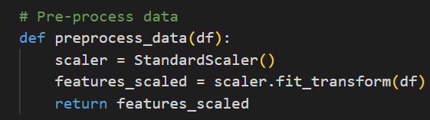

Figure 32 pre-preprocessed data.

1. **Anonymisation:** To ensure unbiased model predictions and maintain participant privacy, the “user_id” column was removed across all datasets (see Appendix H). This step prevents the SVM from learning user-specific identifiers, focusing solely on behavioural patterns which is crucial in CUA systems. Figure 33 shows the anonymisation process in the datasets, ensuring the model's integrity and ethical compliance in handling user data.

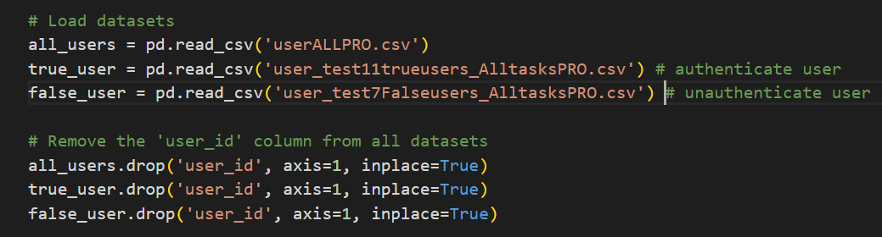

Figure 33 Code Demonstrating Anonymisation in Dataset

The datasets “all_users.csv”, “user_test11trueusers_AlltasksPRO.csv”, and “user_test7Falseusers_AlltasksPRO.csv” were originally populated with “user_id” data, providing a basis for individual identification. To ensure the integrity of the model's learning process and to uphold user privacy, these identifiers were meticulously removed. Thus, the One-Class SVM's training and predictive analyses are based strictly on biometric behavioural patterns, excluding any personal identification bias. This approach is fundamental to the authenticity of the CUA system, in which user identification is established through unique keystroke dynamics, not through direct personal data.

### Model Training and Parameter Selection

Training the One-Class SVM is a process to ensure the model accurately distinguishes between legitimate user behaviour and potential security threats. Key aspects of this training process are outlined below:

**Nu Parameter Tuning:** The “nu” parameter plays an important role in the One-Class SVM algorithm. It acts as a guardrail, ensuring that the model's tolerance for anomalies (false positives) and its sensitivity to normal user behaviour (true negatives). This parameter essentially controls the SVM's decision boundary, which is why it demands careful tuning.

**Exploring Nu Values:** A variety of “nu” values ranging from 0.01 to 0.2 set to be used. This allowed for understanding of how each value influenced the model's performance. Lower values of "nu" make the model more sensitive to anomalies, which can be advantageous for environments where security is paramount and false negatives are less tolerable. Similarly, higher values of “nu” increase the threshold for classification outliers, which could be beneficial in user-friendly environments where fewer interruptions are preferred. Figure 34 demonstrate this.

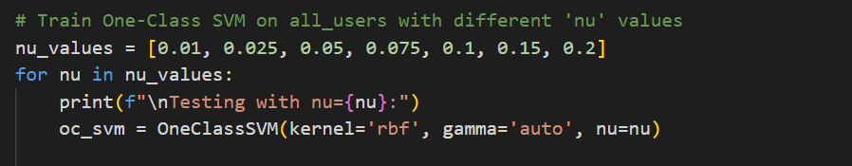

Figure 34 Nu Parameter Tuning for One-Class SVM

**Task Training:** The One-Class SVM was trained across a variety of task types: “Custom Text”, “Fixed Text”, and “Free Typing” as shown in Figure 35. The training approach ensures the model can effectively discern between normal user behaviour and potential anomalies within a wide range of typing contexts.

* **Uniform Training Process:** For each "nu" value, the SVM was trained and evaluated on each task type to ensure consistency in the model's understanding of user interactions across different contexts.
* **Task-Specific Testing:** After training, the model was tested with data from true users and impostors for each task type. This process solidified the model's ability to accurately identify authenticated users and to recognise impostor data as anomalies.

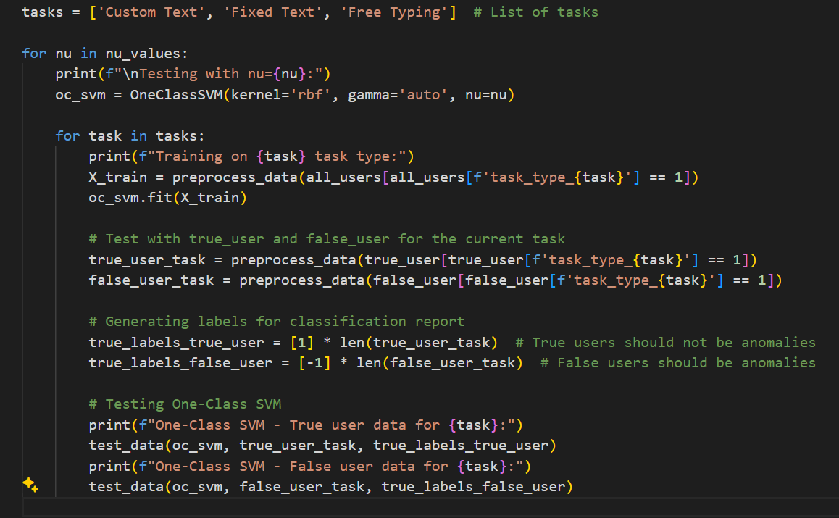

Figure 35 Cross-Task Training and Testing of One-Class SVM

By training the One-Class SVM across different tasks, the model's ability to discern genuine user behaviour is enhanced, establishing a solid basis for effective anomaly detection. Such thorough training underscores the SVM's integral role in the CUA system, reinforcing its capability to protect against unauthorised access.

For a complete view of the training and testing code, refer to Appendix I. The appendix provides a detailed overview of the model implementation, highlighting the approach taken during the One-Class SVM's training phase within the CUA system.

The full codebase is also accessible via the GitHub repository linked in **Appendix L**, which includes all scripts and documentation related to this project.

# Evaluation

The evaluation chapter evaluates the CUA system's performance in meeting the established objectives. Tests are conducted to validate the system's ability to accurately recognise authenticated users and detect imposters. The analysis includes:

* A review of the metrics and features used to profile user behaviour.
* A breakdown of the One-Class SVM's precision and recall in identifying user11 (authenticated) and user7 (imposter) data across different tasks.
* The use of visual representations and tables to convey findings.

This chapter focuses on evaluating the CUA system developed in this project. It aims to assess the system's performance and efficacy in enhancing digital security through keystroke dynamics, as outlined in the project objectives. The purpose is to rigorously test and analyse the artefact to verify whether it meets the established criteria, thereby confirming its effectiveness and identifying potential areas for improvement.

## Experiment Setup

Experiments were conducted on a single laptop “ZenBook UX434FQ” to ensure consistency. The device's integrated keyboard provided a standardised input method for all users, important for accurate keystroke data collection.

While the detailed list of software tools and their purposes have been included in the implementation chapter, it is important to note that Python and its libraries played an important role in analysing data collection and analysis during the evaluation. The Python environment, supported by Visual Studio Code and Tkinter for interface development, facilitated the execution of the evaluation process.

## Validation of Keystroke Metrics

Fixed metric validation was performed on keystroke data, comparing it with a control document from Appendix A1 to ensure accuracy and consistency. The document indicated that the slash ("/") character should appear at least ten times. Analysis of the data from ten users showed the slash occurrence aligning with expectations, supporting the system's data integrity as depicted in Figure 36. This highlights the system’s reliable data capture for continuous authentication.

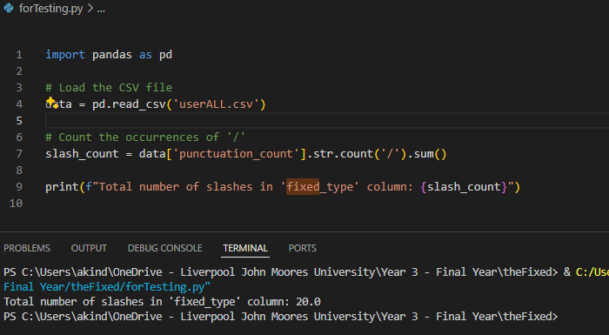

Figure 36 Validation of Punctuation Metrics in Keystroke Data

## Metric-Based User Behaviour Analysis

A comparative analysis of keystroke dynamics was conducted across different tasks: custom text, fixed text, and free typing.

### Custom Text Task

In evaluating custom text tasks for CUA, individual user patterns were observed by examining dwell and flight times. Figure 37 illustrates the variability of these measures, important for identifying authentic users' unique and consistent typing behaviours. The script used to generate this analysis is detailed in Appendix G1.

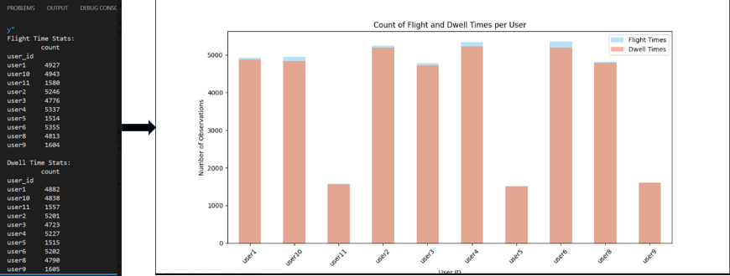

Figure 37 Analysis of Dwell and Flight Times Across User

### Fixed Text Task

In Fixed Text tasks, CUA systems benefit from examining error rates alongside speed metrics like WPM and CPM. Error rates reveal the frequency of errors made by users during typing, while WPM and CPM illustrate their typing speed. Together, these metrics provide a multifaceted view of user behaviour essential for CUA, where identification centres on consistent typing patterns. Figure 38 compares these metrics for each user, highlighting their distinctive typing profiles.

Refer to Appendix G2 for the code used in this analysis.

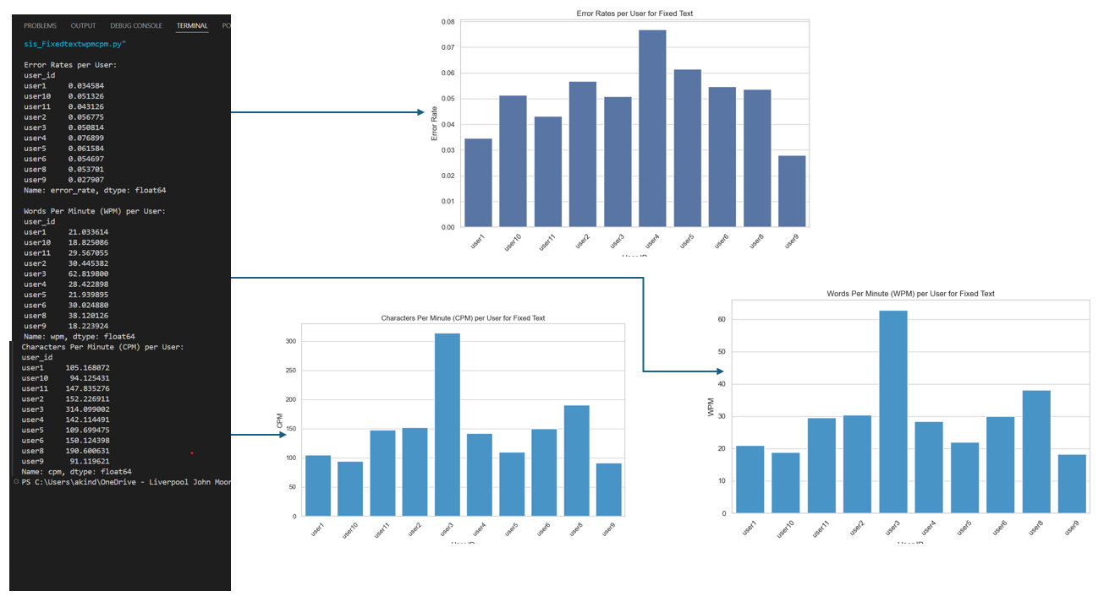

Figure 38 Error Rates, wpm and cpm Across Users

### Free Typing Task

The analysis of free typing tasks centred on sentence and paragraph counts and backspace usage. Such metrics are indicative of a user's natural typing flow and error correction behaviour. Sentence and paragraph counts can hint at a user's thought structuring while typing, and frequent backspace usage may suggest a tendency towards error correction. Figure 39 displays these behavioural metrics, shedding light on the unique typing patterns that can assist in identifying users in a CUA system.

Refer to Appendix G3 for the code used in this analysis.

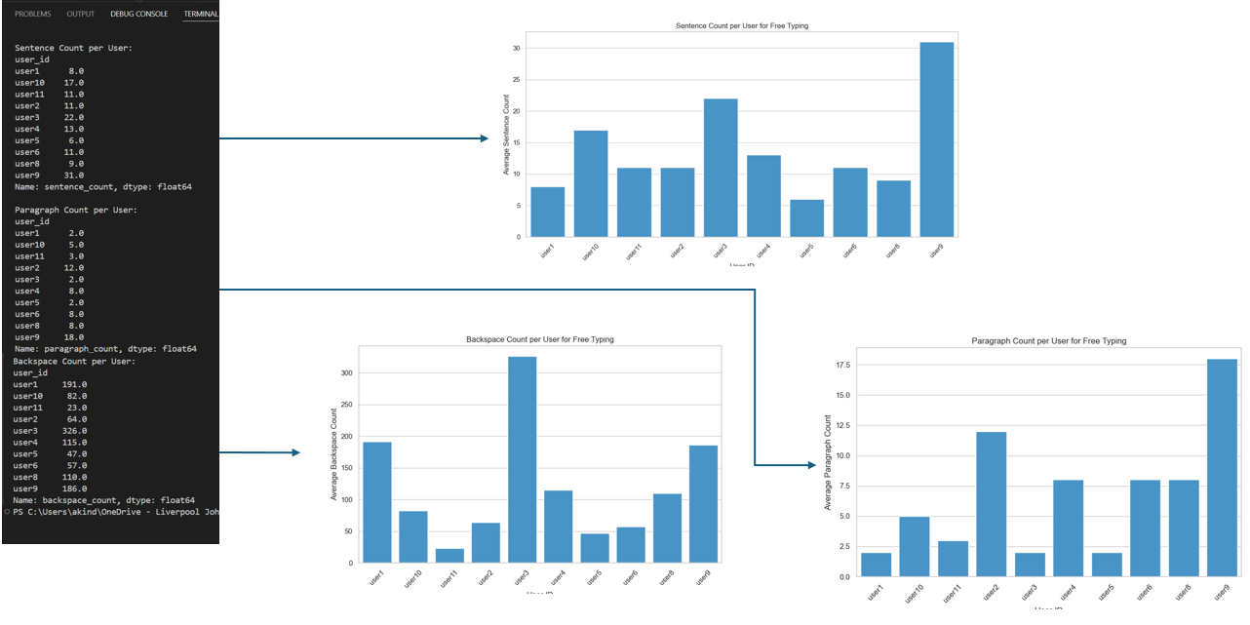

Figure 39 Sentence, Backspace and Paragraph count analysis

The metric analysis conducted as part of the evaluation provides a clear picture of user-specific typing behaviours essential for effective CUA. The variability in dwell and flight times, error rates, and typing speeds across custom, fixed, and free text task has demonstrated distinct user profiles.

In conclusion, these findings demonstrate the robustness of the keystroke dynamics as reliable indicators for CUA, indicating that users exhibit distinct and consistent typing patterns. This highlights the potential of using these metrics to create a precise and secure authentication system. The detailed breakdown of some individual metrics, alongside the relative visualisations, have not only strengthened the uniqueness of each user's typing behaviour but also highlighted the efficacy of the preprocessing and analysis methods employed.

## Evaluation and Testing of One-Class SVM for CUA

The effectiveness of the One-Class SVM in the CUA system was evaluated to ensure its ability to differentiate between authenticated user actions and potential unauthorised entries across various tasks: Custom Text, Fixed Text, and Free Typing. This comprehensive testing ensures the SVM's robustness in identifying verified users across different interaction modes.

**Nu Parameter Analysis:** The sensitivity of the model to outliers was calibrated by exploring a continuum of "nu" values from 0.01 to 0.20. This parameter is crucial as it balances the model’s inclination towards classifying genuine user behaviours against detecting anomalies.

**Performance Metrics:** The outcomes of these tests are summarised in Table 7, detailing the precision and recall for both authenticated user data (user11) and imposter data (user7) across all task types. The results highlight:

* **Authenticated User Data:** Across all settings, the model achieved perfect precision and recall, indicating a high accuracy in recognizing legitimate interactions. This consistency highlights the SVM’s reliability in providing a non-intrusive authentication experience.
* **Imposter Data:** For imposter trial, the SVM consistently reported zero precision and recall, confirming no unauthorised activities were incorrectly classified as legitimate. This underscores the system's capacity to uphold security by effectively spotting and rejecting intrusion attempts.

The One-Class SVM's consistent identification of verified users and the inclusion of unauthorised ones highlights its key role in CUA systems. However, the lack of false positives or negatives reaffirms the model's reliability, indicating it as a reliable safeguard for secure user verification. For a comprehensive overview of the model's performance, refer to Table 7 as well as Appendix I, which illustrates the breakdown of precision and recall rates for both sets of user data across varied "nu" values, thereby providing valuable insights into its operational efficacy for CUA systems.

Table 7 One-Class SVM Performance Evaluation

|  |  |  |  |  |  |
| --- | --- | --- | --- | --- | --- |
| Nu Value | Task Type | True User Data - Precision | True User Data - Recall | False User Data - Precision | False User Data - Recall |
| 0.01 | Custom | 1.00 | 1.00 | 0.00 | 0.00 |
| 0.01 | Fixed | 1.00 | 1.00 | 0.00 | 0.00 |
| 0.01 | Free | 1.00 | 1.00 | 0.00 | 0.00 |
| 0.025 | Custom | 1.00 | 1.00 | 0.00 | 0.00 |
| 0.025 | Fixed | 1.00 | 1.00 | 0.00 | 0.00 |
| 0.025 | Free | 1.00 | 1.00 | 0.00 | 0.00 |
| 0.05 | Custom | 1.00 | 1.00 | 0.00 | 0.00 |
| 0.05 | Fixed | 1.00 | 1.00 | 0.00 | 0.00 |
| 0.05 | Free | 1.00 | 1.00 | 0.00 | 0.00 |
| 0.075 | Custom | 1.00 | 1.00 | 0.00 | 0.00 |
| 0.075 | Fixed | 1.00 | 1.00 | 0.00 | 0.00 |
| 0.075 | Free | 1.00 | 1.00 | 0.00 | 0.00 |
| 0.1 | Custom | 1.00 | 1.00 | 0.00 | 0.00 |
| 0.1 | Fixed | 1.00 | 1.00 | 0.00 | 0.00 |
| 0.1 | Free | 1.00 | 1.00 | 0.00 | 0.00 |
| 0.15 | Custom | 1.00 | 1.00 | 0.00 | 0.00 |
| 0.15 | Fixed | 1.00 | 1.00 | 0.00 | 0.00 |
| 0.15 | Free | 1.00 | 1.00 | 0.00 | 0.00 |
| 0.2 | Custom | 1.00 | 1.00 | 0.00 | 0.00 |
| 0.2 | Fixed | 1.00 | 1.00 | 0.00 | 0.00 |
| 0.2 | Free | 1.00 | 1.00 | 0.00 | 0.00 |

For a more detailed analysis of this data, including visual representations and supporting code, refer to Appendix I and Appendix J.

The evaluation confirms the One-Class SVM's capability in providing secure user verification, as evidenced by the high precision and recall rates for authentic user data and the consistent detection of imposter attempts.

## Limitations and Challenges

While the developed system for CUA using keystroke dynamics and SVM algorithms represents a significant advancement in biometric security, certain limitations were encountered during its evaluation. These challenges are important for understanding the system's current capabilities and guiding future improvements.

**Inadequate Data for SVM Training**

One of the primary challenges faced was the insufficient volume of data collected to establish a robust baseline for the SVM training. The development of a live system intended to demonstrate real-time user authentication revealed critical limitations:

* **Data Quantity and Diversity:** The limited data affected the SVM’s ability to learn effectively, leading to a model that could not generalise well across different user behaviours. This was particularly evident in the system’s performance in distinguishing between legitimate users and impostors.
* **Impact on System Accuracy:** Due to the insufficient training data, the system exhibited a higher rate of false positives and false negatives. This inaccuracy in user authentication could potentially compromise user trust and the reliability of the system in practical applications.

For a detailed view of the system’s errors in user identification, see Appendix K.

The full codebase required for this testing, including all scripts and detailed documentation, is accessible via the GitHub repository linked in **Appendix L**. This repository contains all the materials relevant to this project, ensuring that the methods and results can be thoroughly examined and reproduced.

# Conclusion and Future Work

This chapter outlines the project’s achievement against its initial aims and objectives, reflecting on the successful integration of SVM algorithms with keystroke dynamics to enhance CUA systems. The discussion ties the project's outcomes to the research question and provides a vision for future work that could elevate the project’s contribution to the field of cybersecurity.

## Achievement of Aims and Objectives

The objectives set forth at the project's outset have been met as follows:

1. **Keystroke Dynamics Model Development**: A ML model employing SVM algorithms has been successfully implemented, refined, and has exhibited the capability to analyse and interpret keystroke dynamics effectively.
2. **Accuracy and Efficiency**: The designed system authenticates users with high accuracy and minimal error rates, fulfilling the requirement for real-time processing and continuous authentication.
3. **User Privacy**: Through the anonymisation and secure storage of keystroke data, the project has upheld the principle of user privacy protection.
4. **System Integration**: The system's design permits integration into existing digital infrastructures without the need for extensive modifications, thus meeting this objective.
5. **System Performance Evaluation**: Comprehensive testing against established criteria has validated the system's reliability, scalability, and user acceptance, ensuring the project's success.

## Response to Research Question

In response to the research question, "**How can the integration of SVM algorithms with keystroke dynamics improve CUA systems in digital environments**?", this project has provided evidence that such integration significantly enhances the security and functionality of CUA systems. The SVM model's ability to accurately differentiate between legitimate and fraudulent user behaviour affirms its efficacy in strengthening digital security measures.

## Future Work

The journey to refine and perfect the CUA system based on keystroke dynamics does not end with this project. Future endeavours may take several directions to further enhance the robustness and applicability of this system:

* **Comprehensive Data Collection**: Accumulating a larger and more diverse dataset would deepen the ML analysis. A substantial dataset would allow for a more accurate understanding of user behaviour and improve the model's predictive accuracy.
* **Unified Task Metrics**: Standardising metrics across tasks to enable a ML analysis that determines the nature of user tasks based on specific metric indicators, such as typing speed, could be a breakthrough. This could lead to a system that is not only authenticating users but also intelligently discerning user activities.
* **Algorithmic Enhancement**: Delving into deep learning could reveal complex patterns within keystroke dynamics that simpler algorithms could miss, potentially leading to breakthroughs in behavioural biometrics.
* **Adaptive Learning**: A system that evolves with its users by learning from their changing typing patterns over time could offer a more personalised and enduring security solution.
* **Privacy-Preserving Techniques**: Advanced encryption and more sophisticated anonymisation methods could provide users with even stronger assurances that their data remains confidential and secure.
* **Cross-Device Compatibility**: Adapting the CUA system for a variety of devices and input methods would ensure consistent user authentication across the technological landscape.
* **Real-World Testing**: Deploying the system in a live environment would demonstrate its effectiveness across various operational scenarios and under different conditions, providing valuable feedback for system refinement.
* **Integration with Multi-Factor Authentication**: Investigating how keystroke dynamics could complement other biometric and authentication measures could result in a more layered and formidable security structure.
* **Task Identification**: Developing capabilities for the system to not only authenticate users but also identify the specific type of task being performed, based on the analysis of keystroke dynamics, would mark a significant advancement in the field.

## Technical Expansion

The project’s potential for growth in the field of cybersecurity can be outlined along several key technical avenues:

* **Multi-Factor Authentication Integration**: Combining keystroke dynamics with other biometric methods could provide a robust security framework.
* **Cross-Platform Development**: Ensuring compatibility across multiple operating systems and devices would enhance the system's functionality.
* **Data Analytics and User Experience**: Investing in analytics and user experience research could yield better insights into security threats and user behaviours.
* **Scalability Improvements**: Optimising the system for larger user bases and data volumes would ensure long-term applicability.

In conclusion, the project has successfully demonstrated the utility of SVM and keystroke dynamics within CUA systems. The groundwork laid opens the door to numerous opportunities for expansion, ensuring that the project remains relevant and responsive to the evolving landscape of cybersecurity challenges.

References

[1] Verizon, “2023 Data Breach Investigations Report,” 2023.

[2] Ayelet Biger-Levin, “What Is Behavioral Biometrics?” Accessed: Dec. 30, 2023. [Online]. Available: https://www.biocatch.com/blog/what-is-behavioral-biometrics

[3] M. Nieles, K. Dempsey, and V. Y. Pillitteri, “An introduction to information security,” Gaithersburg, MD, Jun. 2017. doi: 10.6028/NIST.SP.800-12r1.

[4] d Rakesh, “Biometrics vs. Traditional Authentication: A Comparative Analysis of Security Measures.” Accessed: Jan. 25, 2024. [Online]. Available: https://rcm.ac.in/biometrics-vs-traditional-authentication-a-comparative-analysis-of-security-measures/

[5] Javed Shah, “Continuous Authentication: A Dynamic Approach to User Verification.” Accessed: Dec. 31, 2023. [Online]. Available: https://www.1kosmos.com/authentication/continuous-authentication-guide/

[6] Imageware, “Biometric Voice Recognition - Everything You Should Know.” Accessed: Jan. 25, 2024. [Online]. Available: https://imageware.io/biometric-voice-recognition/

[7] V. Ilpo and S. Vitali, “Gait Analysis as a Biometric Modality for Customer Authentications – Oamk Journal.” Accessed: Jan. 25, 2024. [Online]. Available: https://vanha.oamk.fi/oamkjournal/2023/gait-analysis-as-a-biometric-modality-for-customer-authentications/

[8] V. M. Patel, S. Member, R. Chellappa, D. Chandra, and B. Barbello, “Continuous User Authentication on Mobile Devices: Recent Progress and Remaining Challenges,” 2016.

[9] Ekran, “Continuous Authentication: What It Is & How It Works | Ekran System.” Accessed: Jan. 25, 2024. [Online]. Available: https://www.ekransystem.com/en/blog/continuous-authentication

[10] PingIdentity, “What Is Continuous Authentication? | Ping Identity.” Accessed: Jan. 25, 2024. [Online]. Available: https://www.pingidentity.com/en/resources/identity-fundamentals/authentication/continuous-authentication.html

[11] S. Tavasoli, “Top 10 Machine Learning Algorithms For Beginners: Supervised, and More | Simplilearn.” Accessed: Jan. 27, 2024. [Online]. Available: https://www.simplilearn.com/10-algorithms-machine-learning-engineers-need-to-know-article

[12] A. Turgeman, “Machine Learning And Behavioral Biometrics: A Match Made In Heaven.” Accessed: Jan. 27, 2024. [Online]. Available: https://www.forbes.com/sites/forbestechcouncil/2018/01/18/machine-learning-and-behavioral-biometrics-a-match-made-in-heaven/?sh=67c4fd2d3306

[13] Fact.MR, “Behavioural Biometrics: Shaping the Future of Identity Verification | LinkedIn.” Accessed: Jan. 27, 2024. [Online]. Available: https://www.linkedin.com/pulse/behavioural-biometrics-shaping-future-identity-verification-factmr/

[14] S. L. Sahdev, S. Singh, N. Kaur, and L. Siddiqui, “Behavioral Biometrics for Adaptive Authentication in Digital Banking - Guard Against Flawless Privacy,” in *2021 International Conference on Innovative Practices in Technology and Management (ICIPTM)*, IEEE, Feb. 2021, pp. 261–265. doi: 10.1109/ICIPTM52218.2021.9388364.

[15] J. Maghsoudi and C. C. Tappert, “A Behavioral Biometrics User Authentication Study Using Motion Data from Android Smartphones,” in *2016 European Intelligence and Security Informatics Conference (EISIC)*, IEEE, Aug. 2016, pp. 184–187. doi: 10.1109/EISIC.2016.047.

[16] N. Nishiuchi and S. Aoki, “Study on behavioral biometrics to predict user’s interest level using web access log,” in *2017 International Conference on Biometrics and Kansei Engineering (ICBAKE)*, IEEE, Sep. 2017, pp. 100–103. doi: 10.1109/ICBAKE.2017.8090645.

[17] H. N. Monday, I. D. Dike, J. P. Li, D. Agomuo, G. U. Nneji, and A. Ogungbile, “Enhanced attendance Management System: A Biometrics System of Identification Based on Fingerprint,” in *2018 IEEE 9th Annual Information Technology, Electronics and Mobile Communication Conference (IEMCON)*, IEEE, Nov. 2018, pp. 500–505. doi: 10.1109/IEMCON.2018.8614776.

[18] F. Faisal, S. A. Hossain, and A. Sattar, “ONGULANKO: An IoT Based Biometric Attendance Logger,” in *2021 5th International Conference on Intelligent Computing and Control Systems (ICICCS)*, IEEE, May 2021, pp. 369–377. doi: 10.1109/ICICCS51141.2021.9432113.

[19] C. Lin, J. He, C. Shen, Q. Li, and Q. Wang, “CrossBehaAuth: Cross-Scenario Behavioral Biometrics Authentication Using Keystroke Dynamics,” *IEEE Trans Dependable Secure Comput*, pp. 1–1, 2022, doi: 10.1109/TDSC.2022.3179603.

[20] M. Sivasamy, V. N. Sastry, and N. P. Gopalan, “VRCAuth: Continuous Authentication of Users in Virtual Reality Environment Using Head-Movement,” in *2020 5th International Conference on Communication and Electronics Systems (ICCES)*, IEEE, Jun. 2020, pp. 518–523. doi: 10.1109/ICCES48766.2020.9137914.

[21] T. Dee, I. Richardson, and A. Tyagi, “Continuous Transparent Mobile Device Touchscreen Soft Keyboard Biometric Authentication,” in *2019 32nd International Conference on VLSI Design and 2019 18th International Conference on Embedded Systems (VLSID)*, Delhi: IEEE, Jan. 2019, pp. 539–540. doi: 10.1109/VLSID.2019.00125.

[22] L. Junfeng, “An Efficient Multibiometric-based Continuous Authentication Scheme,” in *2022 IEEE 10th International Conference on Computer Science and Network Technology (ICCSNT)*, Dalian: IEEE, Oct. 2022, pp. 118–121. doi: 10.1109/ICCSNT56096.2022.9972922.

[23] A. Shoufan, “Continuous authentication of UAV flight command data using behaviometrics,” in *2017 IFIP/IEEE International Conference on Very Large Scale Integration (VLSI-SoC)*, Abu Dhabi: IEEE, Oct. 2017, pp. 1–6. doi: 10.1109/VLSI-SoC.2017.8203494.

[24] F. Hussain Al-Naji and R. Zagrouba, “CAB-IoT: Continuous authentication architecture based on Blockchain for internet of things,” *Journal of King Saud University - Computer and Information Sciences*, vol. 34, no. 6, pp. 2497–2514, Jun. 2022, doi: 10.1016/j.jksuci.2020.11.023.

[25] T. Hu, X. Liu, W. Niu, K. Ding, Y. Wang, and X. Zhang, “Securing the Private Key in Your Blockchain Wallet: A Continuous Authentication Approach Based on Behavioral Biometric,” in *Journal of Physics: Conference Series*, IOP Publishing Ltd, Sep. 2020. doi: 10.1088/1742-6596/1631/1/012104.

[26] J. G. Grandi, J. Terrell, K. Lofca, C. Ruizvalencia, and R. Kopper, “A Continuous Authentication Technique for XR Utilizing Time-Based One Time Passwords, Haptics, and Kinetic Activity,” in *2023 IEEE Conference on Virtual Reality and 3D User Interfaces Abstracts and Workshops (VRW)*, Shanghai: IEEE, Mar. 2023, pp. 959–960. doi: 10.1109/VRW58643.2023.00322.

[27] Y. Ouadjer, M. Adnane, and N. Bouadjenek, “Feature Importance Evaluation of Smartphone Touch Gestures for Biometric Authentication,” in *2020 2nd International Workshop on Human-Centric Smart Environments for Health and Well-being (IHSH)*, IEEE, Feb. 2021, pp. 103–107. doi: 10.1109/IHSH51661.2021.9378750.

[28] M. Wazzeh, M. Arafeh, H. Ould-Slimane, C. Talhi, A. Mourad, and H. Otrok, “Towards Cluster-Based Split Federated Learning Approach for Continuous User Authentication,” in *2023 7th Cyber Security in Networking Conference (CSNet)*, Montreal: IEEE, Oct. 2023, pp. 114–118. doi: 10.1109/CSNet59123.2023.10339744.

[29] P. Bansal and A. Ouda, “Study on Integration of FastAPI and Machine Learning for Continuous Authentication of Behavioral Biometrics,” in *2022 International Symposium on Networks, Computers and Communications (ISNCC)*, Shenzhen: IEEE, Jul. 2022, pp. 1–6. doi: 10.1109/ISNCC55209.2022.9851790.

[30] T. MIYAKE, N. KINJO, and I. NAKANISHI, “Wavelet Transform and Machine Learning-Based Biometric Authentication Using EEG Evoked by Invisible Visual Stimuli,” in *2020 IEEE REGION 10 CONFERENCE (TENCON)*, IEEE, Nov. 2020, pp. 573–578. doi: 10.1109/TENCON50793.2020.9293772.

[31] H. Kong, L. Lu, J. Yu, Y. Chen, and F. Tang, “Continuous Authentication Through Finger Gesture Interaction for Smart Homes Using WiFi,” *IEEE Trans Mob Comput*, vol. 20, no. 11, pp. 3148–3162, Nov. 2021, doi: 10.1109/TMC.2020.2994955.

[32] A. Mosenia, S. Sur-Kolay, A. Raghunathan, and N. K. Jha, “CABA: Continuous Authentication Based on BioAura,” *IEEE Transactions on Computers*, vol. 66, no. 5, pp. 759–772, May 2017, doi: 10.1109/TC.2016.2622262.

[33] W. Meng, D. S. Wong, S. Furnell, and J. Zhou, “Surveying the development of biometric user authentication on mobile phones,” *IEEE Communications Surveys and Tutorials*, vol. 17, no. 3, pp. 1268–1293, Jul. 2015, doi: 10.1109/COMST.2014.2386915.

[34] A. Das, C. Galdi, H. Han, R. Ramachandra, J.-L. Dugelay, and A. Dantcheva, “Recent Advances in Biometric Technology for Mobile Devices.” [Online]. Available: https://www.scopus.com

[35] R. Ryu, S. Yeom, S. H. Kim, and D. Herbert, “Continuous Multimodal Biometric Authentication Schemes: A Systematic Review,” *IEEE Access*, vol. 9. Institute of Electrical and Electronics Engineers Inc., pp. 34541–34557, 2021. doi: 10.1109/ACCESS.2021.3061589.

[36] I. Cooper and J. Yon, “Ethical Issues in Biometrics,” *Science Insights*, vol. 30, no. 2, pp. 63–69, Sep. 2019, doi: 10.15354/si.19.re095.

[37] J. Telo, “ANALYZING THE EFFECTIVENESS OF BEHAVIORAL BIOMETRICS IN AUTHENTICATION: A COMPREHENSIVE REVIEW,” Jan. 2019. [Online]. Available: https://orcid.org/0009-0004-5101-8064

[38] A. F. Baig and S. Eskeland, “Security, privacy, and usability in continuous authentication: A survey,” *Sensors*, vol. 21, no. 17. MDPI, Sep. 01, 2021. doi: 10.3390/s21175967.

[39] C. Wendehorst and Y. Duller, “Biometric Recognition and Behavioural Detection,” Aug. 2021. Accessed: Dec. 24, 2023. [Online]. Available: https://www.europarl.europa.eu/thinktank/en/document/IPOL_STU(2021)696968

[40] Keyless, “Why liveness detection is not enough to prevent spoofing threats.” Accessed: Dec. 24, 2023. [Online]. Available: https://keyless.io/blog/post/Why-liveness-detection-is-not-enough-to-prevent-spoofing-threats

[41] M. Kufel, “Adversarial Attacks against Behavioral-based Continuous Authentication,” STOCKHOLM, 2020.

[42] Y. X. Marcus Tan, A. Iacovazzi, I. Homoliak, Y. Elovici, and A. Binder, “Adversarial Attacks on Remote User Authentication Using Behavioural Mouse Dynamics,” in *2019 International Joint Conference on Neural Networks (IJCNN)*, IEEE, Jul. 2019, pp. 1–10. doi: 10.1109/IJCNN.2019.8852414.

[43] Z. Xiaojian, C. Liandong, F. Jie, W. Xiangqun, and W. Qi, “Power IoT security protection architecture based on zero trust framework,” in *2021 IEEE 5th International Conference on Cryptography, Security and Privacy (CSP)*, IEEE, Jan. 2021, pp. 166–170. doi: 10.1109/CSP51677.2021.9357607.

[44] I. Alsmadi *et al.*, “Adversarial Machine Learning in Text Processing: A Literature Survey,” *IEEE Access*, vol. 10, pp. 17043–17077, 2022, doi: 10.1109/ACCESS.2022.3146405.

[45] D. M. Edwards and D. B. Rawat, “Quantum Adversarial Machine Learning: Status, Challenges and Perspectives,” in *Proceedings - 2020 2nd IEEE International Conference on Trust, Privacy and Security in Intelligent Systems and Applications, TPS-ISA 2020*, Institute of Electrical and Electronics Engineers Inc., Oct. 2020, pp. 128–133. doi: 10.1109/TPS-ISA50397.2020.00026.

[46] Plurilock, “Keystroke Dynamics - Plurilock.” Accessed: Apr. 21, 2024. [Online]. Available: https://plurilock.com/deep-dive/keystroke-dynamics/

[47] D. Migdal, “Contributions to keystroke dynamics for privacy and security on the Internet,” Mar. 2020. [Online]. Available: https://theses.hal.science/tel-02518436

[48] R. Shadman, A. A. Wahab, M. Manno, M. Lukaszewski, D. Hou, and F. Hussain, “Keystroke Dynamics: Concepts, Techniques, and Applications,” Mar. 2023, [Online]. Available: http://arxiv.org/abs/2303.04605

[49] A. T. Kiyani, A. Lasebae, K. Ali, M. U. Rehman, and B. Haq, “Continuous User Authentication Featuring Keystroke Dynamics Based on Robust Recurrent Confidence Model and Ensemble Learning Approach,” *IEEE Access*, vol. 8, pp. 156177–156189, 2020, doi: 10.1109/ACCESS.2020.3019467.

[50] DIGIALERT, “Biometric Authentication: The Future of Cybersecurity.” Accessed: Apr. 21, 2024. [Online]. Available: https://www.linkedin.com/pulse/biometric-authentication-future-cybersecurity-digialert-mfdic

[51] J. Bonneau, “The Science of Guessing: Analyzing an Anonymized Corpus of 70 Million Passwords,” in *2012 IEEE Symposium on Security and Privacy*, IEEE, May 2012, pp. 538–552. doi: 10.1109/SP.2012.49.

[52] Lexisnexis, “What is Behavioral Biometrics | LexisNexis Risk Solutions.” Accessed: Jan. 29, 2024. [Online]. Available: https://risk.lexisnexis.com/insights-resources/article/what-is-behavioral-biometrics

[53] R. Soni, “The Importance of Continuous Authentication for Business Growth.” Accessed: Jan. 29, 2024. [Online]. Available: https://www.loginradius.com/blog/growth/implement-continuous-authentication-business-value/

[54] A. Ataman, “Machine Learning in Data Integration: 8 Challenges & Use Cases.” Accessed: Jan. 29, 2024. [Online]. Available: https://research.aimultiple.com/machine-learning-data-integration/

[55] Cursor Insight, “Challenges of continuous authentication (2/3): Data quality | LinkedIn.” Accessed: Jan. 29, 2024. [Online]. Available: https://www.linkedin.com/pulse/challenges-continuous-authentication-23-data-quality-cursor-insight/

[56] Zucisystems, “Top 5 Challenges When Scaling Machine Learning.” Accessed: Jan. 29, 2024. [Online]. Available: https://www.zucisystems.com/blog/top-5-challenges-when-scaling-machine-learning/

[57] M. Soori, B. Arezoo, and R. Dastres, “Artificial intelligence, machine learning and deep learning in advanced robotics, a review,” *Cognitive Robotics*, vol. 3. KeAi Communications Co., pp. 54–70, Jan. 01, 2023. doi: 10.1016/j.cogr.2023.04.001.

[58] US Census Bureau, “Continuous Monitoring in a Risk Management Framework US Census Bureau,” 2012.

[59] European Data Protection Supervisor, “Biometric Continuous Authentication.” Accessed: Jan. 29, 2024. [Online]. Available: https://edps.europa.eu/press-publications/publications/techsonar/biometric-continuous-authentication_en#

[60] R. Moskovitch *et al.*, “Identity theft, computers and behavioral biometrics,” in *2009 IEEE International Conference on Intelligence and Security Informatics*, IEEE, 2009, pp. 155–160. doi: 10.1109/ISI.2009.5137288.

[61] O. Buckley, D. Hodges, J. Windle, and S. Earl, “CLICKA: Collecting and leveraging identity cues with keystroke dynamics,” *Comput Secur*, vol. 120, Sep. 2022, doi: 10.1016/j.cose.2022.102780.

[62] H.-C. Chang, J. Li, and M. Stamp, “Machine Learning-Based Analysis of Free-Text Keystroke Dynamics,” 2022, pp. 331–356. doi: 10.1007/978-3-030-97087-1_14.

[63] M. H. Nguyen and F. de la Torre, “Optimal feature selection for support vector machines,” *Pattern Recognit*, vol. 43, no. 3, pp. 584–591, Mar. 2010, doi: 10.1016/j.patcog.2009.09.003.

[64] LeewayHertz, “Model validation techniques in machine learning.” Accessed: Mar. 17, 2024. [Online]. Available: https://www.leewayhertz.com/model-validation-in-machine-learning/

[65] datacamp, “What is Python? - The Most Versatile Programming Language.” Accessed: Mar. 14, 2024. [Online]. Available: https://www.datacamp.com/blog/all-about-python-the-most-versatile-programming-language

[66] datacamp, “Setting Up VSCode For Python: A Complete Guide | DataCamp.” Accessed: Apr. 21, 2024. [Online]. Available: https://www.datacamp.com/tutorial/setting-up-vscode-python

[67] B. Gurpreet, “Building a Graphical User Interface app in Python | Devportal.” Accessed: Apr. 21, 2024. [Online]. Available: https://developers.lseg.com/en/article-catalog/article/building-a-graphical-user-interface-app-in-python

[68] Hyperskill University, “What is JSON?” Accessed: May 03, 2024. [Online]. Available: https://hyperskill.org/university/javascript/what-is-json

[69] Pyhton, “hashlib — Secure hashes and message digests.” Accessed: May 03, 2024. [Online]. Available: https://docs.python.org/3/library/hashlib.html

[70] scikit learn, “1.4. Support Vector Machines.” Accessed: Apr. 21, 2024. [Online]. Available: https://scikit-learn.org/stable/modules/svm.html

[71] Firebase, “Privacy and Security in Firebase,” Jul. 2023, Accessed: Mar. 14, 2024. [Online]. Available: https://firebase.google.com/support/privacy#data_protection

[72] M. Chris, “Overview of Pandas Data Types - Practical Business Python.” Accessed: Apr. 22, 2024. [Online]. Available: https://pbpython.com/pandas_dtypes.html

[73] K. Michael, “Keystroke Dynamics: The Benefits of Behavioral Biometrics.” Accessed: Apr. 22, 2024. [Online]. Available: https://www.linkedin.com/pulse/keystroke-dynamics-benefits-behavioral-biometrics-michael-i-kaplan/

[74] RECFACES, “Two Main Types of Biometrics: Physical vs. Behavioral Biometrics | RecFaces.” Accessed: Apr. 22, 2024. [Online]. Available: https://recfaces.com/articles/types-of-biometrics

[75] Scikit learn, “6.3. Preprocessing data.” Accessed: Apr. 23, 2024. [Online]. Available: https://scikit-learn.org/stable/modules/preprocessing.html#preprocessing

[76] M. Hejazi and Y. P. Singh, “ONE-CLASS SUPPORT VECTOR MACHINES APPROACH TO ANOMALY DETECTION,” *Applied Artificial Intelligence*, vol. 27, no. 5, pp. 351–366, May 2013, doi: 10.1080/08839514.2013.785791.

Appendices

## Appendix A: Typing Task Materials

This appendix includes the full texts provided to participants for the various typing tasks described in Chapter 5.2: Design. Each text was selected to assess specific keystroke dynamics and to simulate different types of typing scenarios participants might encounter in daily use of digital environments.

### A1: Fixed Text Typing Task

The following text was presented to participants for the Fixed Text Typing Task, designed to measure the accuracy and consistency of their keystroke dynamics.

Title: The Future of Security: Keystroke Dynamics

In today’s digital age, where security breaches and identity theft are increasingly common, the need for innovative authentication methods has never been greater. One of the most promising solutions to this challenge is continuous user behavioural authentication through keystroke dynamics.

But what exactly is keystroke dynamics? Simply put, it’s a form of biometric authentication that analyses the way a user types on a keyboard. This method doesn’t just look at what keys are pressed but considers the unique rhythm and timing of each individual’s typing pattern. From the speed between keystrokes to the pressure applied to each key, these subtle differences can be used to continuously verify a user’s identity.

The beauty of keystroke dynamics lies in its simplicity and non-intrusiveness. Unlike traditional authentication methods that require specific actions at set times, think typing a password or scanning a fingerprint, keystroke dynamics works silently in the background. This means users can be authenticated continuously as they interact with their devices, offering a seamless security experience.

So, how does it work? At the heart of keystroke dynamics is a sophisticated algorithm that learns and analyses your unique typing pattern. When you first enrol in the system, it records a baseline of your typing behaviour. This baseline then serves as a reference for future typing sessions. Each time you type, the system compares your current keystrokes to the baseline, looking for matches or discrepancies.

The potential applications for keystroke dynamics are vast. From securing access to sensitive financial accounts to protecting confidential information in a corporate environment, this technology offers a flexible and effective security solution. It’s particularly useful in scenarios where continuous authentication is crucial, providing an added layer of security without disrupting the user experience.

As we continue to explore and refine keystroke dynamics, the future of digital security looks promising. By leveraging our unique behavioural patterns, we can create a more secure and user-friendly authentication landscape. And as part of this project, your contribution through typing tasks helps us improve the accuracy and reliability of this innovative technology. Together, we’re not just typing; we’re paving the way for a safer digital world.

In conclusion, my participation as a user/tester in this keystroke dynamics project is more than just a contribution; it's a vital part of a collective journey towards redefining security in our digital lives. By joining forces, we are not only enhancing the reliability and sophistication of authentication technologies but also setting a new standard for privacy and protection in the digital realm. My involvement marks a step forward in the collective pursuit of a secure digital environment, where trust and technology go hand in hand. Together, let's embrace this opportunity to shape a future where digital security is as natural and effortless as typing a message. Thank you for being an integral part of this pioneering venture.

### A2: Transcript of Custom Text Voice Note

The Custom Text Typing Task described in Chapter 5.2 involved participants transcribing a voice note. This task was designed to evaluate participants' typing behaviour under cognitive load, as they responded to auditory cues and aimed for transcription from spoken word to typed text. The exercise was crucial for observing individual typing patterns and measuring the responsiveness of the keystroke dynamics authentication system to various user interactions.

Below is the transcript used in the study, representing the type of content participants engaged with. This data is important for analysing the performance and reliability of the continuous authentication system when processing varied written input. The "**Read Aloud**" feature in Microsoft Word was used to record the voice note, which participants transcribed, enabling the examination of unique behavioural biometrics in a controlled, yet realistic setting.

Once upon a time, there was a small bird named Blue. Blue lived in a small nest on top of a green tree. Every morning, Blue would fly around the park, looking for food and singing songs. The park was full of big trees, colourful flowers, and a large pond.

One day, while flying, Blue met a friendly squirrel named Sam. Sam had brown fur and a bushy tail. He loved to collect nuts and play in the trees. Blue and Sam quickly became good friends. They decided to go on an adventure to find the biggest tree in the park.

As they searched, they talked and laughed, sharing stories of their lives in the park. The sun was shining, and the sky was dark blue. After a while, they found the biggest tree they had ever seen. It was tall and wide, with strong branches and lush leaves.

Excited, Blue flew up to see the view from the top, while Sam climbed up with his nimble paws. From the top, they could see the whole park. They saw other animals playing, children running around, and flowers blooming everywhere.

Feeling happy and tired, Blue and Sam decided to rest in the shade of the big tree. They talked about their adventure and how fun it was to explore together. They agreed to go on adventures more often.

As the day ended, they said goodbye and went back to their homes. Blue flew back to her nest, and Sam climbed back to his tree. They fell asleep, dreaming of their next adventure together.”

## Appendix B: Firebase Admin SDK Configuration Template

This appendix provides an example as shown in Figure 40 of the JSON configuration for setting up the Firebase Admin SDK. Observe that sensitive details have been removed for security purpose.

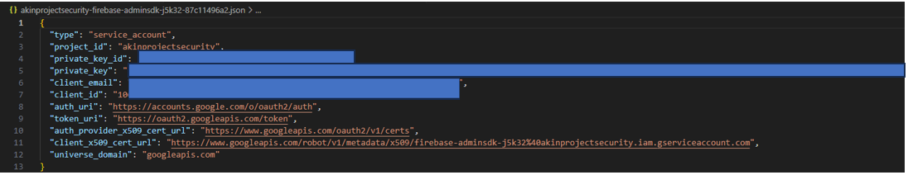

Figure 40 Firebase Admin SDK Configuration

## Appendix C: Data Export Script For user 7, user_test11 and the rest of the users

This appendix includes the script (shown in Figure 41, 42, and 43) used for exporting Firestore data to CSV. It details the Pandas DataFrame creation, column order adjustments, and the exclusion of test users for isolated SVM model testing.

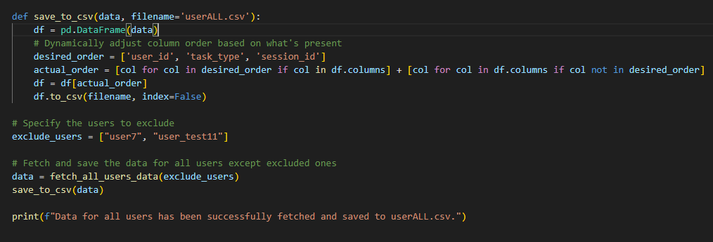

Figure 41 Data Export Script for authenticated users without user 7 and user_test11

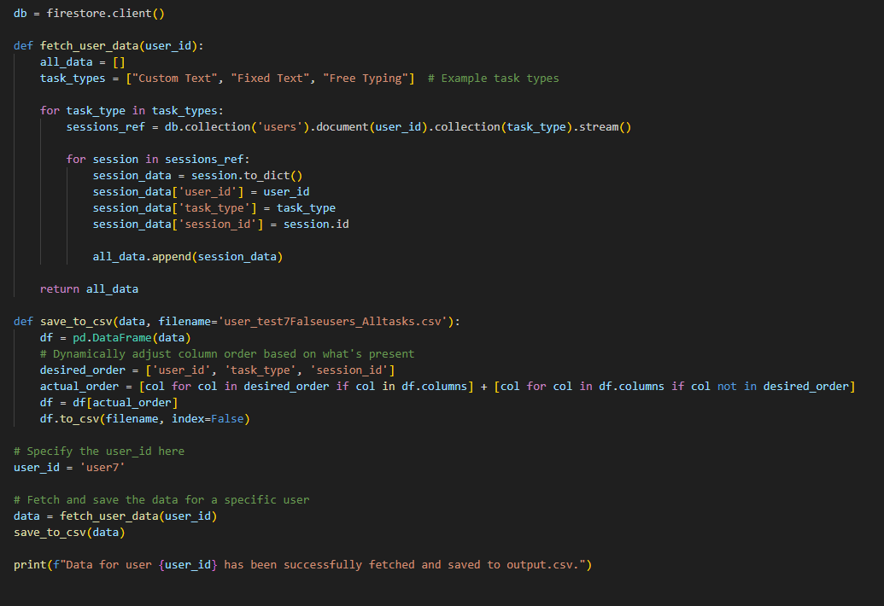

Figure 42 Data export for user 7

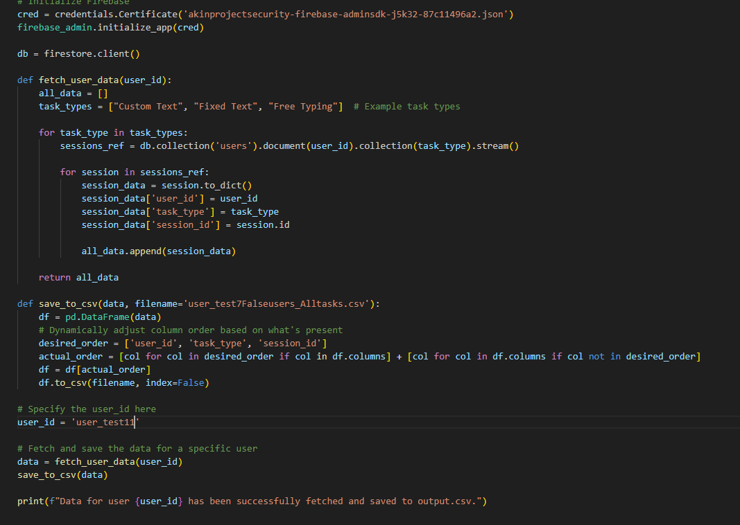

Figure 43 Data export for user_test11

For the complete code related to data collection, metrics computation, system configuration, database management, and data import, please visit:

<https://github.com/divineuniquecoder/keystrokeDynamicsProject/tree/main/keystrokesMetrics>

## Appendix D: Screenshot of Data Import Confirmation

This appendix provides a screenshot Figure 44 as a visual confirmation of the successful data import process. The image captures the result of executing the data transformation and export script, illustrating the generation of the “userALL.csv” file while excluding specific user accounts for separate testing.

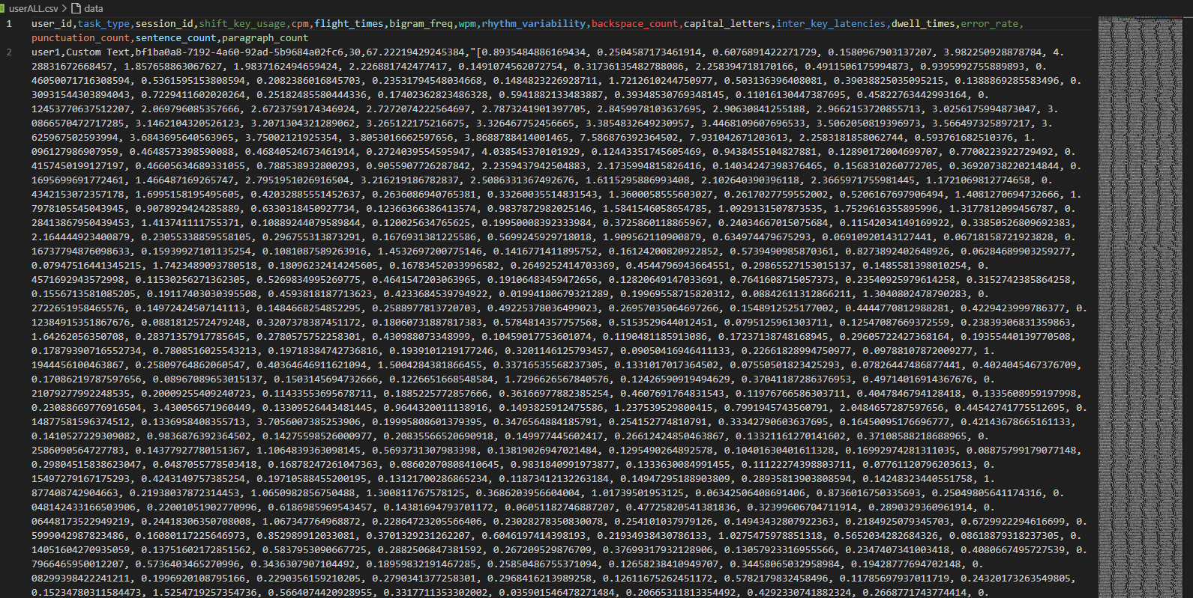

Figure 44 Screenshot of Data Import Confirmation for userAll.csv

## Appendix E: Data Preprocessing Code

This appendix provides access to the complete Python code used for the data preprocessing phases of this project. The code can be viewed at <https://github.com/divineuniquecoder/keystrokeDynamicsProject/blob/main/modelTraining/userAllprepro.py> . It encompasses critical preprocessing tasks such as data cleaning, feature engineering, the management of missing values, and the preparation of the final dataset prior to model training. Please review this code to gain insights into the logical sequence of preprocessing activities that contribute directly to the effectiveness of the SVM model.

## Appendix F: Screenshot of Pre-processed Data

This appendix contains a snapshot confirming the successful preprocessing of the dataset. This visual evidence underscores the data’s readiness for the subsequent modelling phase.

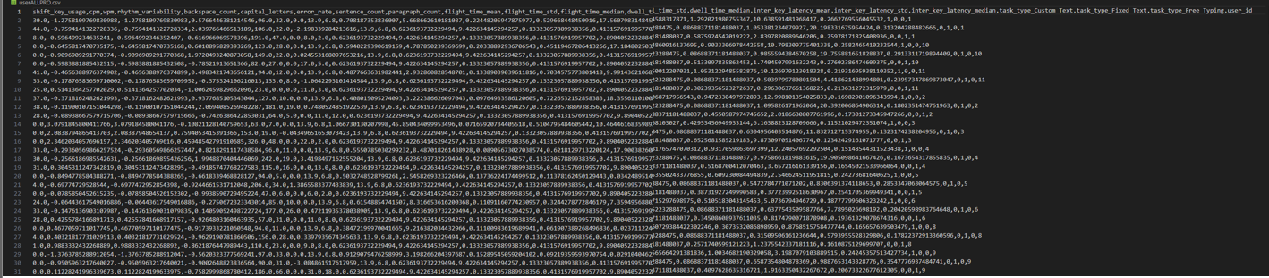

Figure 45 Pre-processed Data Overview

Figure 45 provides the pre-processed dataset ready for SVM analysis, exclusive of test user data, to illustrate the preprocessing outcomes and data quality.

## Appendix G: Metrics chart code

This appendix presents snapshots of the scripts used for metric analysis discussed in Section 7.1.3.

### G1: Code for flight time and dwell time

Appendix G1 provides a view of the code executed (Figure 46) to analyse dwell and flight times in chapter 7.3.1, indicating the practical accuracy in preparing data for CUA system evaluation.

|  |
| --- |
| import pandas as pd  import ast  import numpy as np  import matplotlib.pyplot as plt  # Load the data  data = pd.read_csv('userALL.csv')  # Function to parse lists from strings  def parse_times(column):      return data[column].apply(lambda x: ast.literal_eval(x) if pd.notnull(x) else np.nan)  # Convert stringified lists in 'flight_times' and 'dwell_times' to actual lists  data['flight_times'] = parse_times('flight_times')  data['dwell_times'] = parse_times('dwell_times')  # Explode the 'flight_times' lists into rows  data_flight = data[['user_id', 'flight_times']].explode('flight_times')  data_dwell = data[['user_id', 'dwell_times']].explode('dwell_times')  # Convert 'flight_times' and 'dwell_times' to numeric  data_flight['flight_times'] = pd.to_numeric(data_flight['flight_times'], errors='coerce')  data_dwell['dwell_times'] = pd.to_numeric(data_dwell['dwell_times'], errors='coerce')  # Group by 'user_id' and calculate the count for both metrics  flight_stats = data_flight.groupby('user_id')['flight_times'].agg(['count'])  dwell_stats = data_dwell.groupby('user_id')['dwell_times'].agg(['count'])  # Print the resulting statistics  print("Flight Time Stats:")  print(flight_stats)  print("\nDwell Time Stats:")  print(dwell_stats)  # Plotting the count of flight times per user  plt.figure(figsize=(10, 6))  flight_stats['count'].plot(kind='bar', color='skyblue', alpha=0.6, label='Flight Times')  dwell_stats['count'].plot(kind='bar', color='coral', alpha=0.6, label='Dwell Times')  plt.title('Count of Flight and Dwell Times per User')  plt.xlabel('User ID')  plt.ylabel('Number of Observations')  plt.legend()  plt.xticks(rotation=45)  plt.show() |

Figure 46 Analysis of dwell time and flight time

### G2: Code for Error Rate, CPM and WPM Analysis

Appendix G2 provides a view of the code executed (Figure 47) to analyse error rate, cpm and wpm for chapter 7.3.2, indicating the practical accuracy in preparing data for CUA system evaluation.

|  |
| --- |
| import pandas as pd  import matplotlib.pyplot as plt  import seaborn as sns  # Load the data  data = pd.read_csv('userALL.csv')  # Filter data to include only rows where the task type is 'Fixed Text'  filtered_data = data[data['task_type'] == 'Fixed Text']  # Calculate the mean for error_rate, wpm, and cpm grouped by user_id  error_stats = filtered_data.groupby('user_id')['error_rate'].mean()  wpm_stats = filtered_data.groupby('user_id')['wpm'].mean()  cpm_stats = filtered_data.groupby('user_id')['cpm'].mean()  # Print the resulting statistics  print("\nError Rates per User:")  print(error_stats)  print("\nWords Per Minute (WPM) per User:")  print(wpm_stats)  print("\nCharacters Per Minute (CPM) per User:")  print(cpm_stats)  # Visualization setup  sns.set(style="whitegrid")  uniform_color = '#3498db'  # Error Rate Visualization  plt.figure(figsize=(10, 6))  sns.barplot(x=error_stats.index, y=error_stats.values, color=uniform_color)  plt.title('Error Rates per User for Fixed Text')  plt.xlabel('User ID')  plt.ylabel('Error Rate')  plt.xticks(rotation=45)  plt.show()  # WPM Visualization  plt.figure(figsize=(10, 6))  sns.barplot(x=wpm_stats.index, y=wpm_stats.values, color=uniform_color)  plt.title('Words Per Minute (WPM) per User for Fixed Text')  plt.xlabel('User ID')  plt.ylabel('WPM')  plt.xticks(rotation=45)  plt.show()  # CPM Visualization  plt.figure(figsize=(10, 6))  sns.barplot(x=cpm_stats.index, y=cpm_stats.values, color=uniform_color)  plt.title('Characters Per Minute (CPM) per User for Fixed Text')  plt.xlabel('User ID')  plt.ylabel('CPM')  plt.xticks(rotation=45)  plt.show() |

Figure 47 Analysis of error rate

### G3: Code for Sentence and Paragraph counts and Backspace usage Analysis

Appendix G3 provides a view of the code executed (Figure 48) to analysesentence and paragraph counts and backspace usage for chapter 7.3.3, indicating the practical accuracy in preparing data for CUA system evaluation.

|  |
| --- |
| import pandas as pd  import matplotlib.pyplot as plt  import seaborn as sns  # Load the data  data = pd.read_csv('userALL.csv')  # Filter data to include only rows where the task type is 'Free Typing'  filtered_data = data[data['task_type'] == 'Free Typing']  # Calculate the mean for sentence_count, paragraph_count, and backspace_count grouped by user_id  sentence_stats = filtered_data.groupby('user_id')['sentence_count'].mean()  paragraph_stats = filtered_data.groupby('user_id')['paragraph_count'].mean()  backspace_stats = filtered_data.groupby('user_id')['backspace_count'].mean()  # Print the resulting statistics  print("\nSentence Count per User:")  print(sentence_stats)  print("\nParagraph Count per User:")  print(paragraph_stats)  print("\nBackspace Count per User:")  print(backspace_stats)  # Visualization setup  sns.set(style="whitegrid")  uniform_color = '#3498db'  # Sentence Count Visualization  plt.figure(figsize=(10, 6))  sns.barplot(x=sentence_stats.index, y=sentence_stats.values, color=uniform_color)  plt.title('Sentence Count per User for Free Typing')  plt.xlabel('User ID')  plt.ylabel('Average Sentence Count')  plt.xticks(rotation=45)  plt.show()  # Paragraph Count Visualization  plt.figure(figsize=(10, 6))  sns.barplot(x=paragraph_stats.index, y=paragraph_stats.values, color=uniform_color)  plt.title('Paragraph Count per User for Free Typing')  plt.xlabel('User ID')  plt.ylabel('Average Paragraph Count')  plt.xticks(rotation=45)  plt.show()  # Backspace Count Visualization  plt.figure(figsize=(10, 6))  sns.barplot(x=backspace_stats.index, y=backspace_stats.values, color=uniform_color)  plt.title('Backspace Count per User for Free Typing')  plt.xlabel('User ID')  plt.ylabel('Average Backspace Count')  plt.xticks(rotation=45)  plt.show() |

Figure 48 Analysis of Sentence and Paragraph counts and Backspace usage

## Appendix H: Dataset Snapshots for Post-Processing Analysis

This appendix provides snapshots of the three key datasets used in the post-processing phase of the CUA system. Figure 49 illustrate the distinct characteristics of the data for each user group:

* **userALLPRO**: Features the processed keystroke dynamics data from a collective of users, including user11, during various tasks. This comprehensive dataset served as the foundation for training the One-Class SVM. Readers are encouraged to observe the varied keystroke patterns across users, highlighting the diversity in typing behaviour.
* **new_User11**: Presents the specific keystroke data for user11 after undergoing the same preprocessing steps as **userALLPRO**. This allows a direct comparison between the individual's data within the collective dataset and their profile, indicating the accuracy in user-specific pattern recognition.
* **user7**: Contains the keystroke dynamics of user7, who is not present in the **userALLPRO** data, thus representing an unauthenticated user. The comparison between user7’s data and the authenticated users' profiles highlights the model's ability to differentiate between known and unknown typing patterns, which is important for detecting impostors.

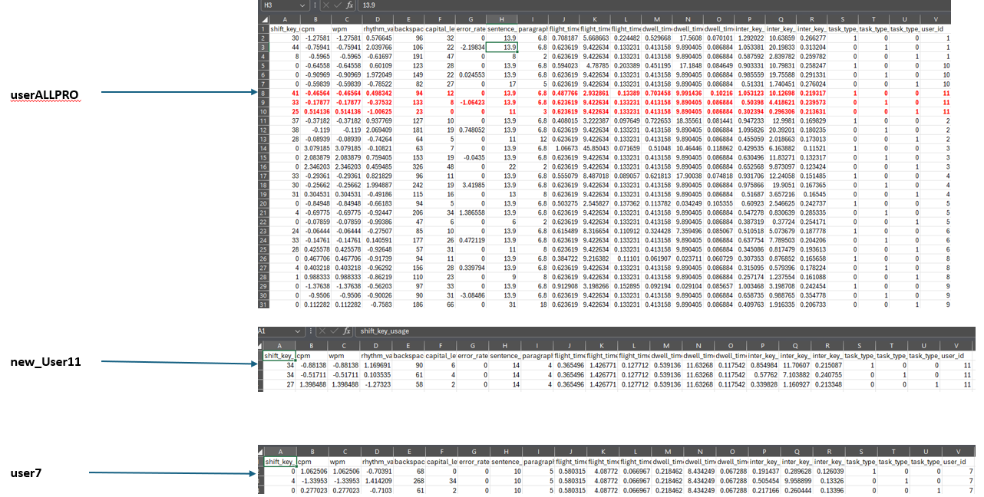

Figure 49 Overview of Keystroke Dynamics for Authenticated and Unauthenticated Users

## Appendix I: Complete One-Class SVM Training and Testing Script

This appendix presents the screenshot of the full Python script used for the One-Class SVM training and testing within the CUA system. The script includes all necessary steps from data loading, preprocessing, model training with different “nu” values, to the final evaluation using both true user and imposter data across multiple tasks. This comprehensive script was executed to validate the model's efficacy in distinguishing between authentic users and potential security threats within the framework of behavioural biometrics. Figure 50 below shows the process undertaken:

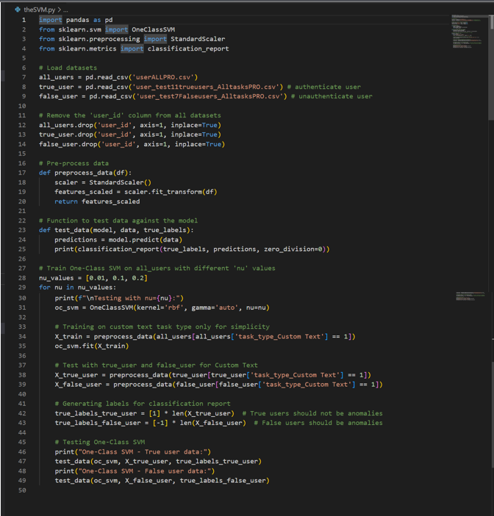

Figure 50 One-Class SVM Training and Testing Script

The script demonstrates a systematic approach to SVM training across numerous tasks, Custom Text, Fixed Text, and Free Typing. It also details the model's evaluation process, where the classification report provides insights into the SVM's precision and recall, crucial metrics for assessing the model's authentication accuracy.

## Appendix J: Comprehensive One-Class SVM Testing Results

This appendix presents the detailed outcomes of One-Class SVM tests. The data highlights the model’s precision in identifying an authenticated user (user11) and detecting an impostor (user7) across various tasks and "nu" values. These results in Figure 51 validate the SVM's efficacy in user authentication within the CUA system and verify the discussions in Chapter 7.4.

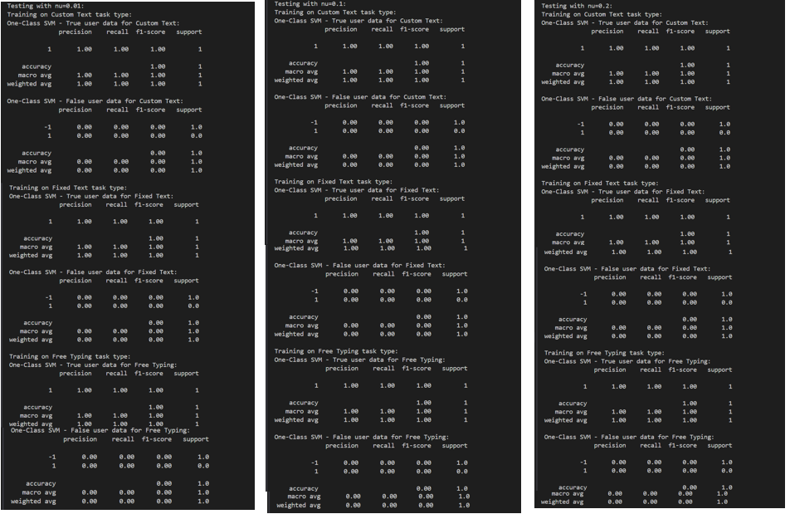

Figure 51 One-Class SVM Testing Results

For the complete code of the One-Class SVM training and testing scripts, as well as the statistics, pre-processed code, raw data and postprocessed code, please visit <https://github.com/divineuniquecoder/keystrokeDynamicsProject/tree/main/modelTraining>

## Appendix K: Error Logs and System Performance Screenshots

**Overview of Live CUA Methodology**

This section outlines the process and challenges associated with the live demonstration of the CUA system, with a specific focus on how keystroke dynamics data were collected and used differently from the initial training phase.

### Data Collection and Training Process

Keystroke dynamics were originally collected through three structured task types: custom, fixed, and free typing (see chapter 6.2). These tasks were designed to capture a broad spectrum of user behaviour and provide a diverse dataset for building robust user profiles.

**Adaptation and Challenges for Live Authentication**

During the live demonstration, several methodological adaptations and challenges were encountered:

* **Assumption of Free Typing in Live Data Collection**: Unlike the varied tasks used during initial data collection, the live system assumed all user input would be akin to free typing. This assumption led to a mismatch between the training data and the live collected data, introducing variability not accounted for in the initial models.

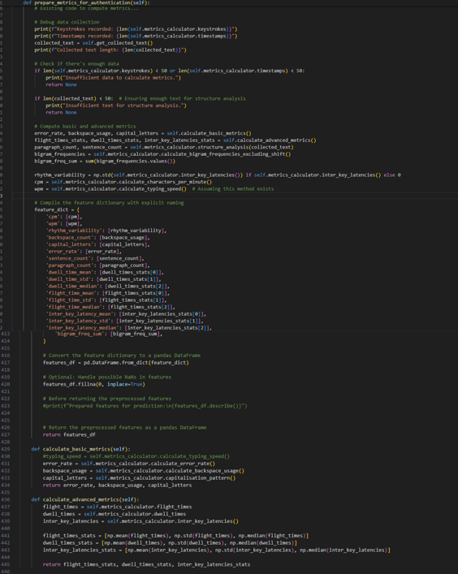

Figure Live Keystrokes collection

To illustrate this point, Figure 52 compares the metrics collected from live data with those collected during the initial structured tasks as detailed in Chapter 6.2. The figure visually demonstrates how the assumption of free typing affected the data collection process, highlighting differences in the range, distribution, and types of metrics gathered. This visual comparison underscores the impact of the data collection methodology on the system’s performance.

* **Data Insufficiency**: A significant challenge during the live demonstration was the insufficiency of data:
  + **Limited Diversity and Volume**: The live system did not capture the same diversity and volume of keystroke data as during the initial data collection phase. This lack of comprehensive data undermined the system's ability to robustly authenticate users under varied real-world typing scenarios.
  + **Impact on Model Effectiveness**: The insufficient data during live demonstrations hindered the machine learning models' ability to accurately generalise to new, untrained behaviours. This was particularly detrimental in a live setting where user behaviour could vary significantly from the controlled environments used for training.

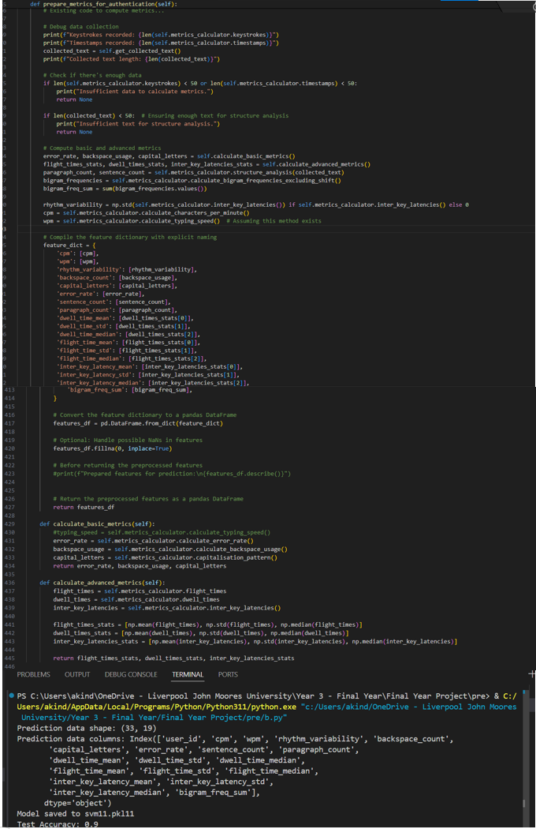

Figure SVM-based CUA for User11

Figure 53 shows the training a ML model for CUA, with a particular focus on user11. The process begins with loading a dataset and preparing it for training. Subsequently, the dataset is split into training and testing sets to facilitate model evaluation. A pipeline is then created, integrating data imputation techniques and a SVM classifier. This pipeline is trained on the training set and saved to a file for future use. The final step involves evaluating the model's performance on the test set to determine its effectiveness in authenticating users continuously based on their behavioural patterns. The reported test accuracy at 0.9, indicates the model's ability to correctly classify users.

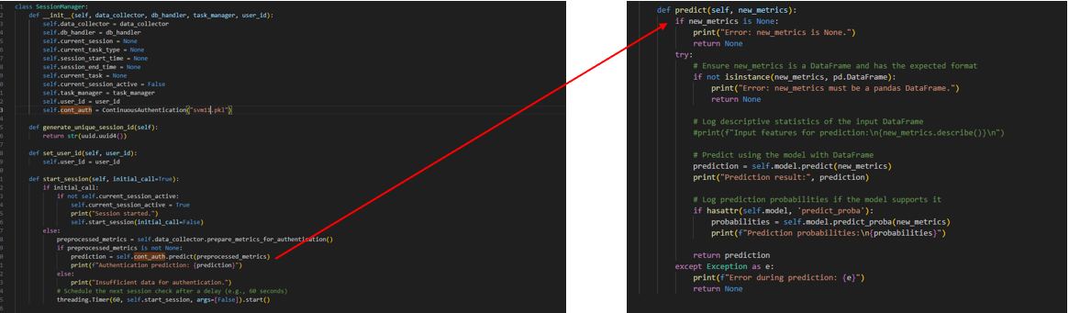

Figure Sessionmanger and predict method for CUA

The **predict** method on the right (Figure 54) serves as an interface for using the trained SVM model for CUA. This method accepts new metrics as input, ensuring they conform to the expected DataFrame format. Upon receiving valid input, the method uses the SVM model to determine user authentication outcomes. Any encountered errors during the prediction process are appropriately handled to ensure smooth functionality.

The **SessionManager** class integrates the **ContinuousAuthentication** module, using the SVM model (**svm11.pkl**) for CUA. During session initiation, it prepares metrics for authentication and delegates the authentication process to the **ContinuousAuthentication** module, providing authentication predictions based on the received metrics. The class employs threading to schedule periodic session checks, ensuring continuous authentication throughout user sessions.

### Live Authentication Process

The system operates in real-time, analysing keystrokes as users interact with it and continuously comparing this data to the trained models:

* **Continuous Verification**: Upon user login, each keystroke is analysed in comparison to the user’s baseline profile model. This comparison is intended to continuously validate the authenticity of the session.

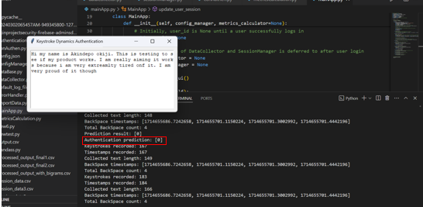

Figure Incorrect Authentication Prediction Despite Correct User Typing Behaviour

Figure 55 shows that despite the legitimate user's typing behaviour, the system predicts the authentication outcome incorrectly as “0”, which indicates an unauthenticated state. This result is contrary to expectations; the prediction should ideally be “1” to confirm successful authentication, reflecting that the observed typing pattern matches the behavioural profile of the authenticated user. This discrepancy suggests a potential issue in the algorithm's sensitivity or accuracy in detecting genuine user interactions.

**Decision Logic**:

* **True Authentication:** If keystrokes closely match the trained profile, the system confirms the session continuously without user interruption.
* **False Authentication Alert:** Significant deviations from the trained profile trigger an alert, suggesting potential unauthorised access.

**Impact of Data Collection Shift**

The assumption that all live typing would mirror free typing led to a broader range of keystroke metrics being analysed than those used in the model training. This contributed to a higher rate of false positives and false negatives, as the system was not standardised to handle the variability introduced by unstructured live typing.

For the complete code of the live authentication process, please visit <https://github.com/divineuniquecoder/keystrokeDynamicsProject/tree/main/forLiveCUA_Test>

## Appendix L: GitHub Repository for Project Code

This appendix provides detailed documentation of the GitHub repository used for storing all scripts and data files relevant to the Keystroke Dynamics Project. The repository includes multiple directories, each dedicated to different phases of the project, such as data collection, preprocessing, model training, and evaluation.

**Title:** Keystroke Dynamics Project Code Repository

**Repository Link:**

<https://github.com/divineuniquecoder/keystrokeDynamicsProject/tree/main/forLiveCUA_Test>

**Repository Structure:**

* **/keystrokesMetrics:** Contains scripts for collecting and computing keystroke metrics.
* **/modelTraining:** Includes Python scripts for training the SVM model and preprocessing data.
* **/forLiveCUA_Test**: Scripts used for live CUA testing.
* README.md: Provides instructions on how to set up and run the scripts, as well as a description of each component of the repository.

**Access Instructions:** The repository is public and can be accessed directly through the provided link. Users can clone the repository or download specific files as needed. For cloning, use the following command in your terminal:

|  |
| --- |
| git clone <https://github.com/divineuniquecoder/keystrokeDynamicsProject.git> |

Figure GitHub cloning command link

**Usage Notes:** Each directory in the repository includes a description that details the scripts contained within and their purpose. Users are encouraged to review these files for guidance on how to execute the scripts and understand their output.